**T.A.P.I. 1.0 - Technical Manual**



**April 12, 2022**



**Permanent Communications**

**Entity Relationship Diagram (ERD)**….……….…………………………………….…………………………………………3

**Data Dictionary**…………………….…………………………………….…………………………………………………………….4

**Data Flow Diagram**…...……………………….………………………………………………….………………………………….5

**Use Cases**………………………………….………………………………………………….……………………………………………6

**Activity Diagrams**…………………………………….………………………………………………………………………..…….25

a. Employee……………….…………………………….…….………………………………………………………….…25

b. Investor……………………………………………….………………………………….………………….……………26

c. Subcontractor…….……………………………….……………….………………….………………….……………27

d. Project Work Breakdown Structure (WBS)……………..……………………………….……….………28

**GUI Images**….……………………………………………….……………………………………………….…………………………30

**Reports/Queries.**……..….……..…………….………………………………………………………………………..………….64

**Future Improvements**….………….………………………………………………………………………………………………70

**Application Development Lessons Learned**…………………………………………………………………………….71

**New Technologies and Lessons Utilized**………………………………………………………………………………….76

**Project Maintenance**……………………………………………………………………………………………………………….77

**Technical Manual……**……...………...………………………………………………………………………………..………….83

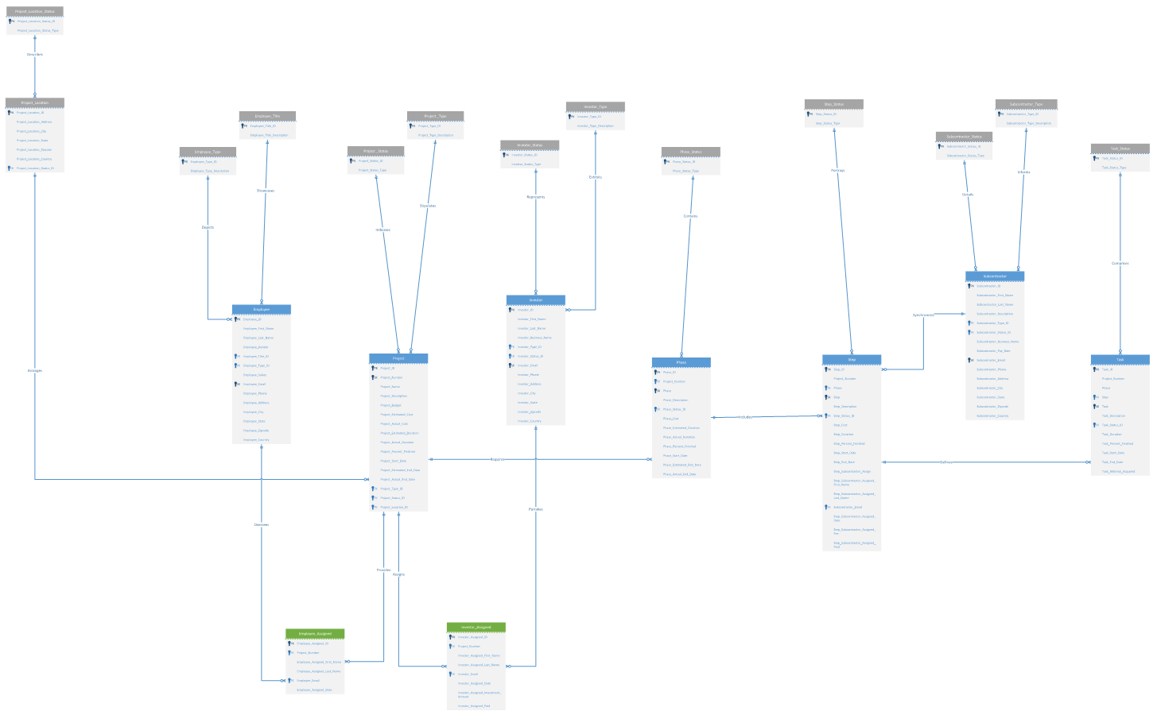



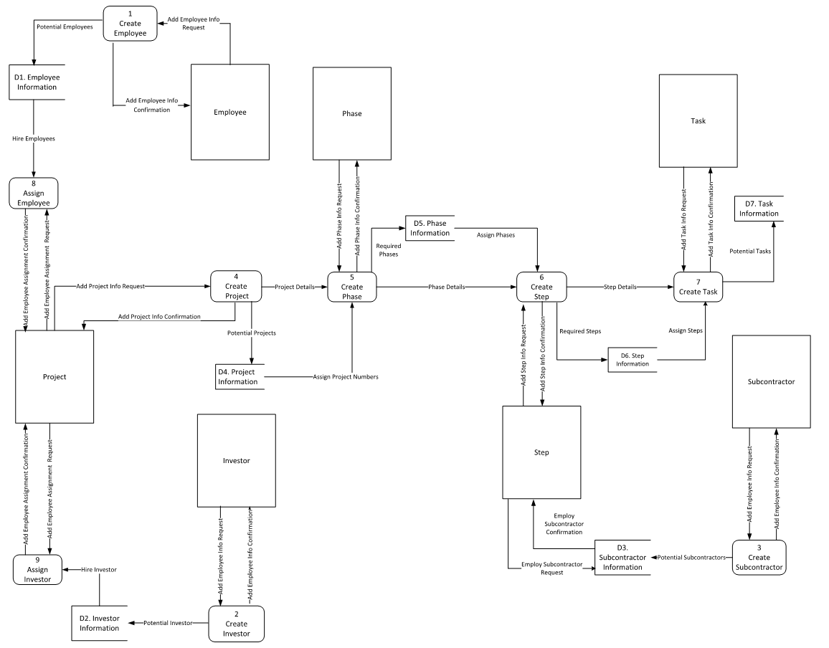

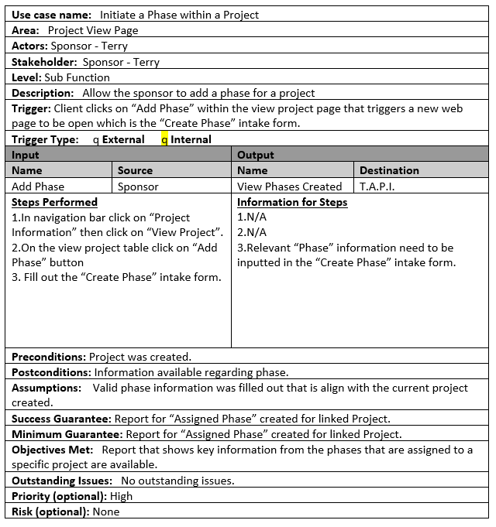

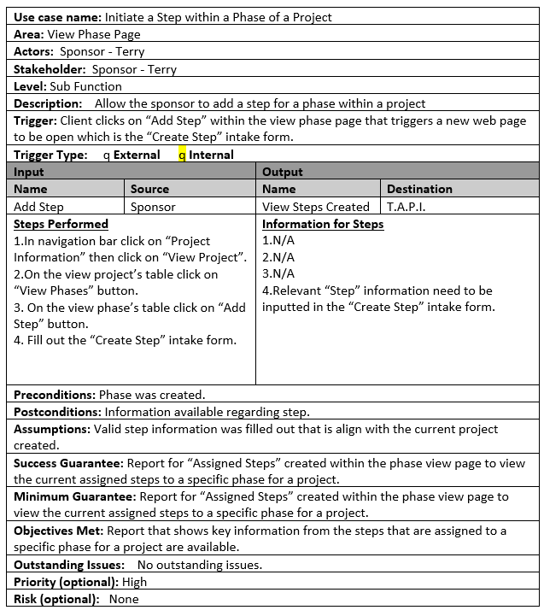

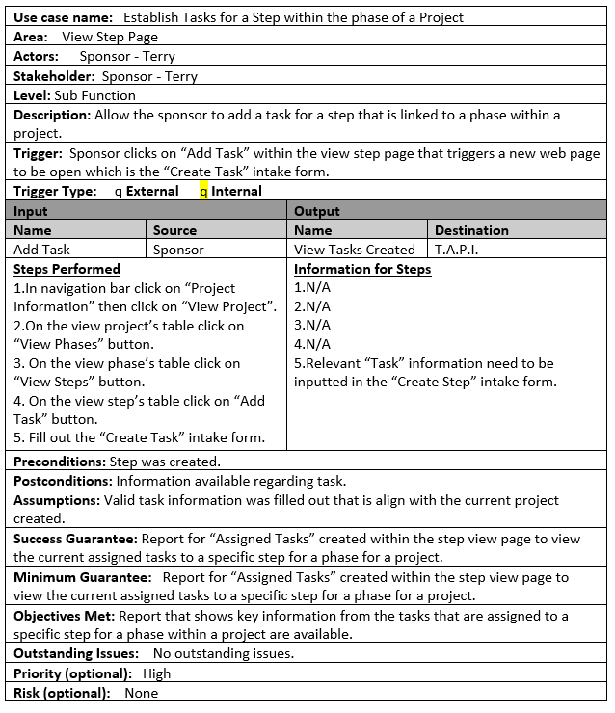

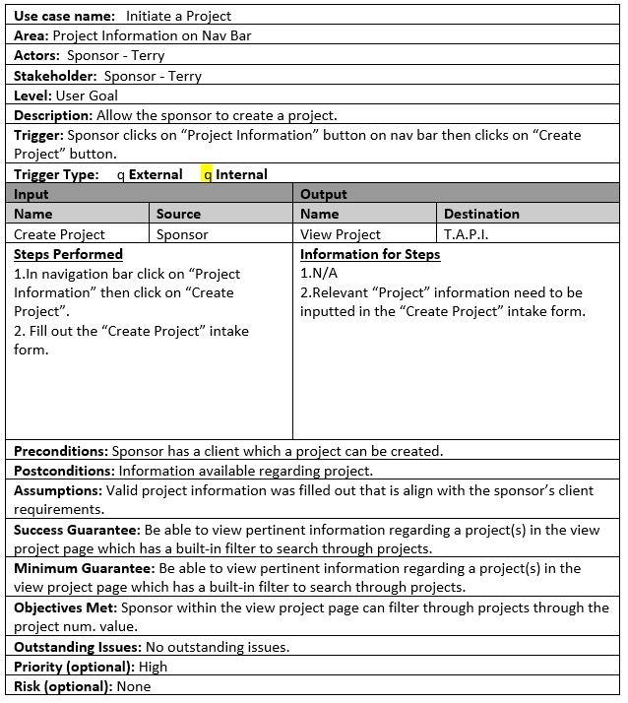

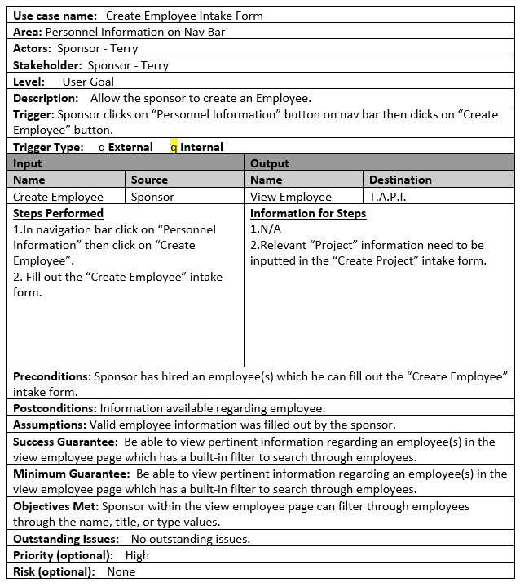

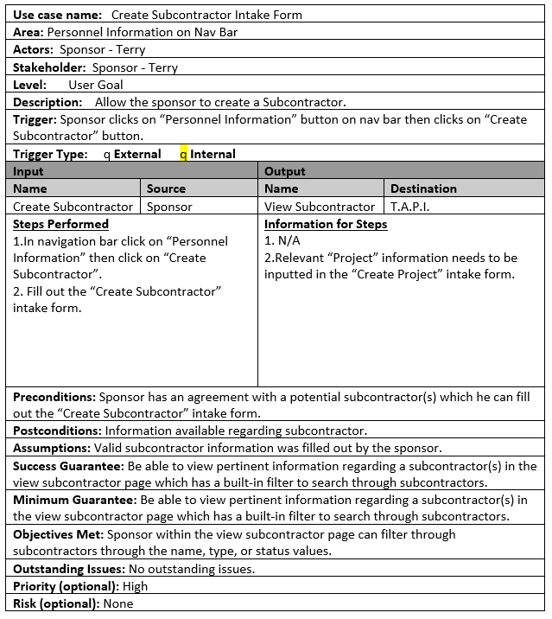

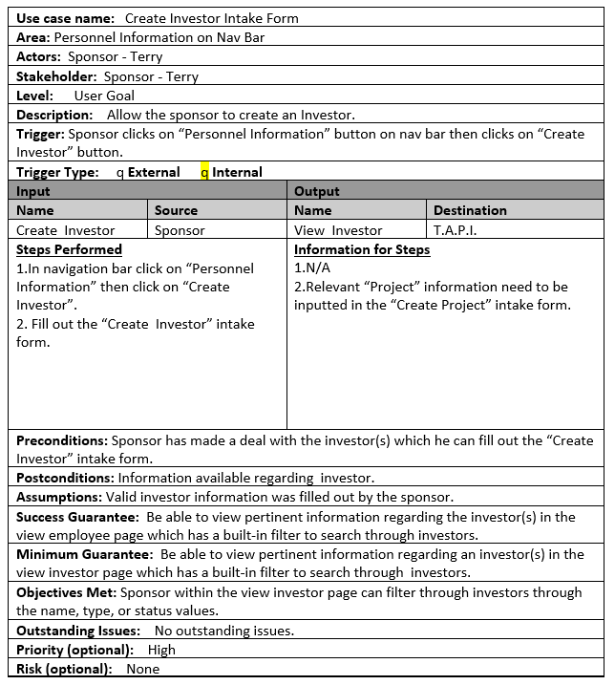

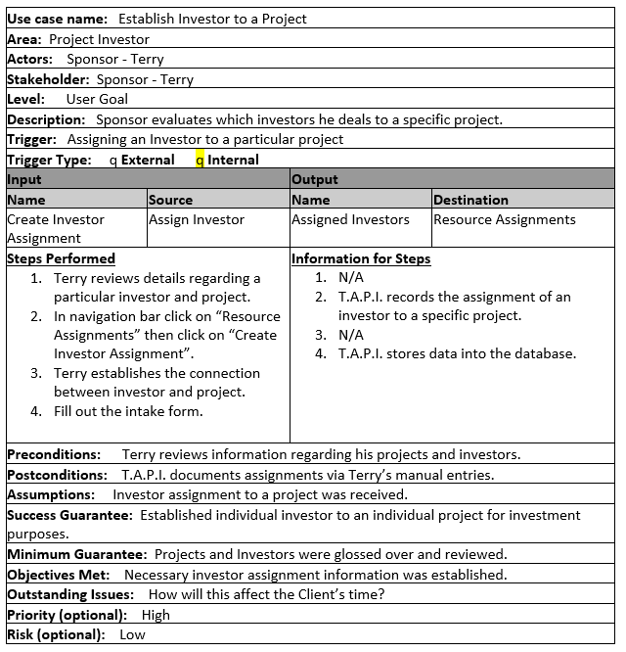

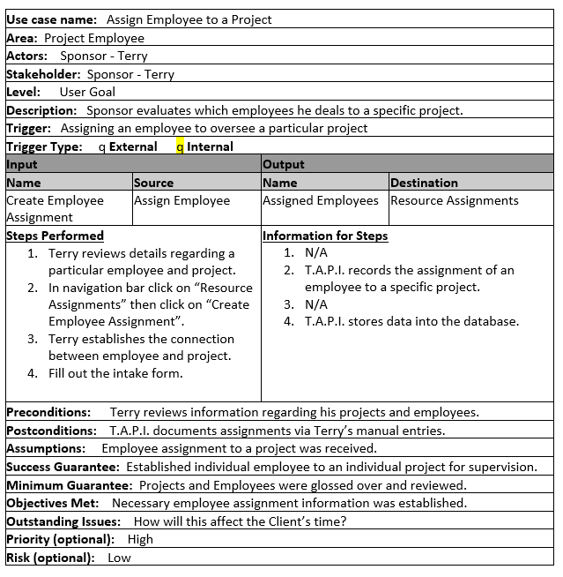

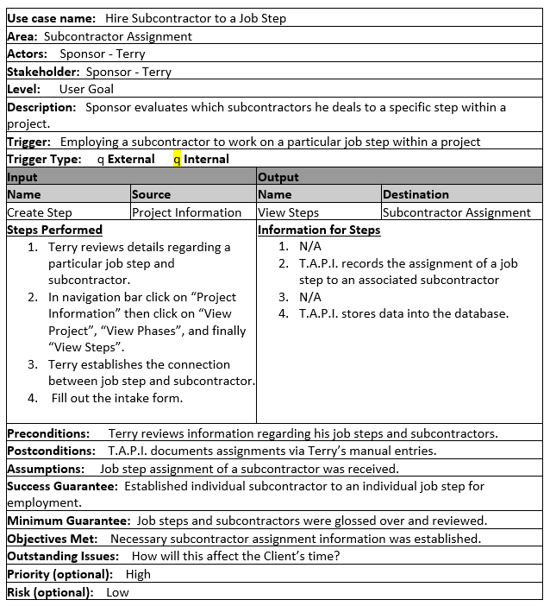

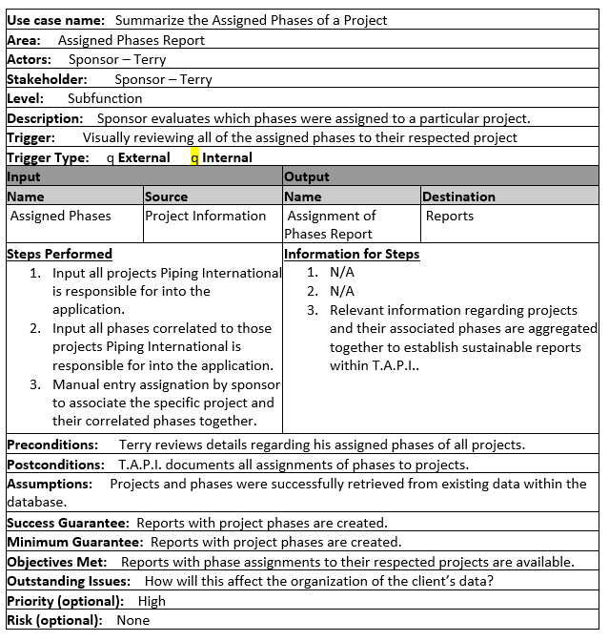

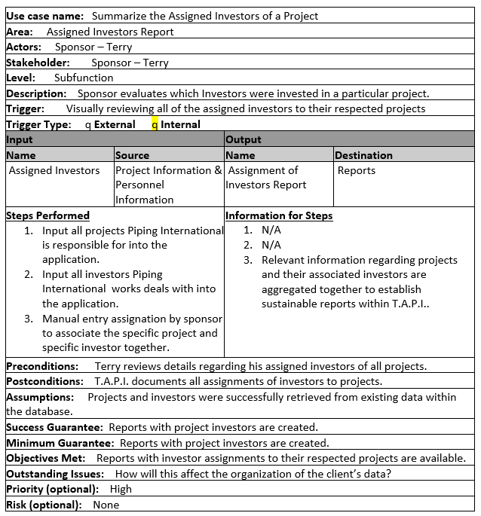

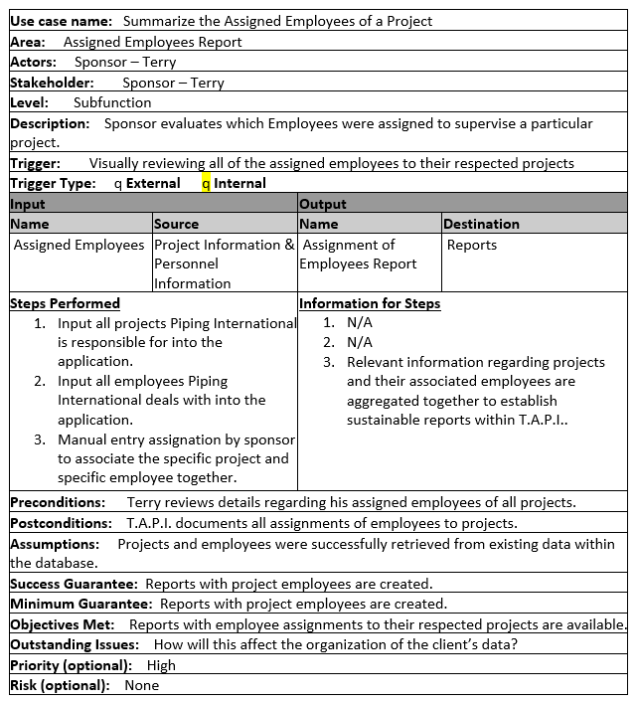

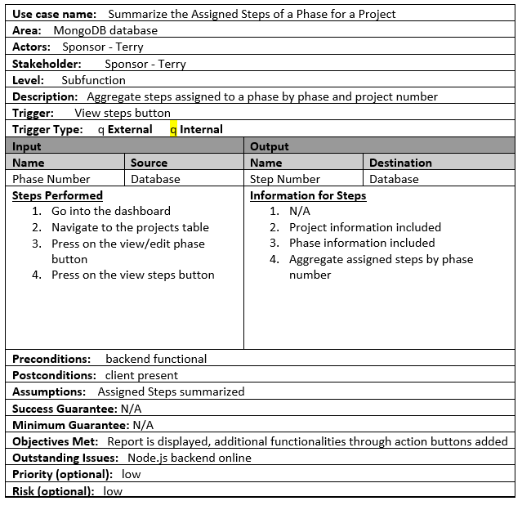

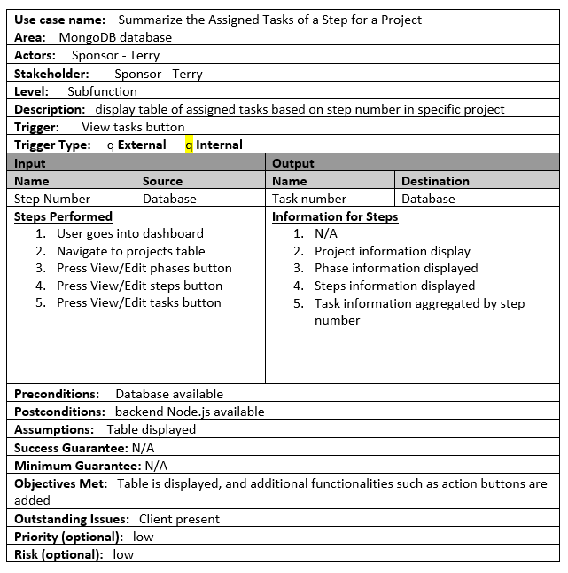

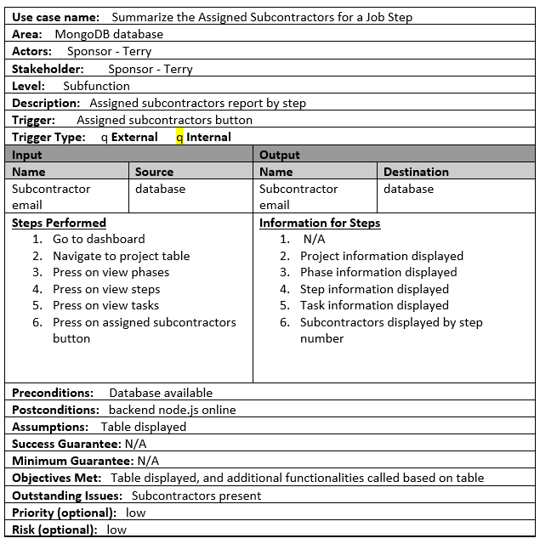

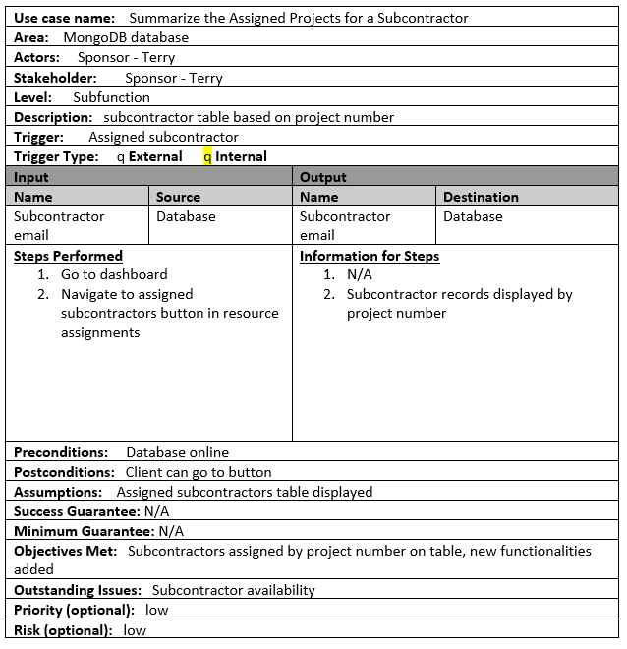

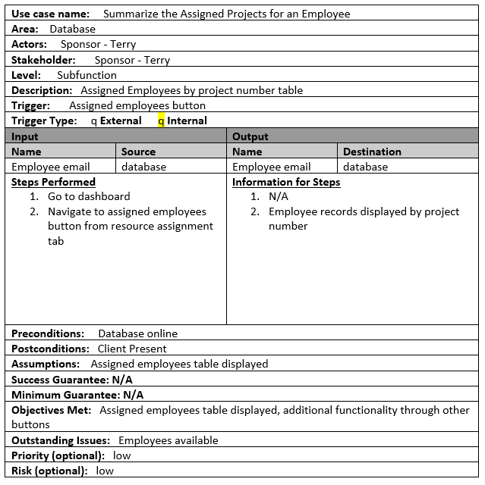

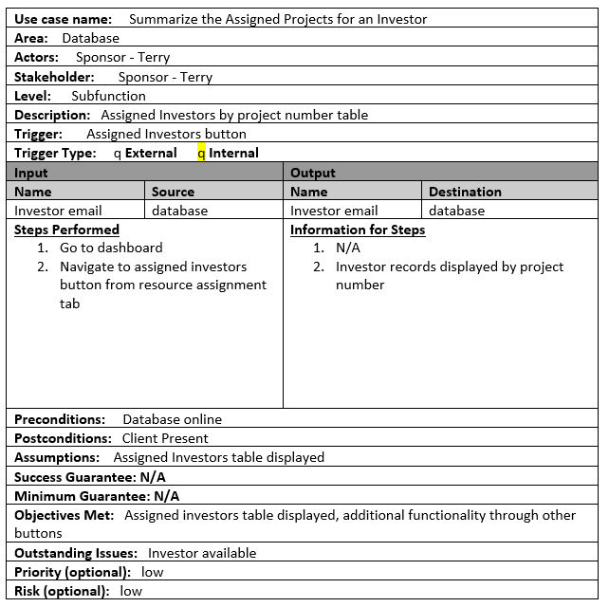

**Employee**

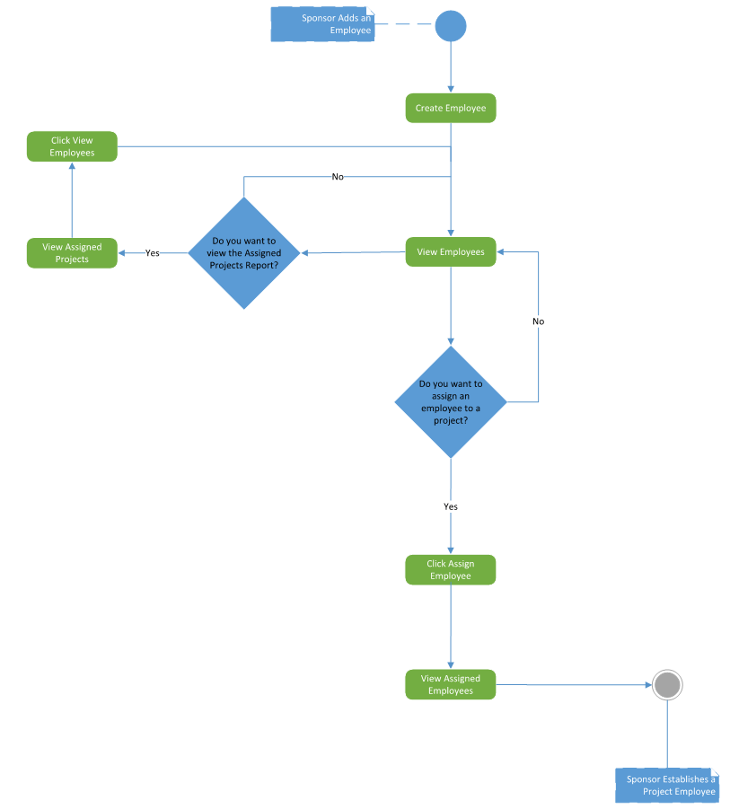

**Investor**

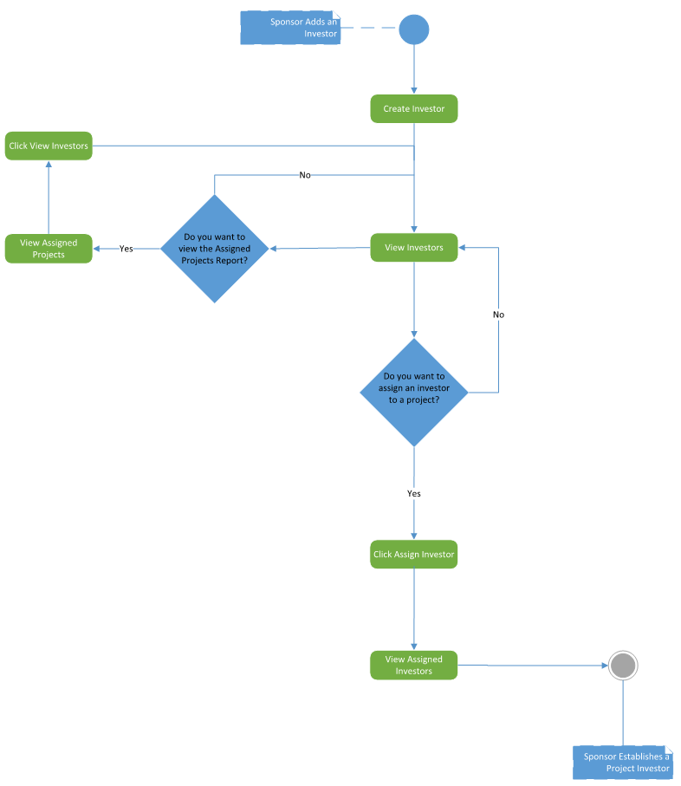

**Subcontractor**

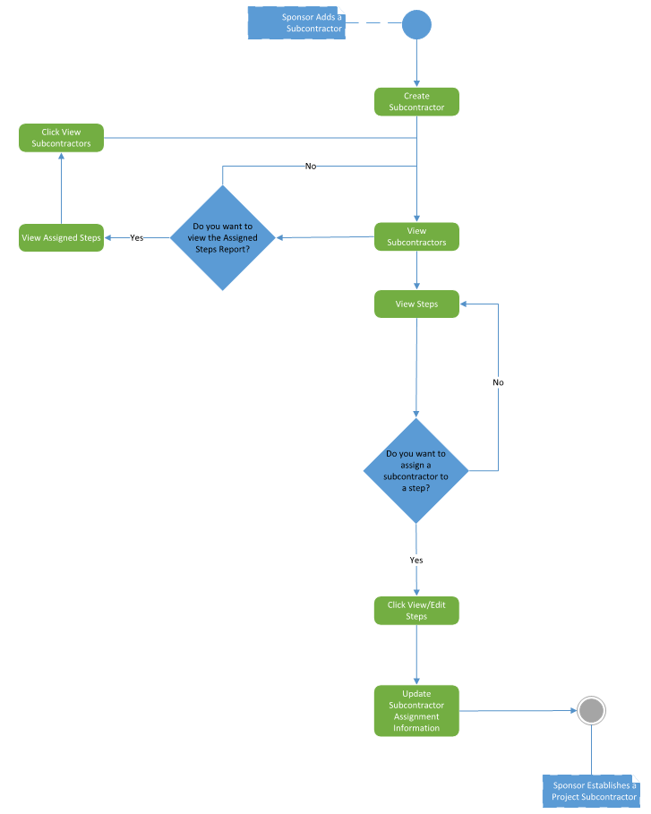

**Project Work Breakdown Structure (WBS)**

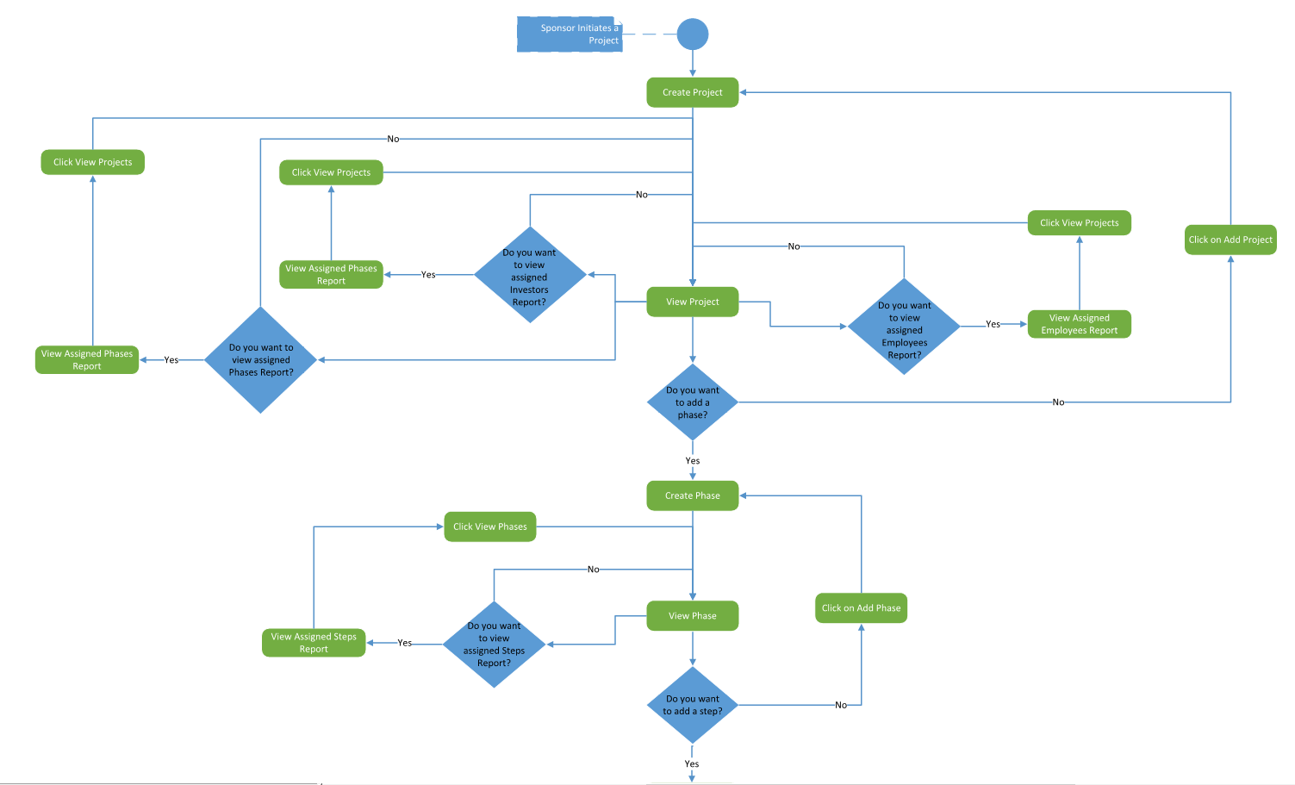

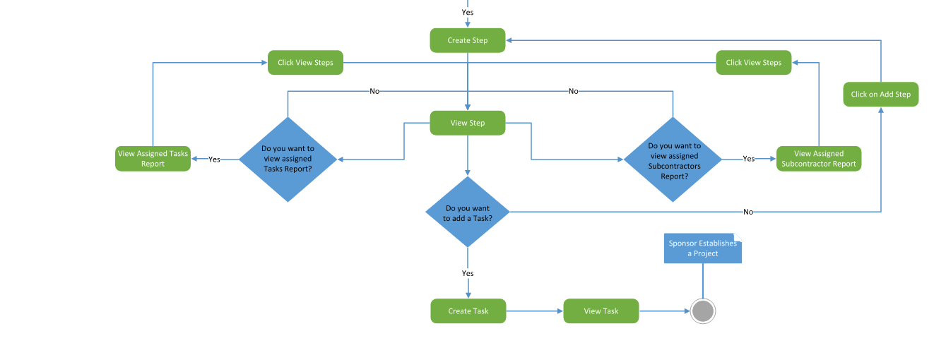

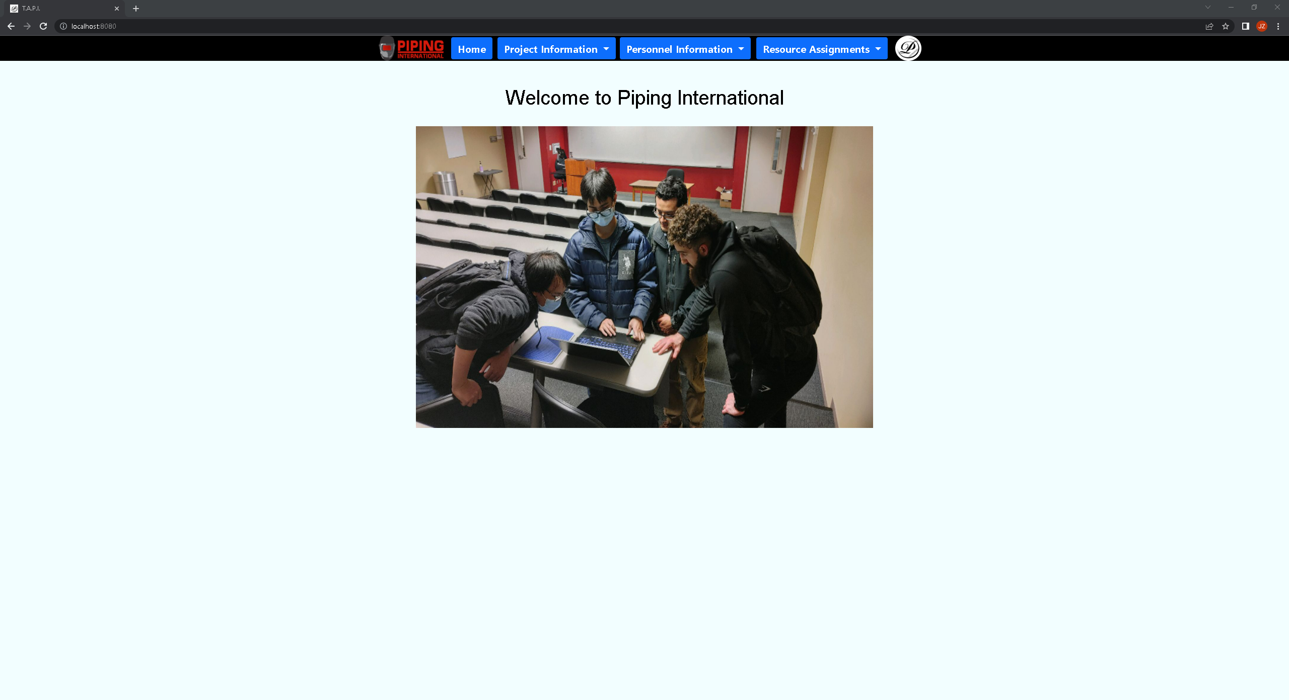

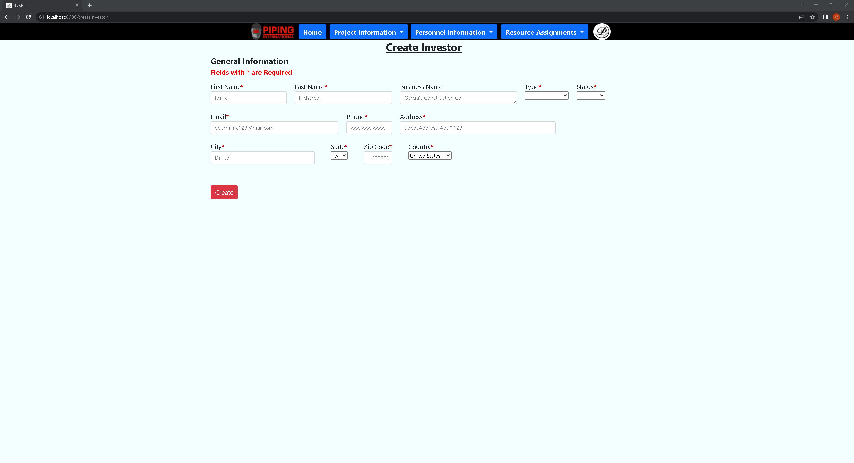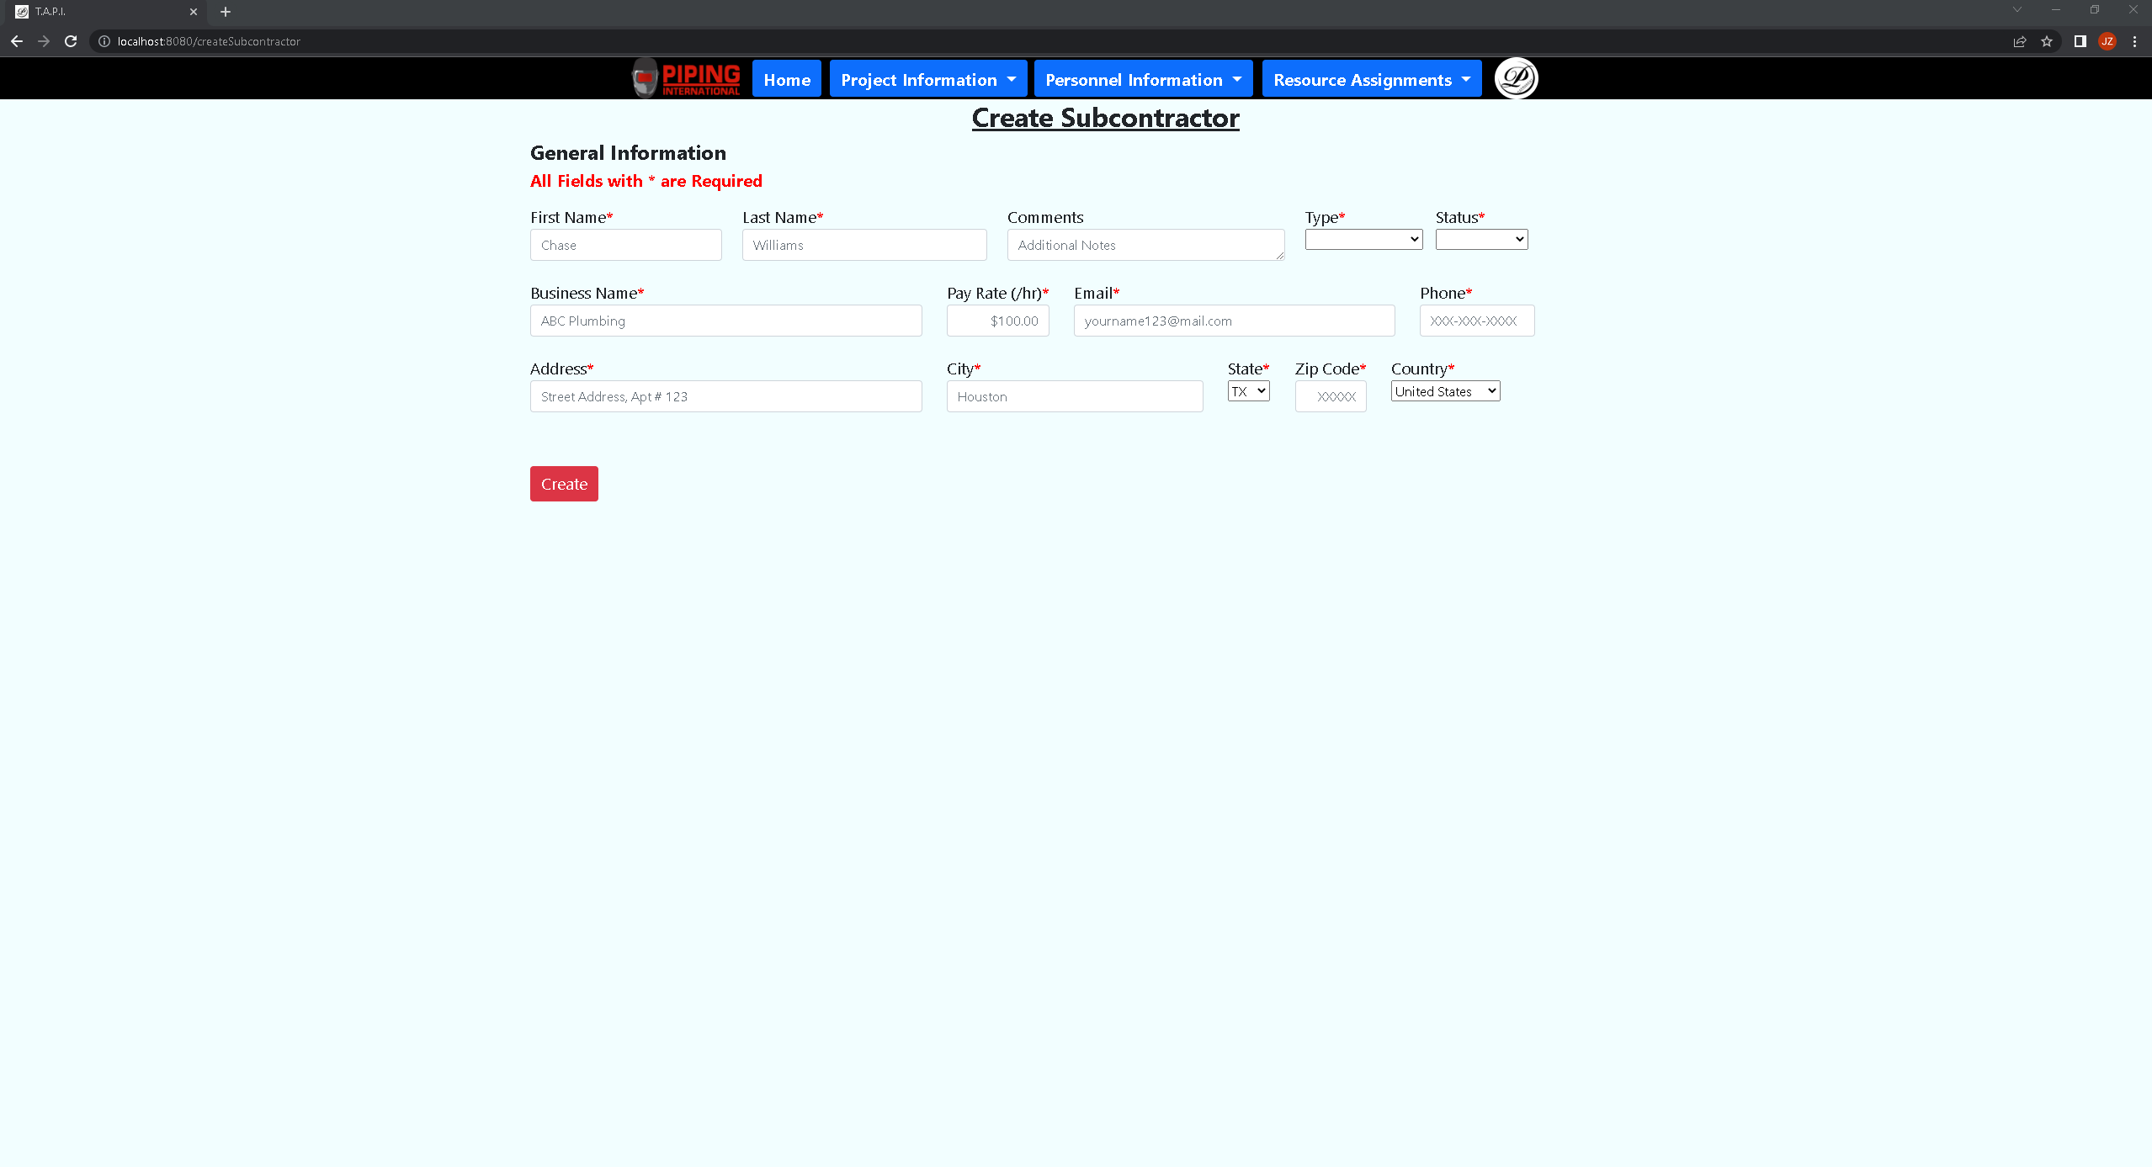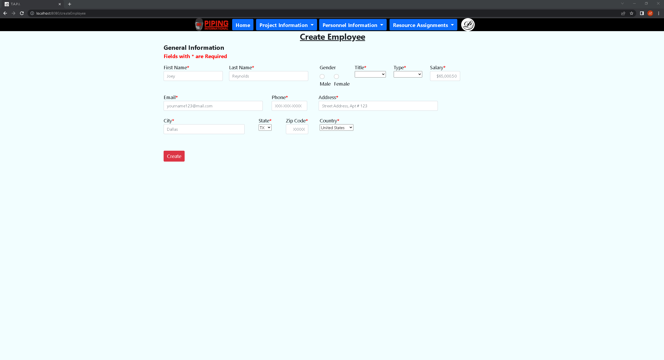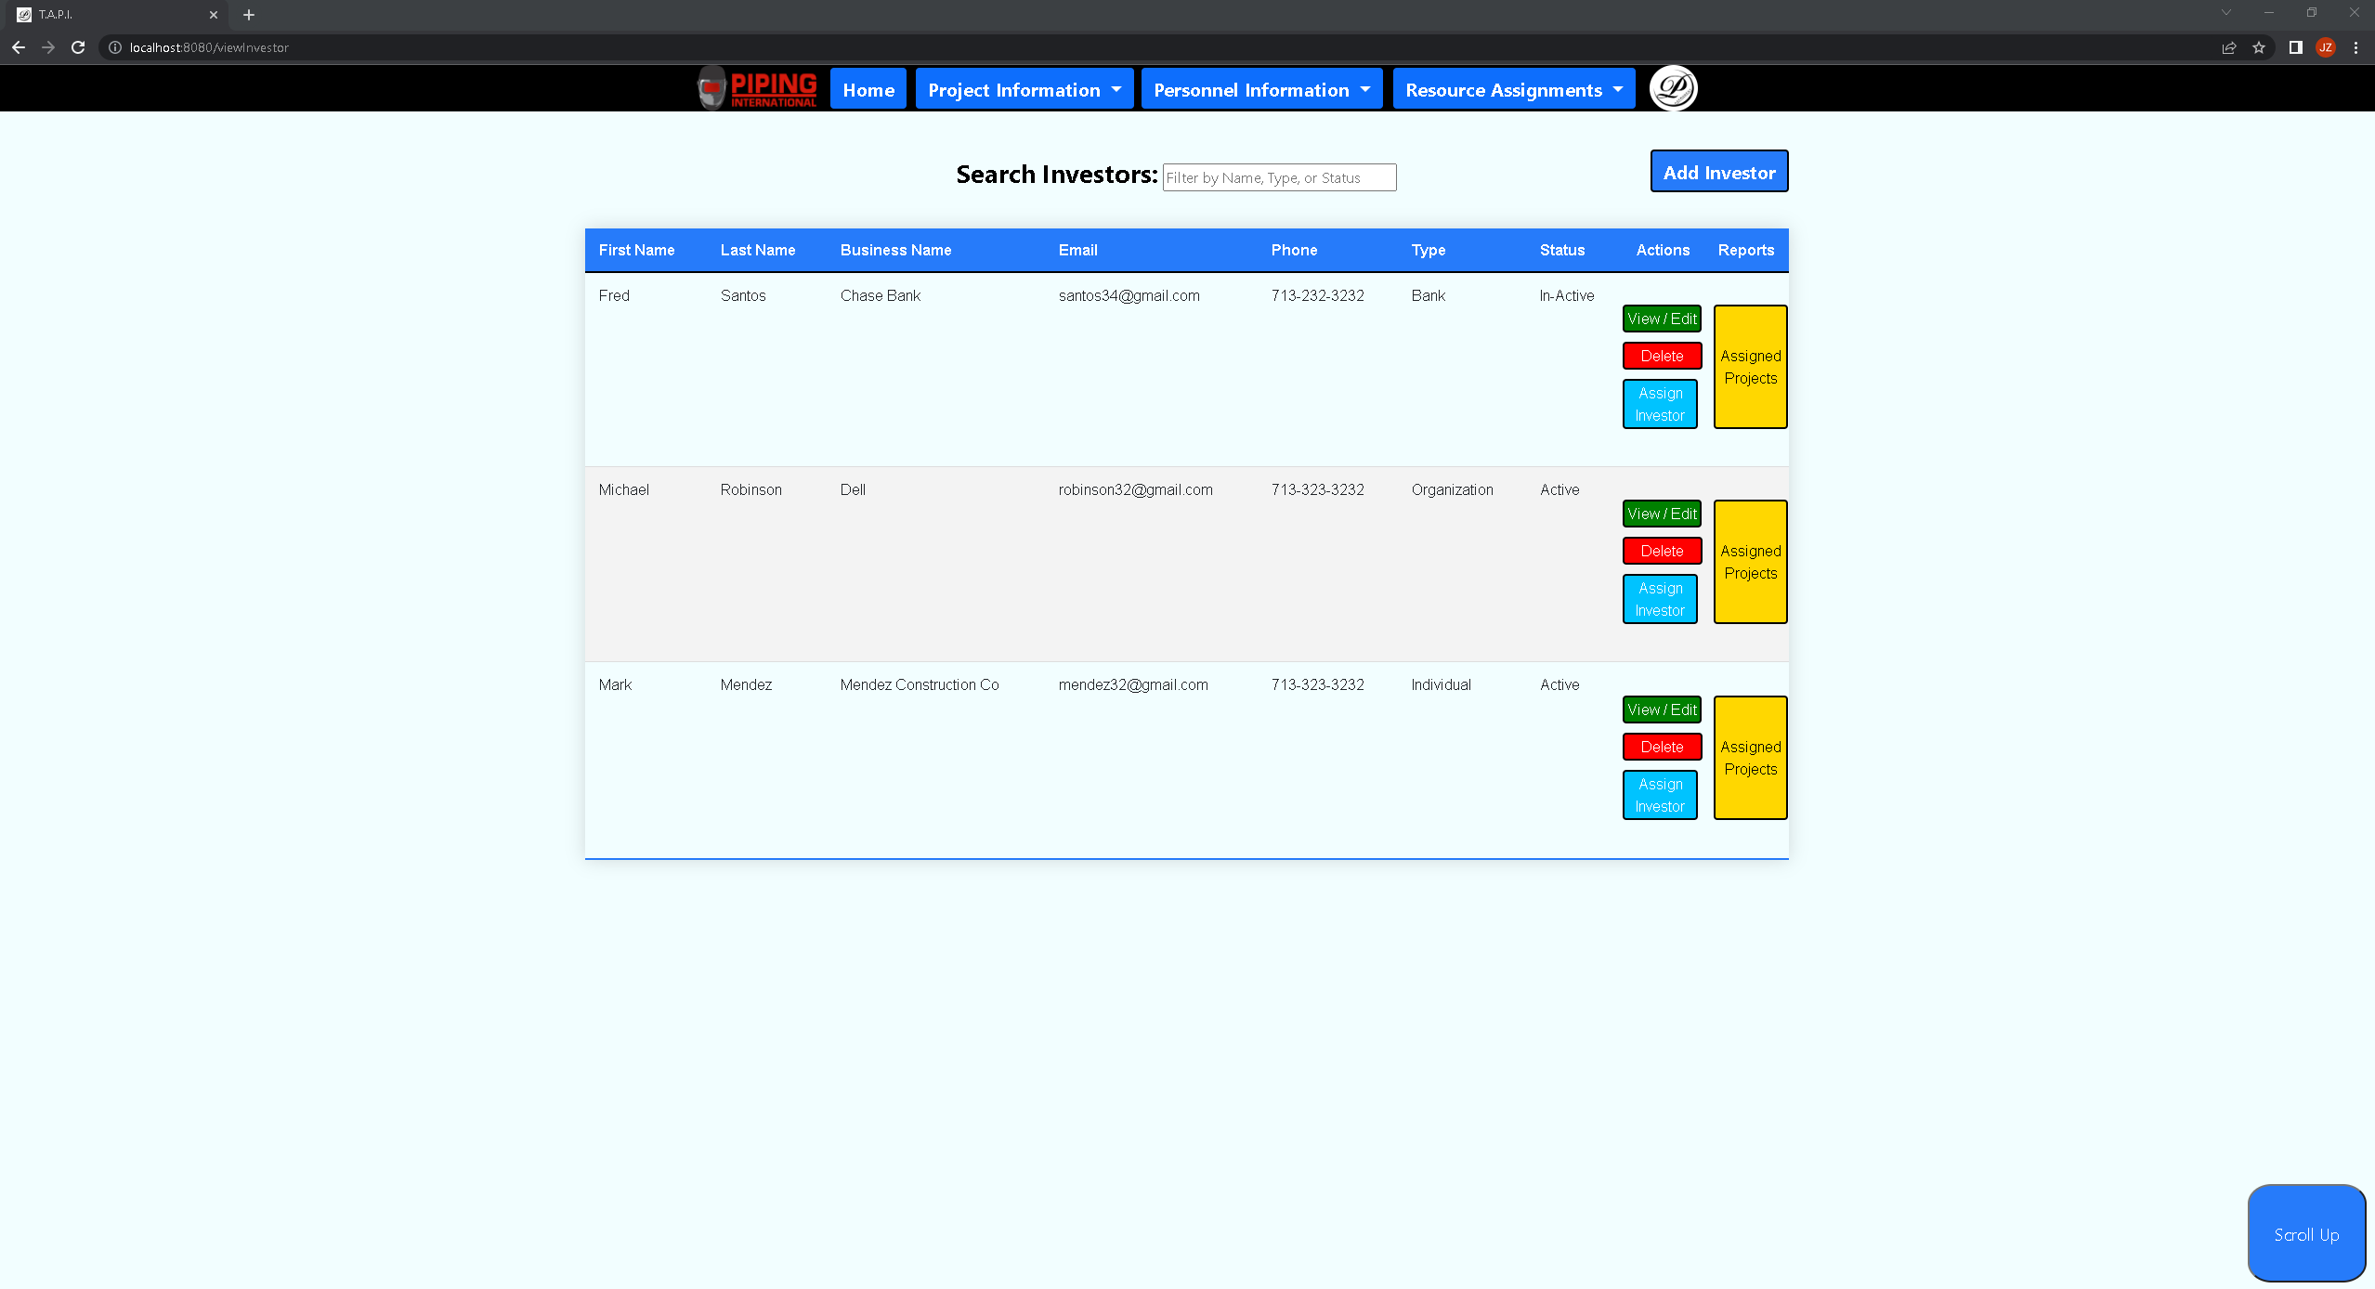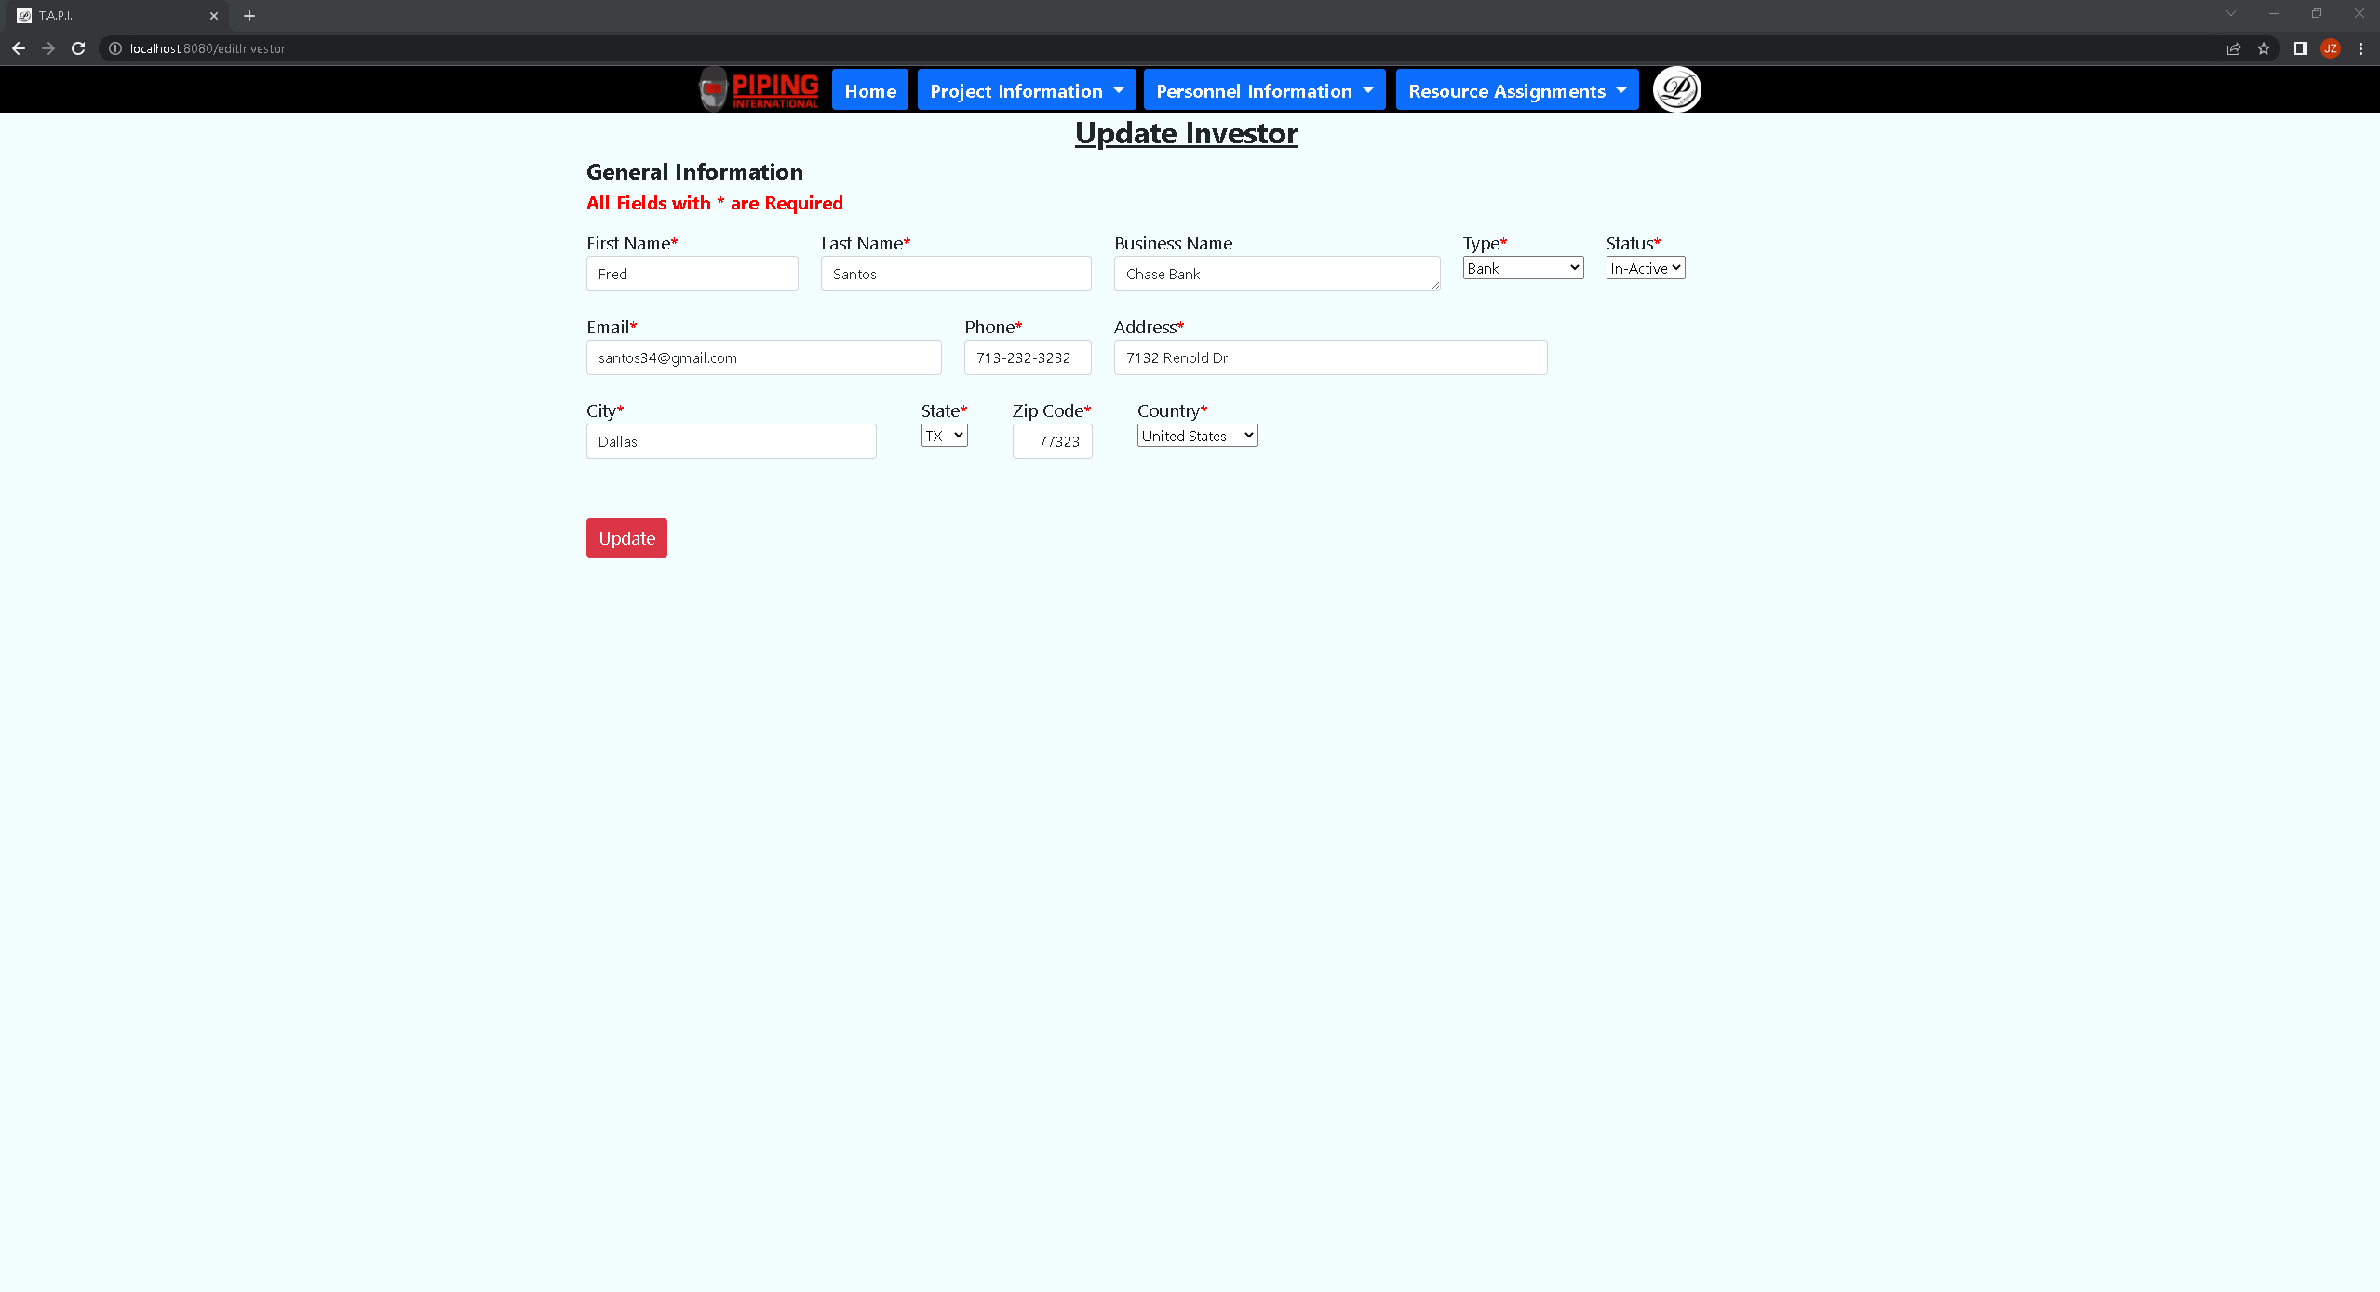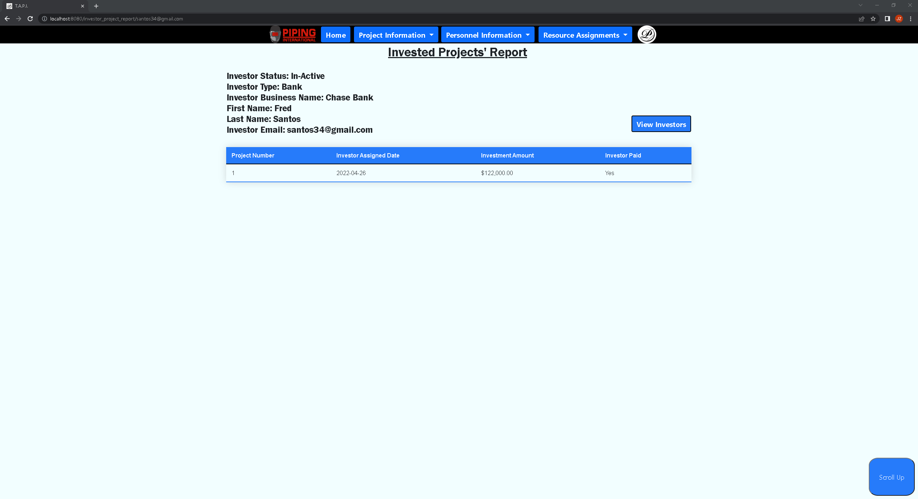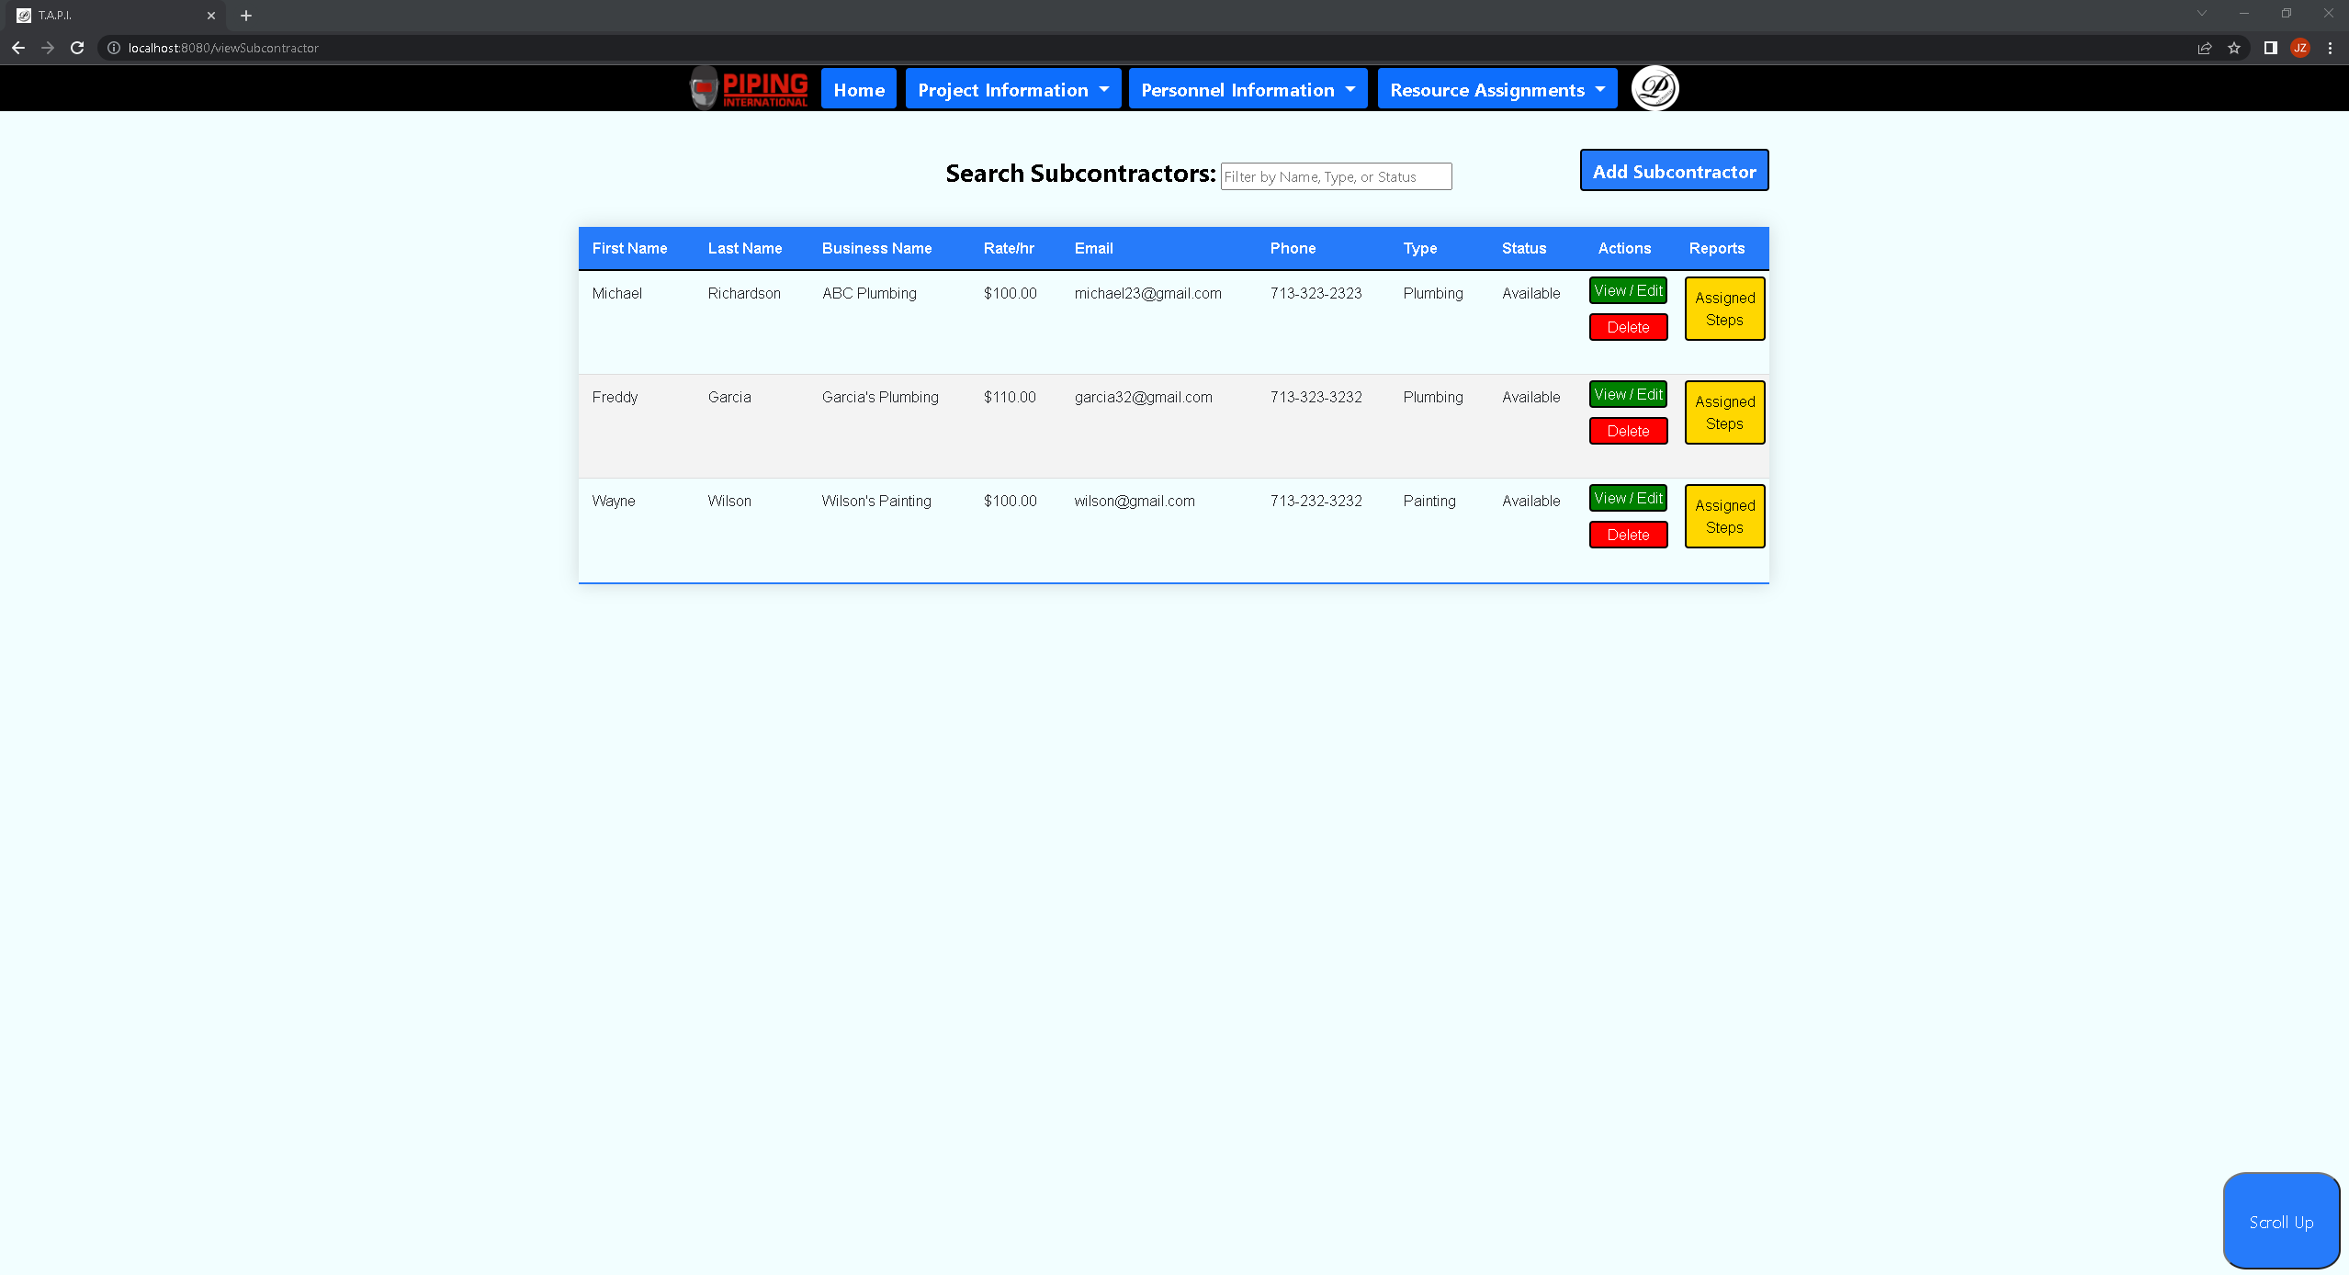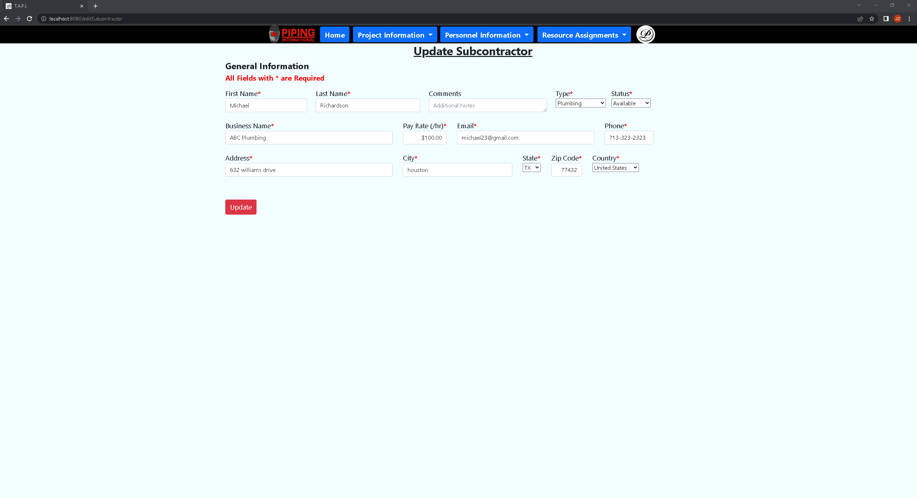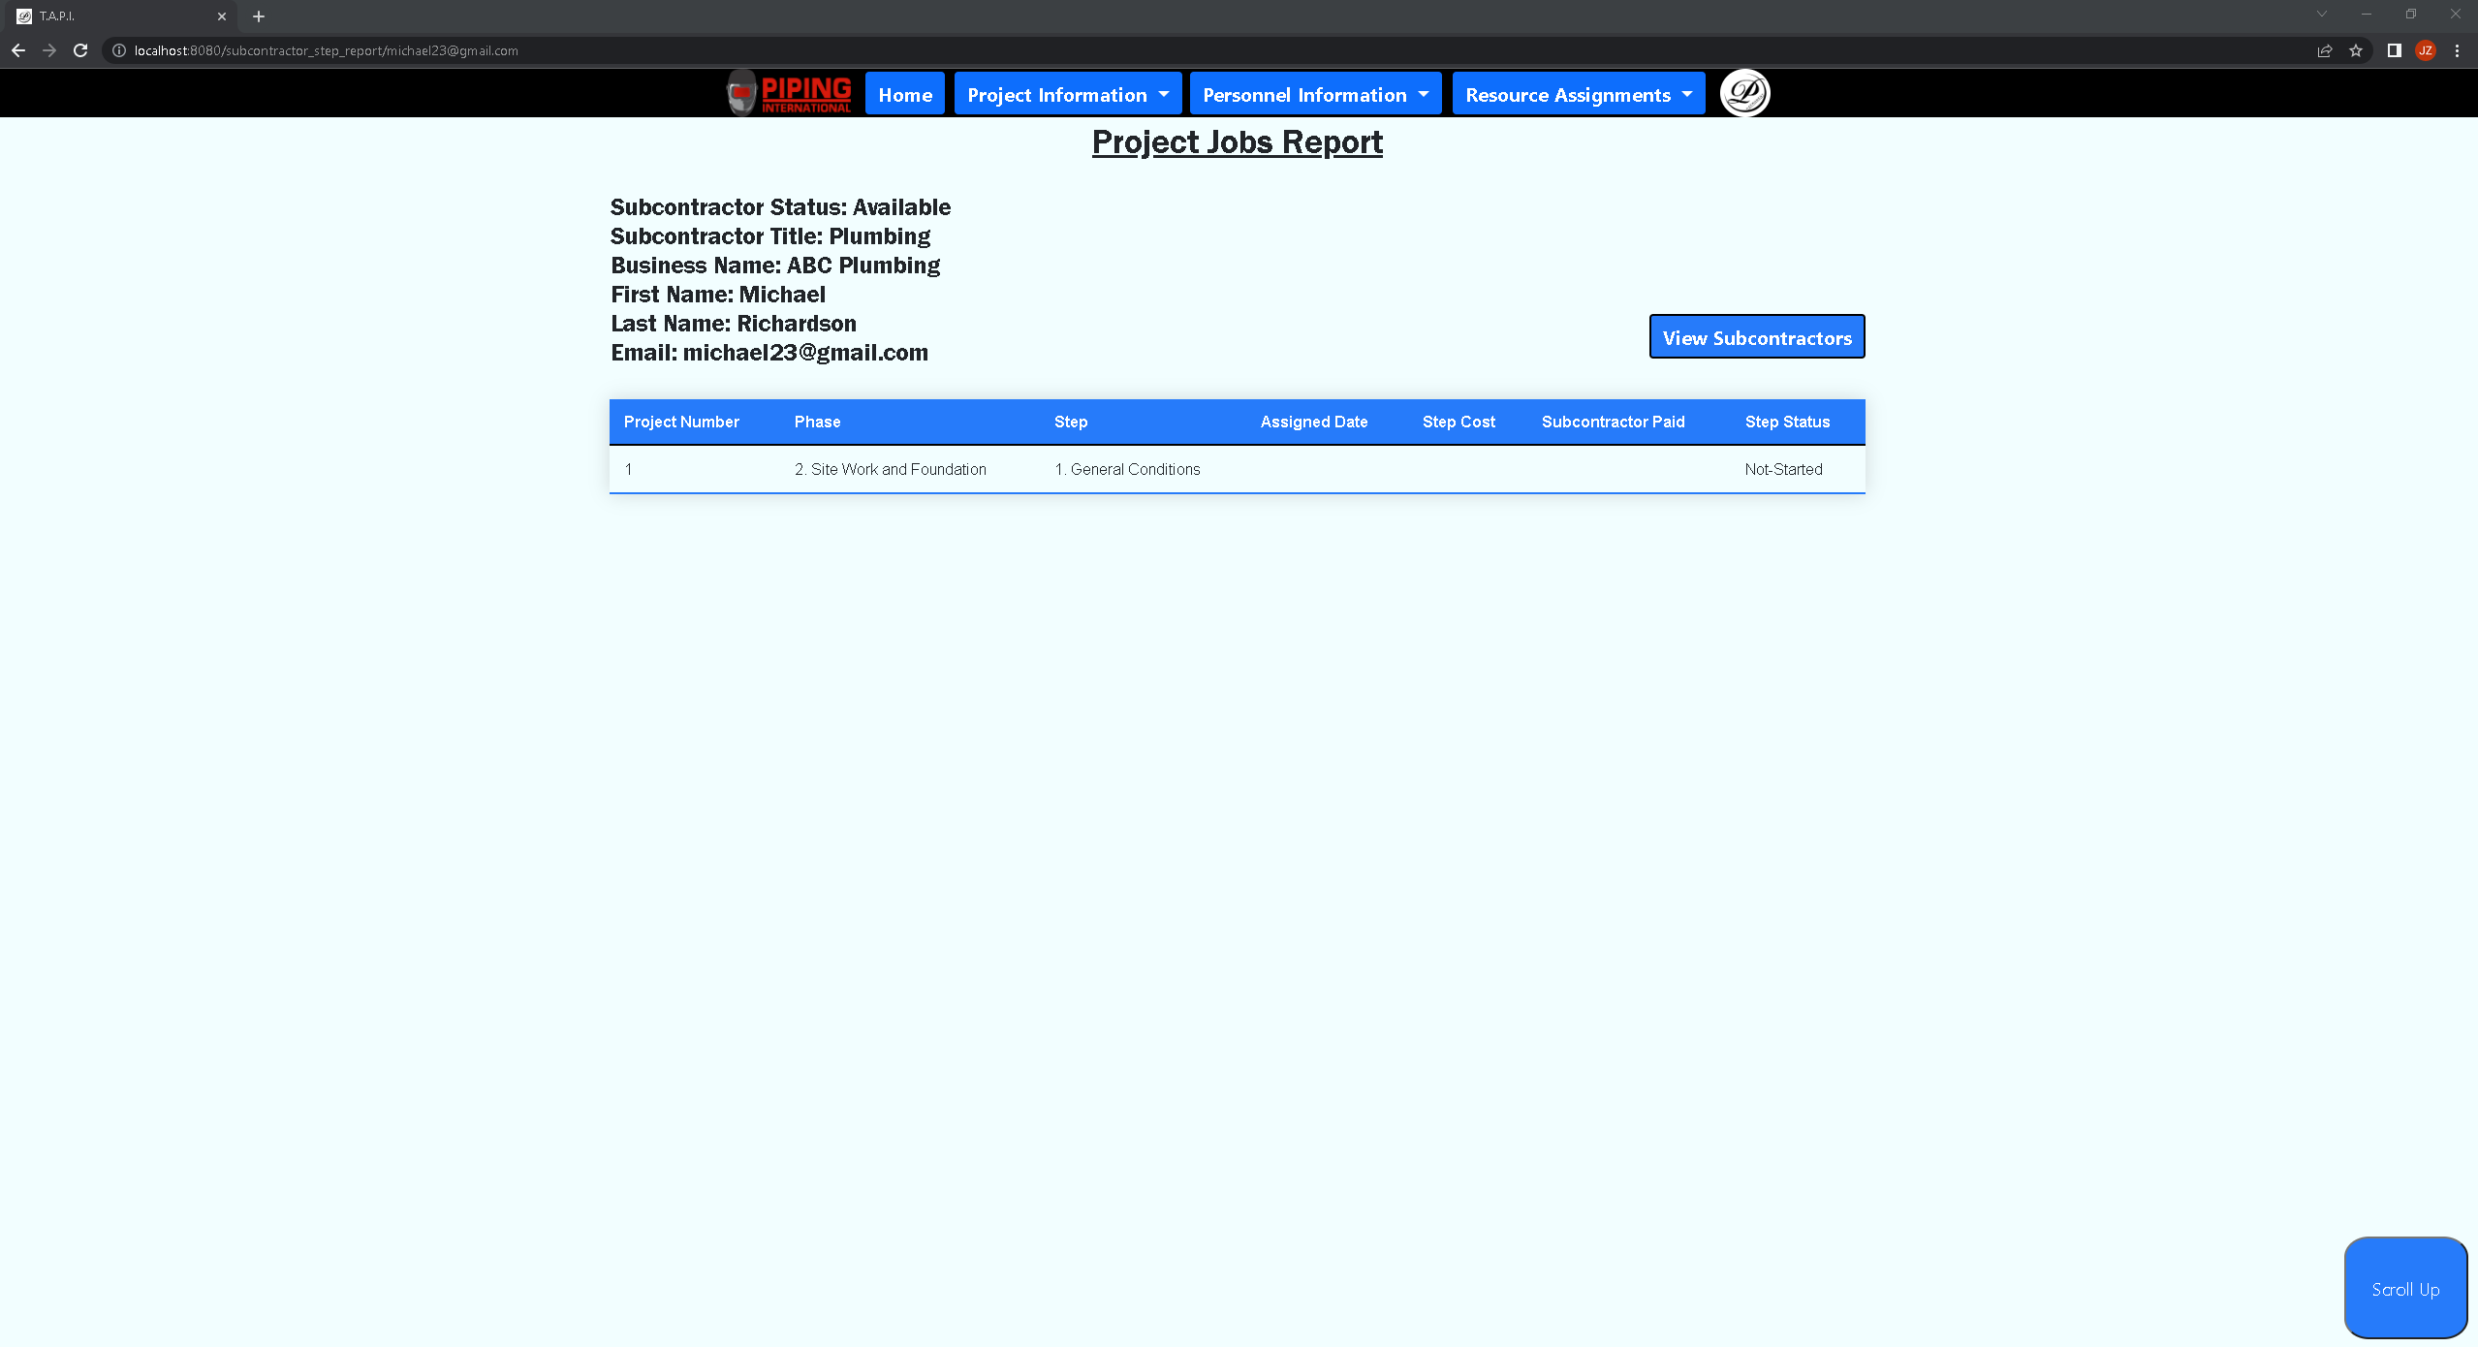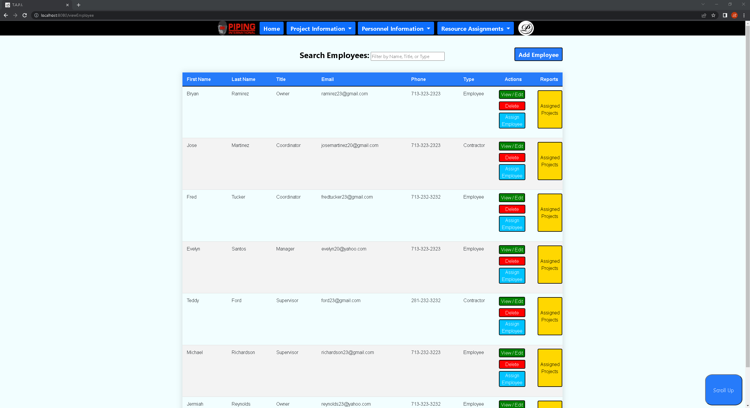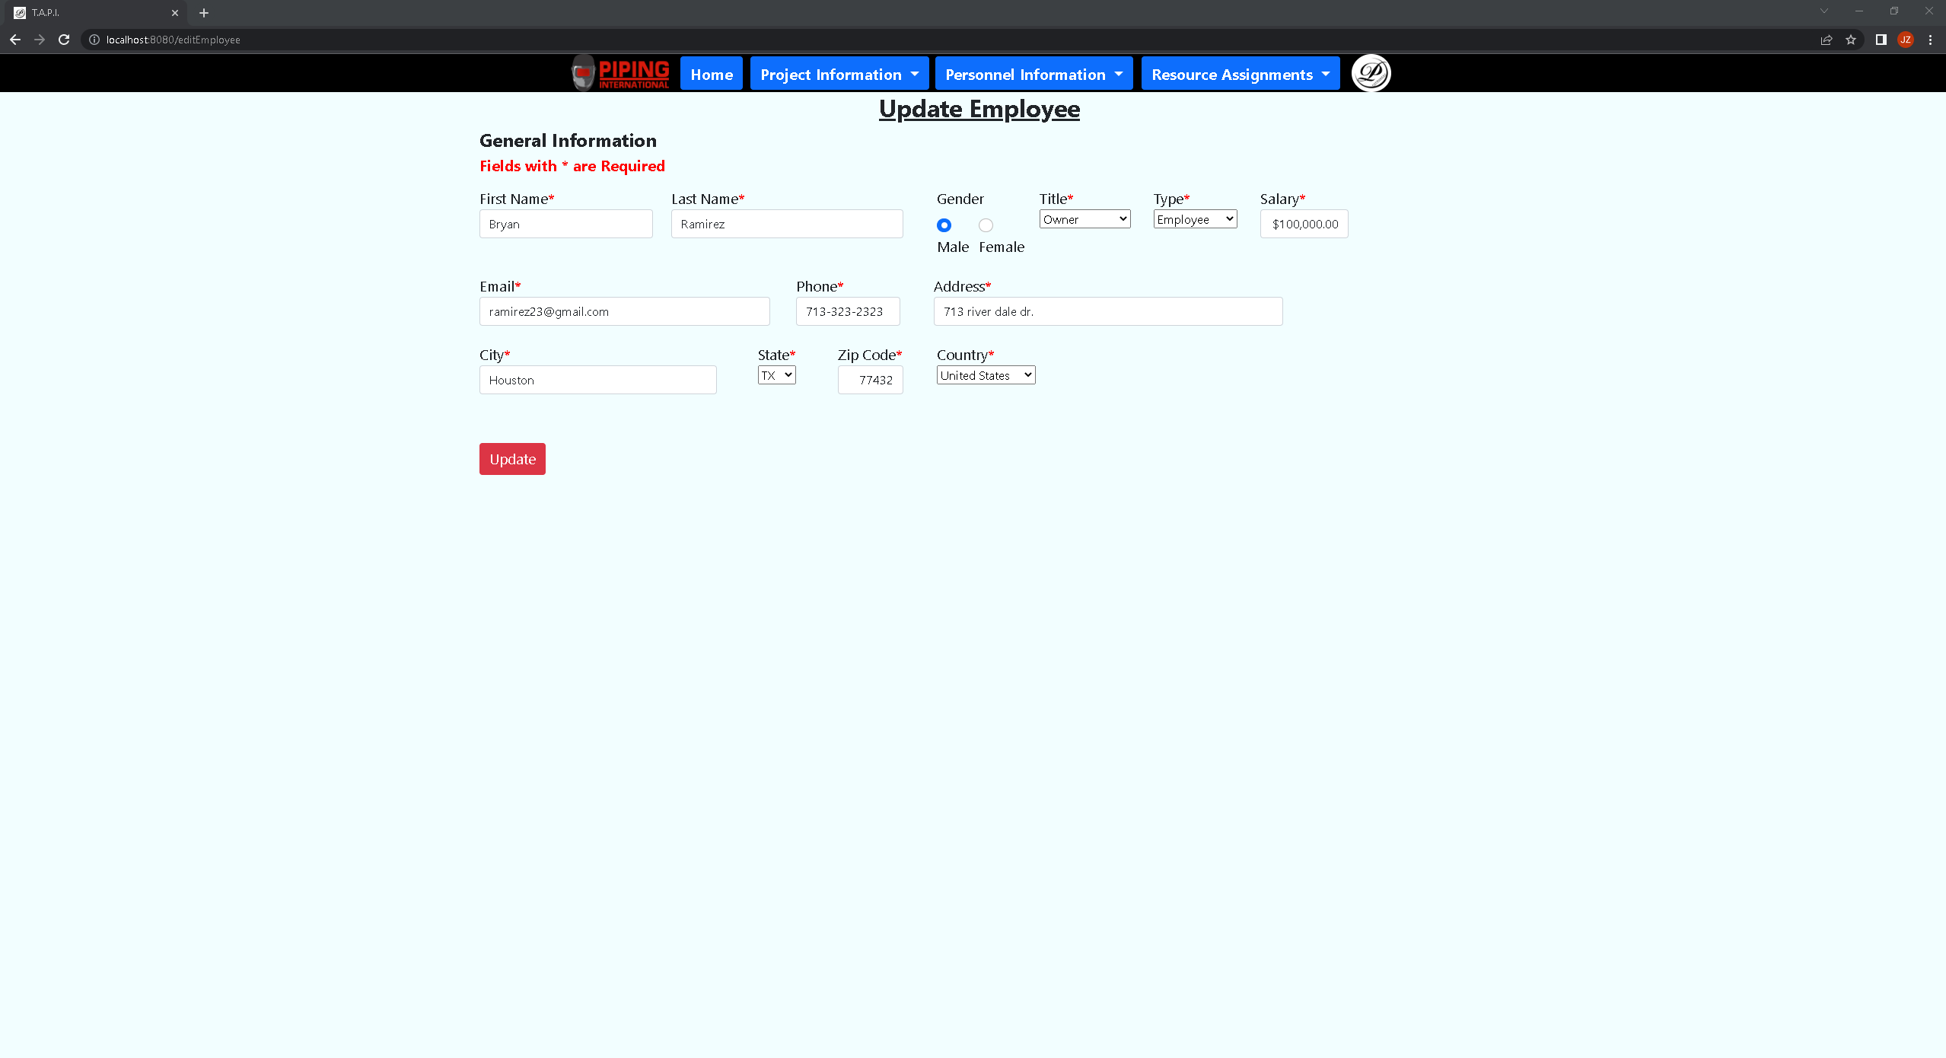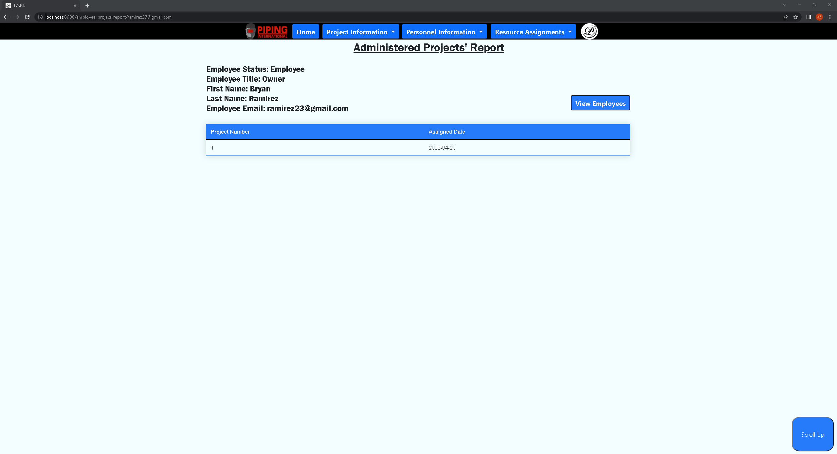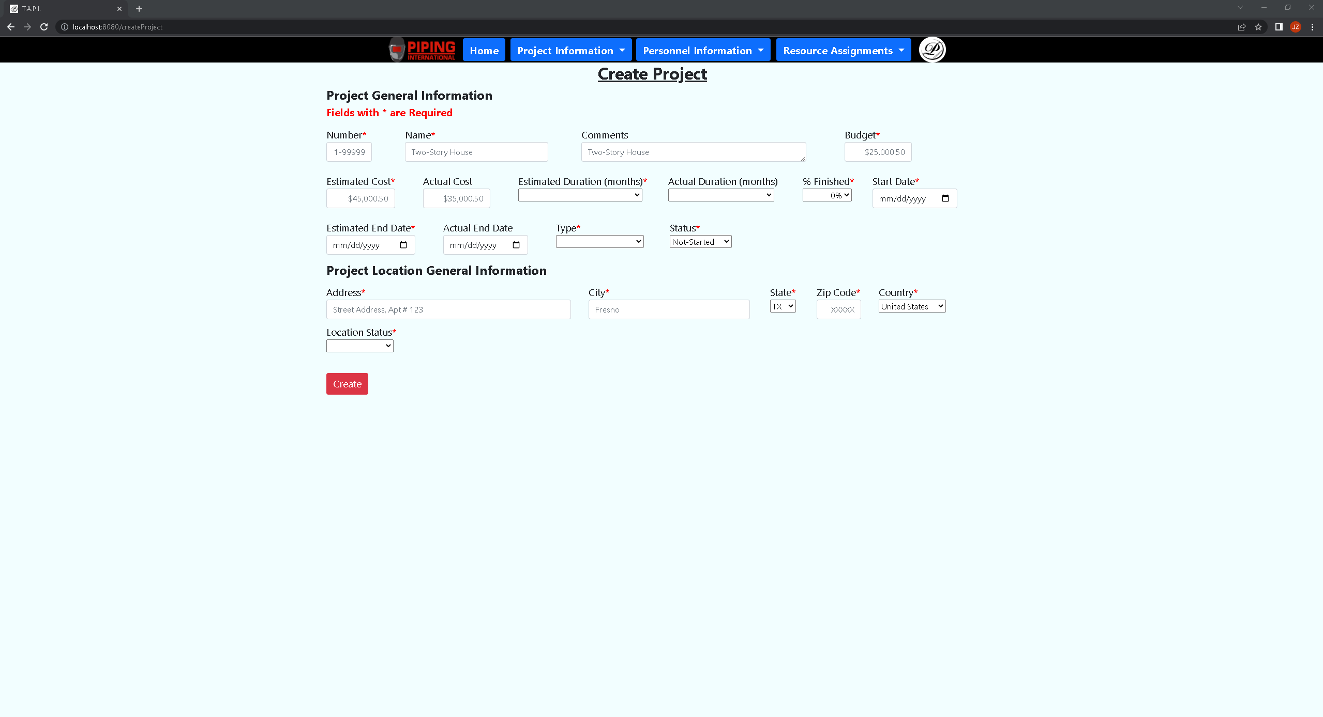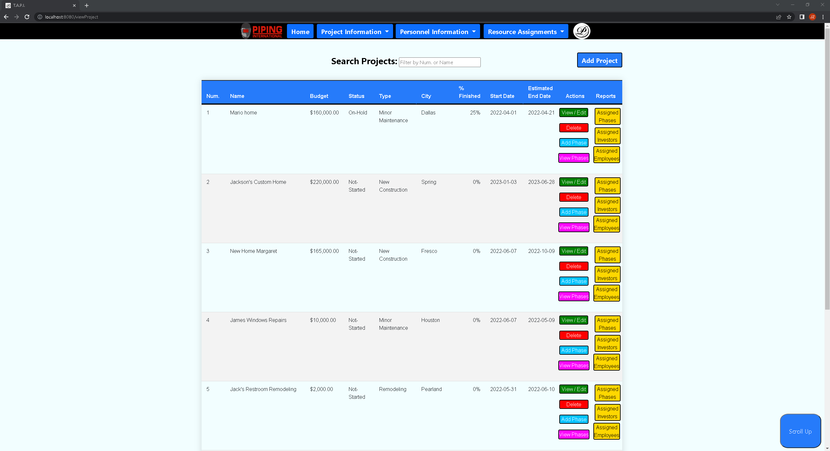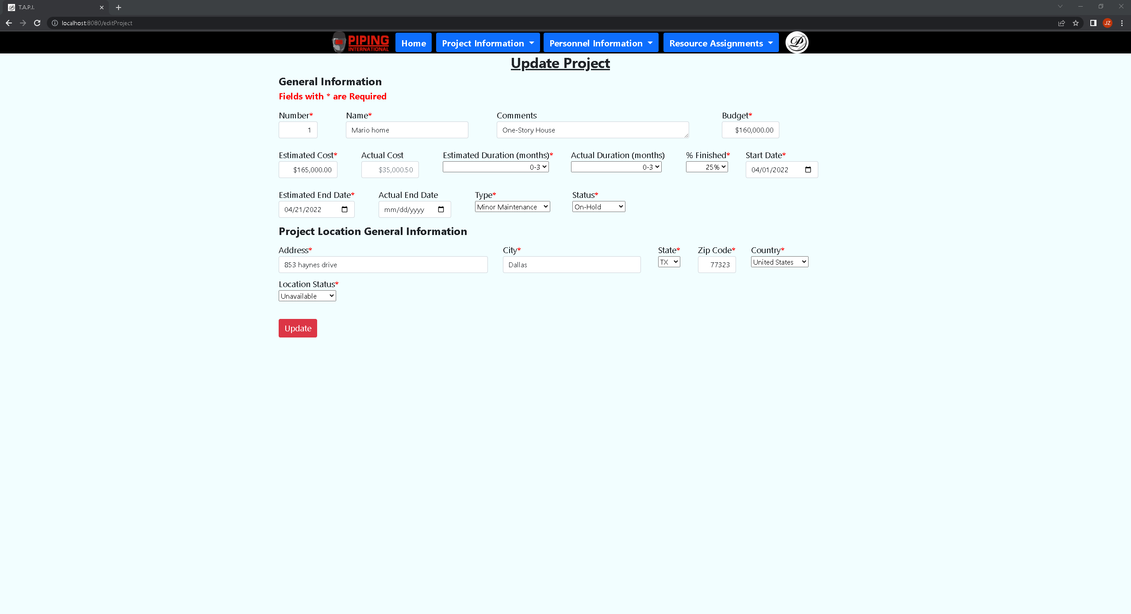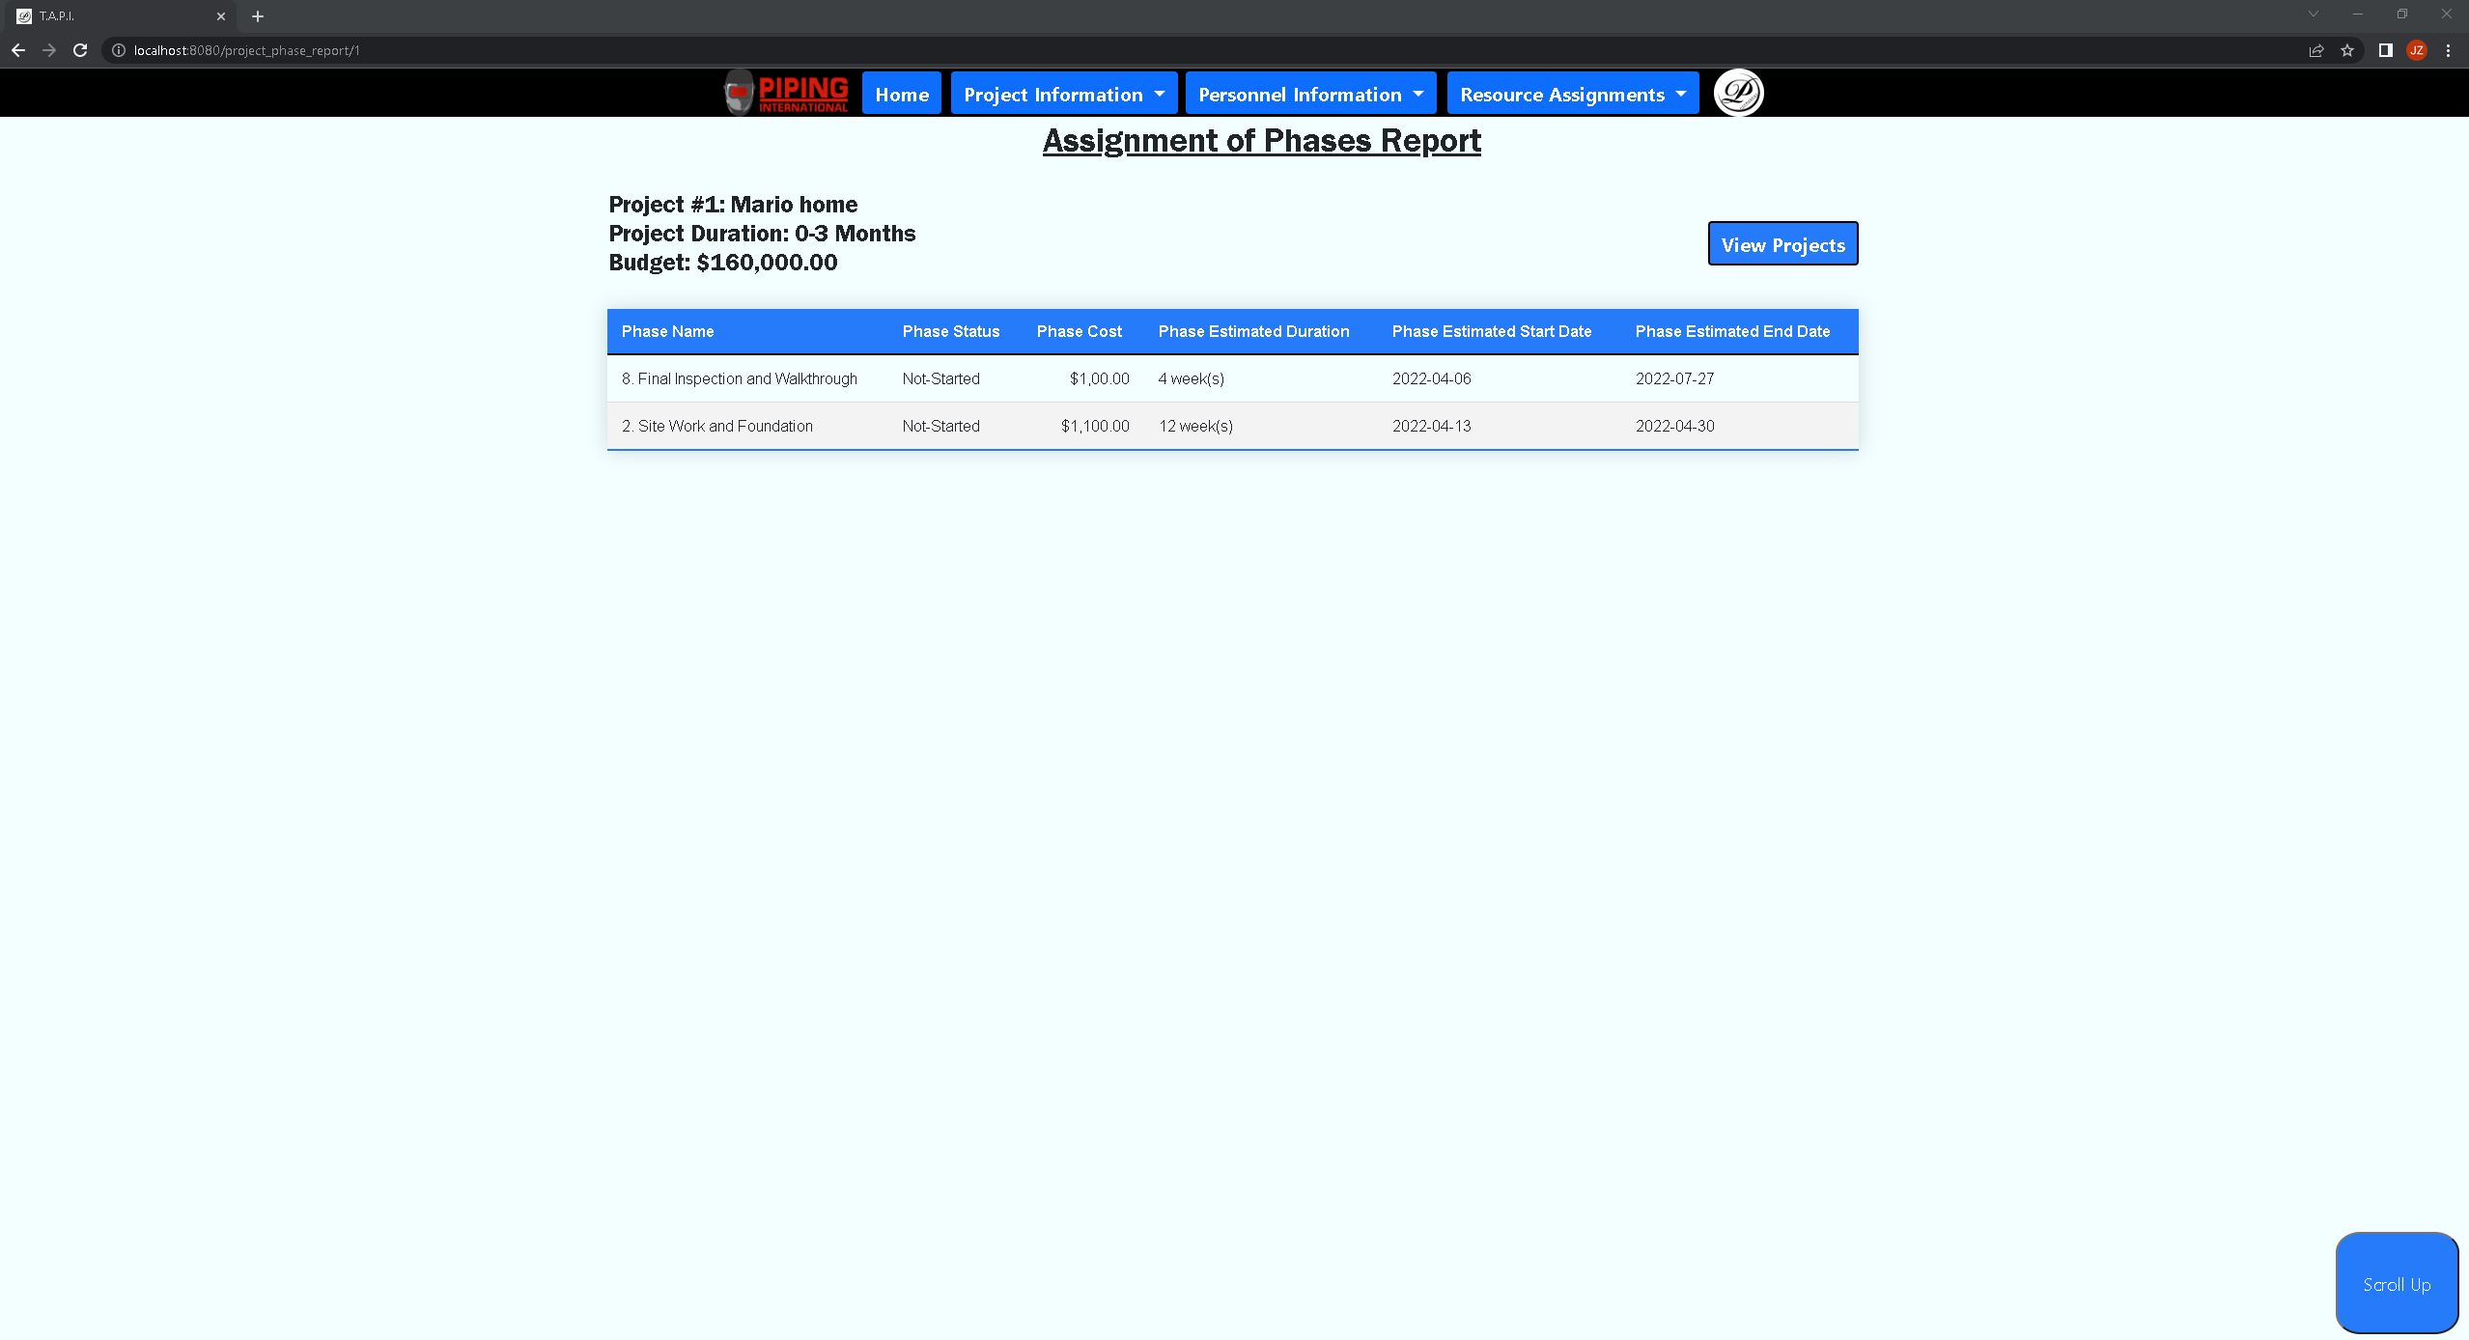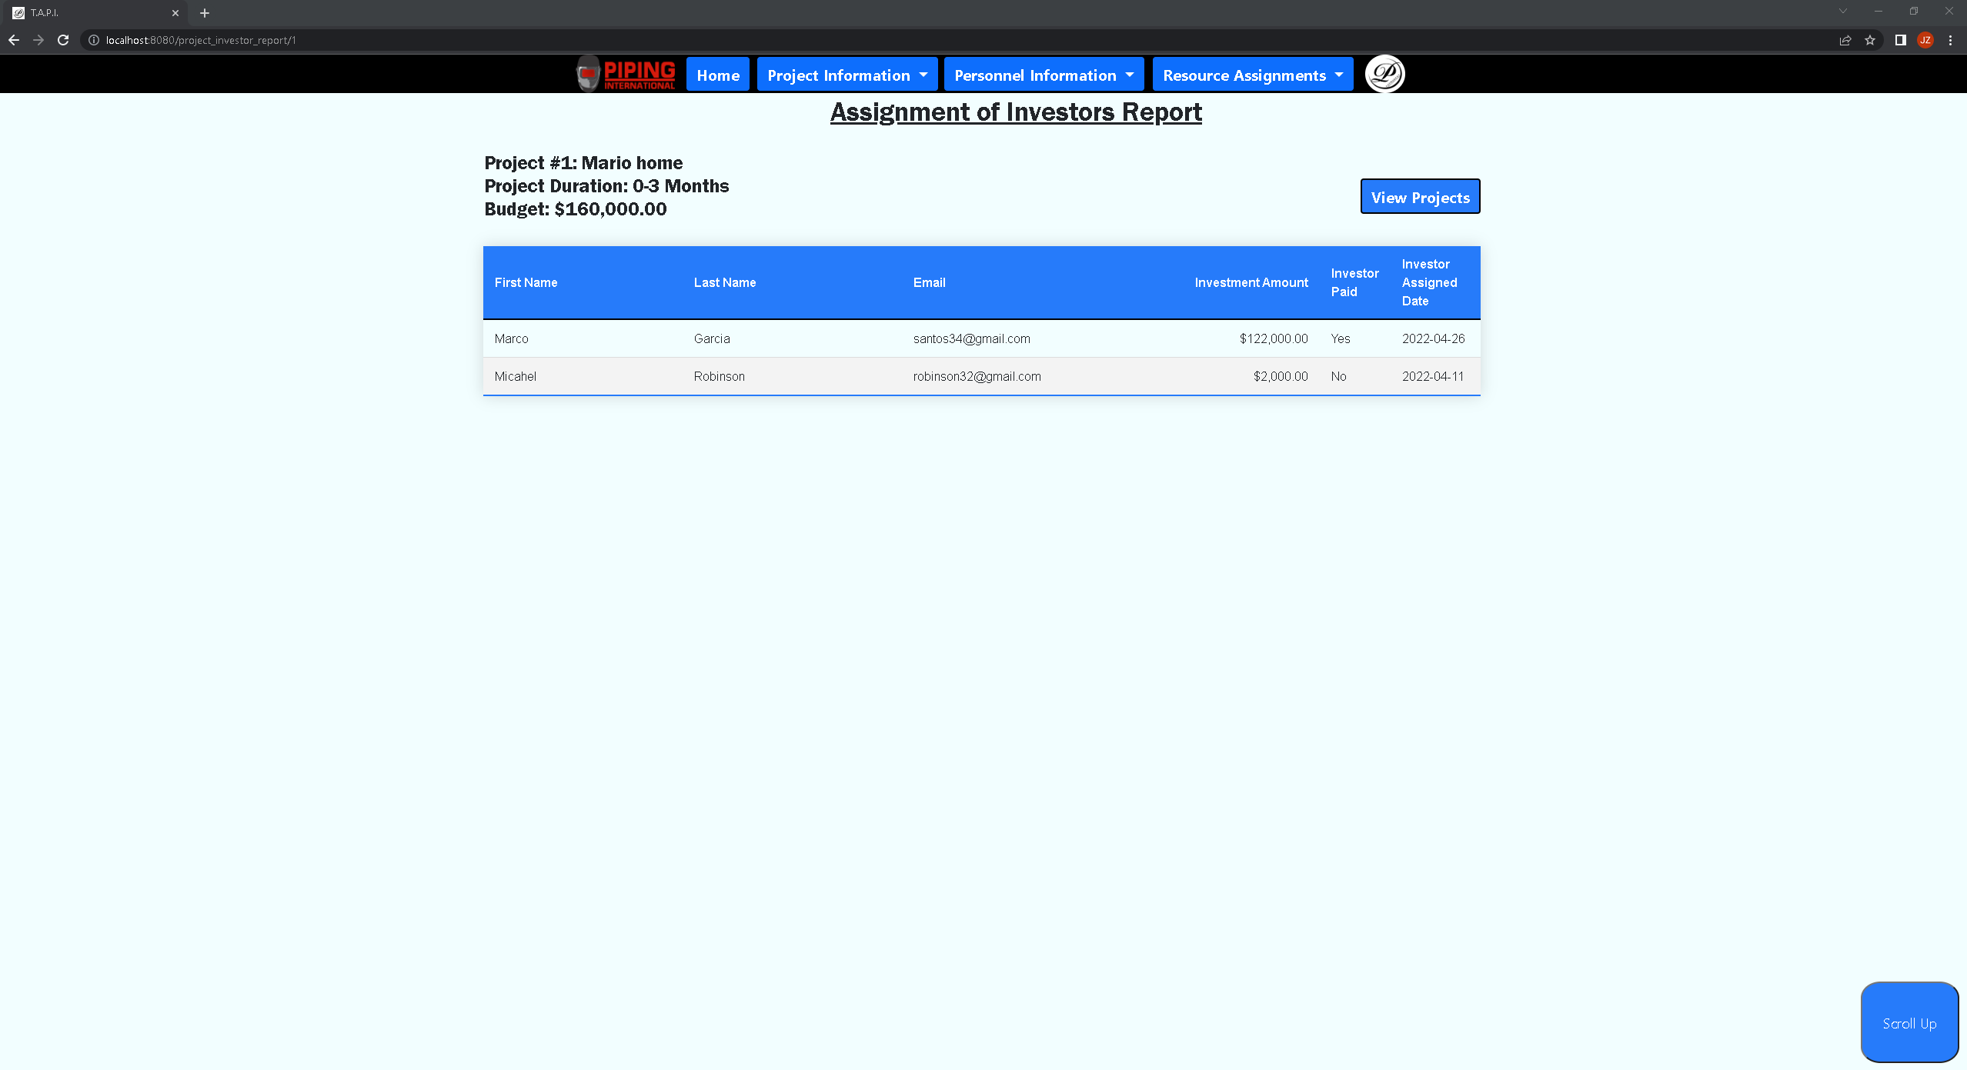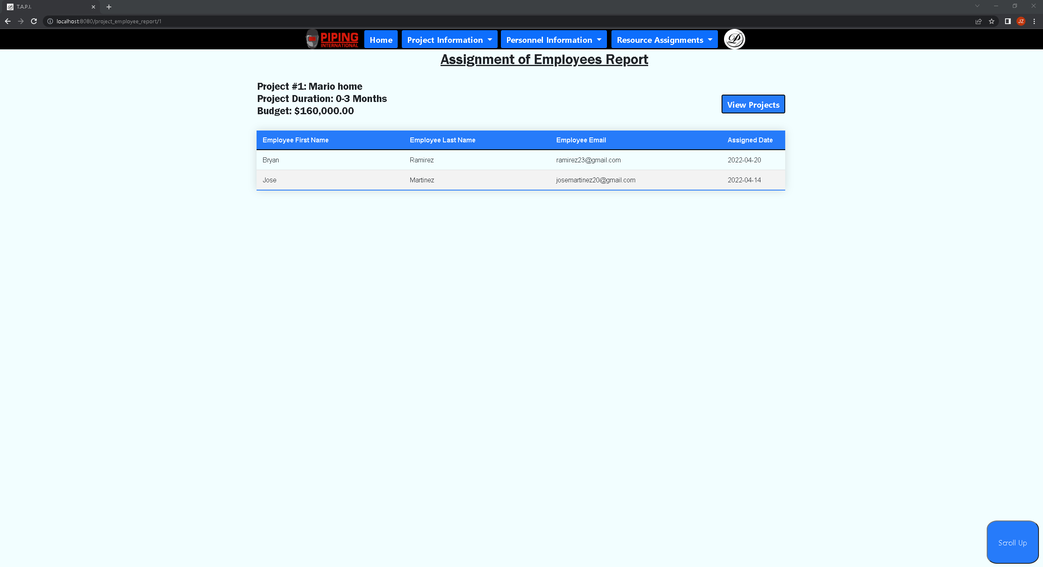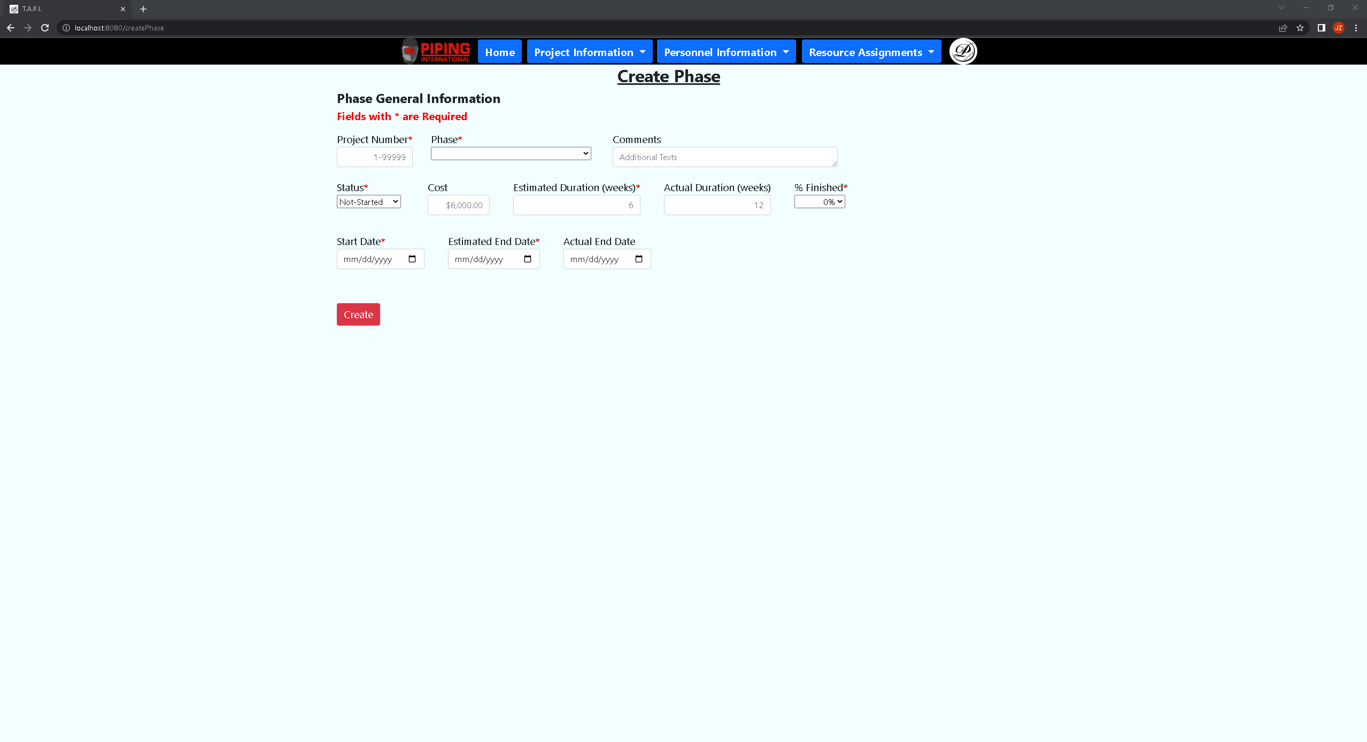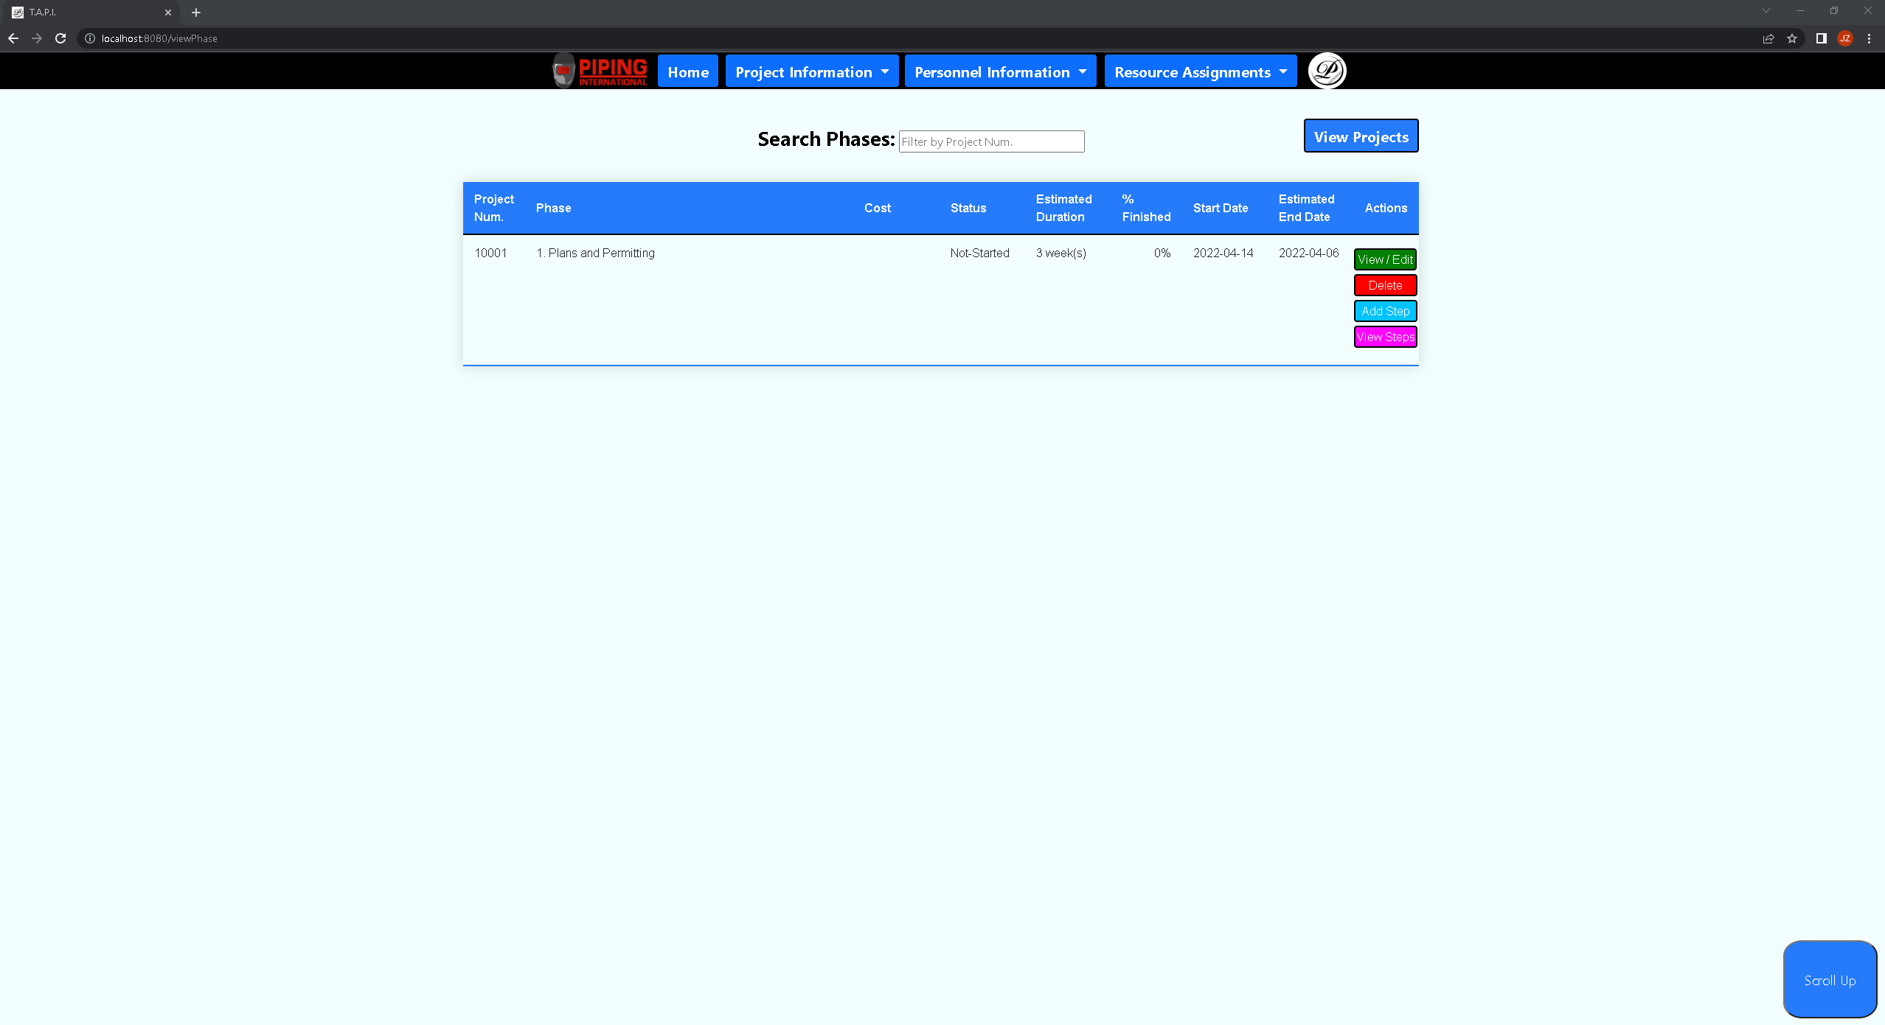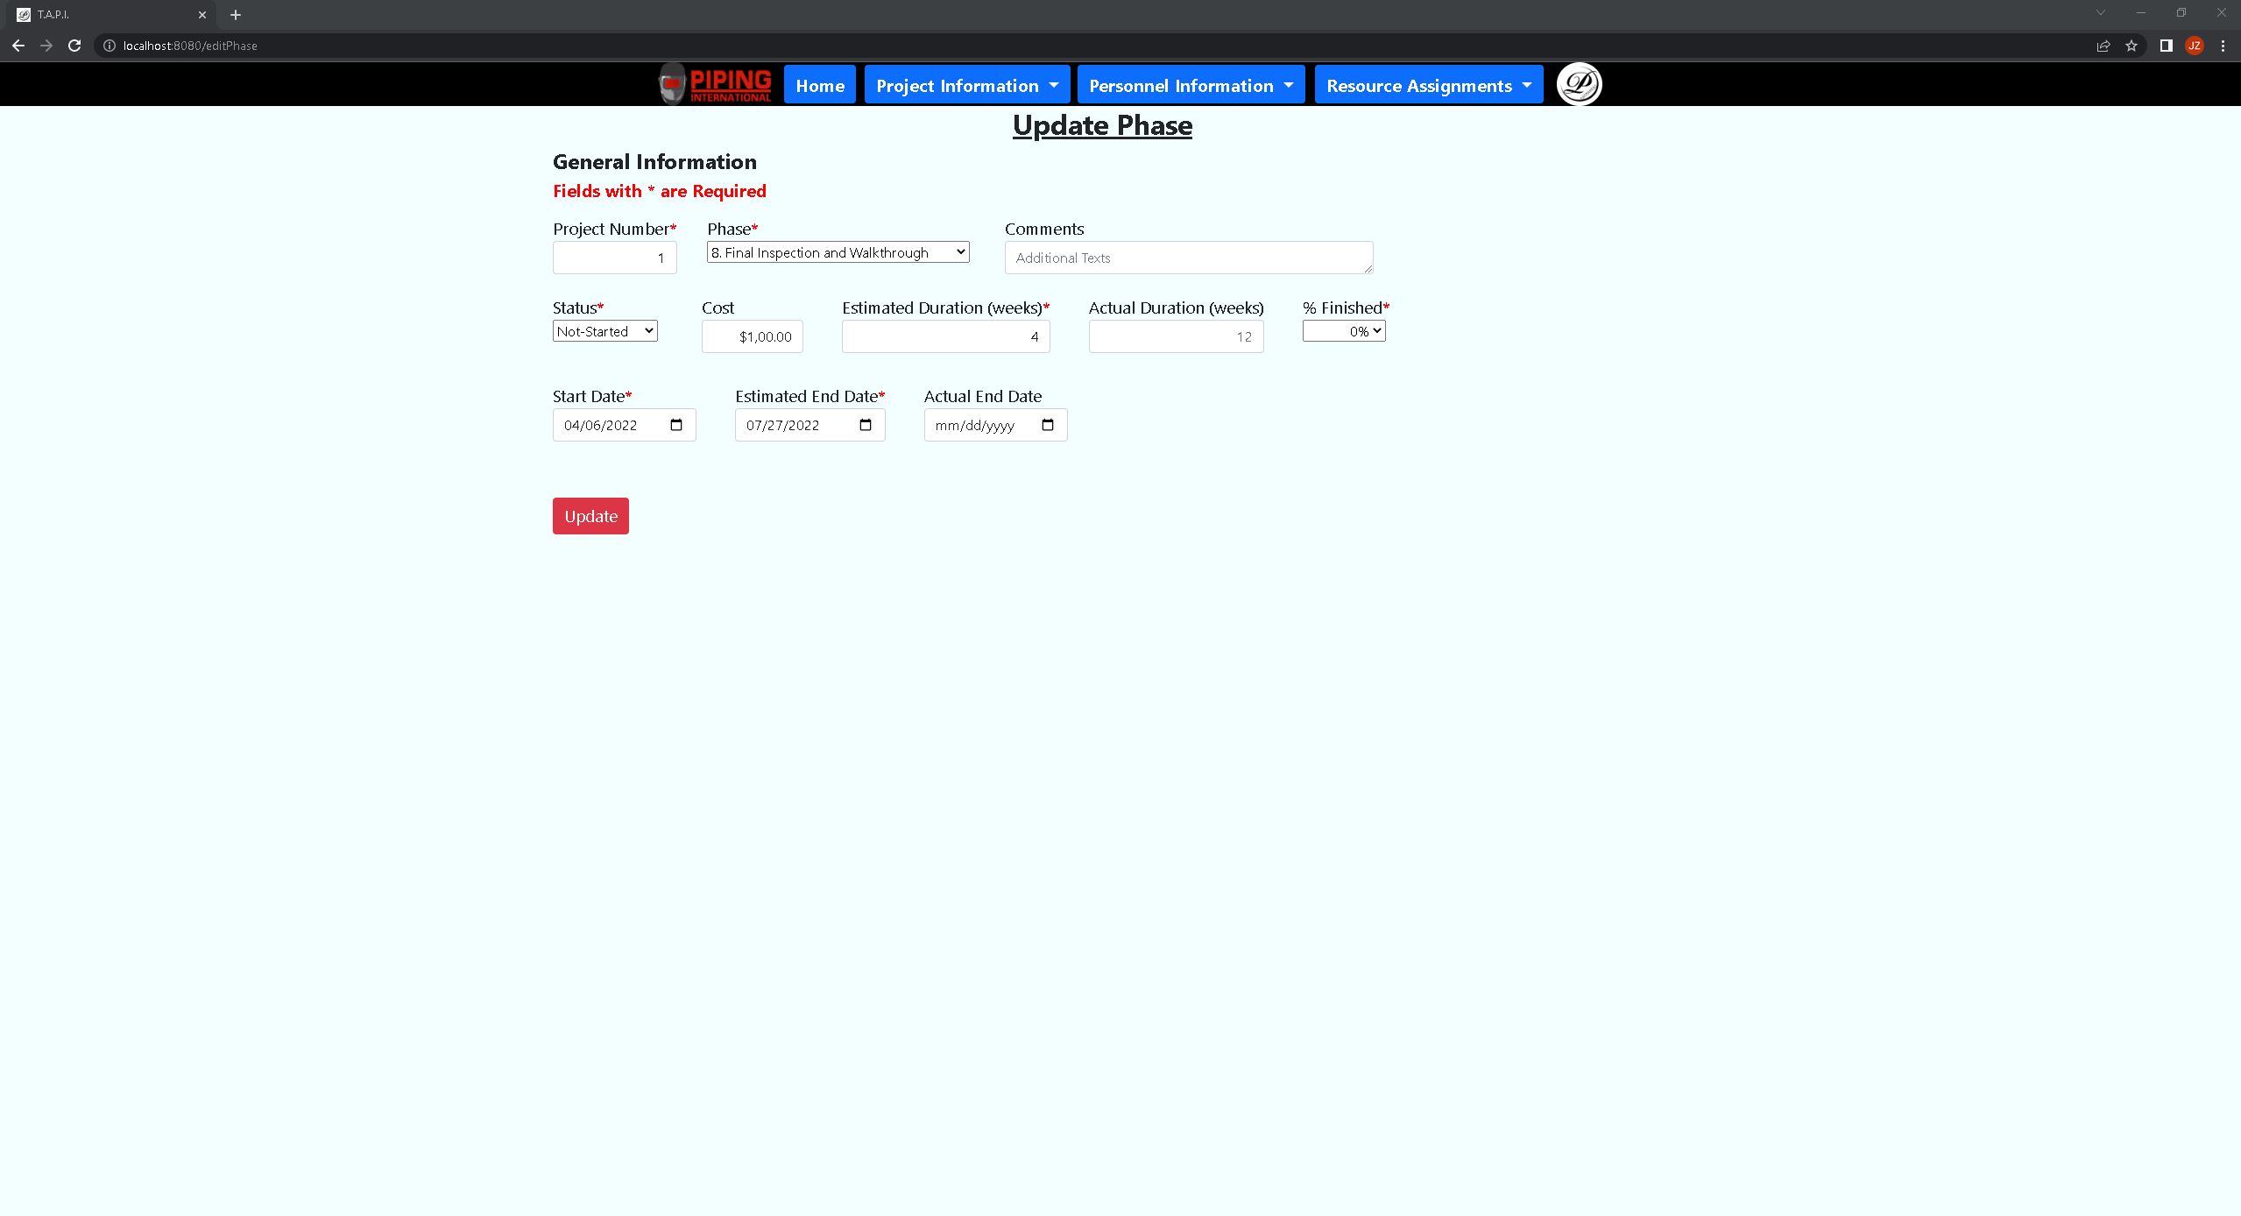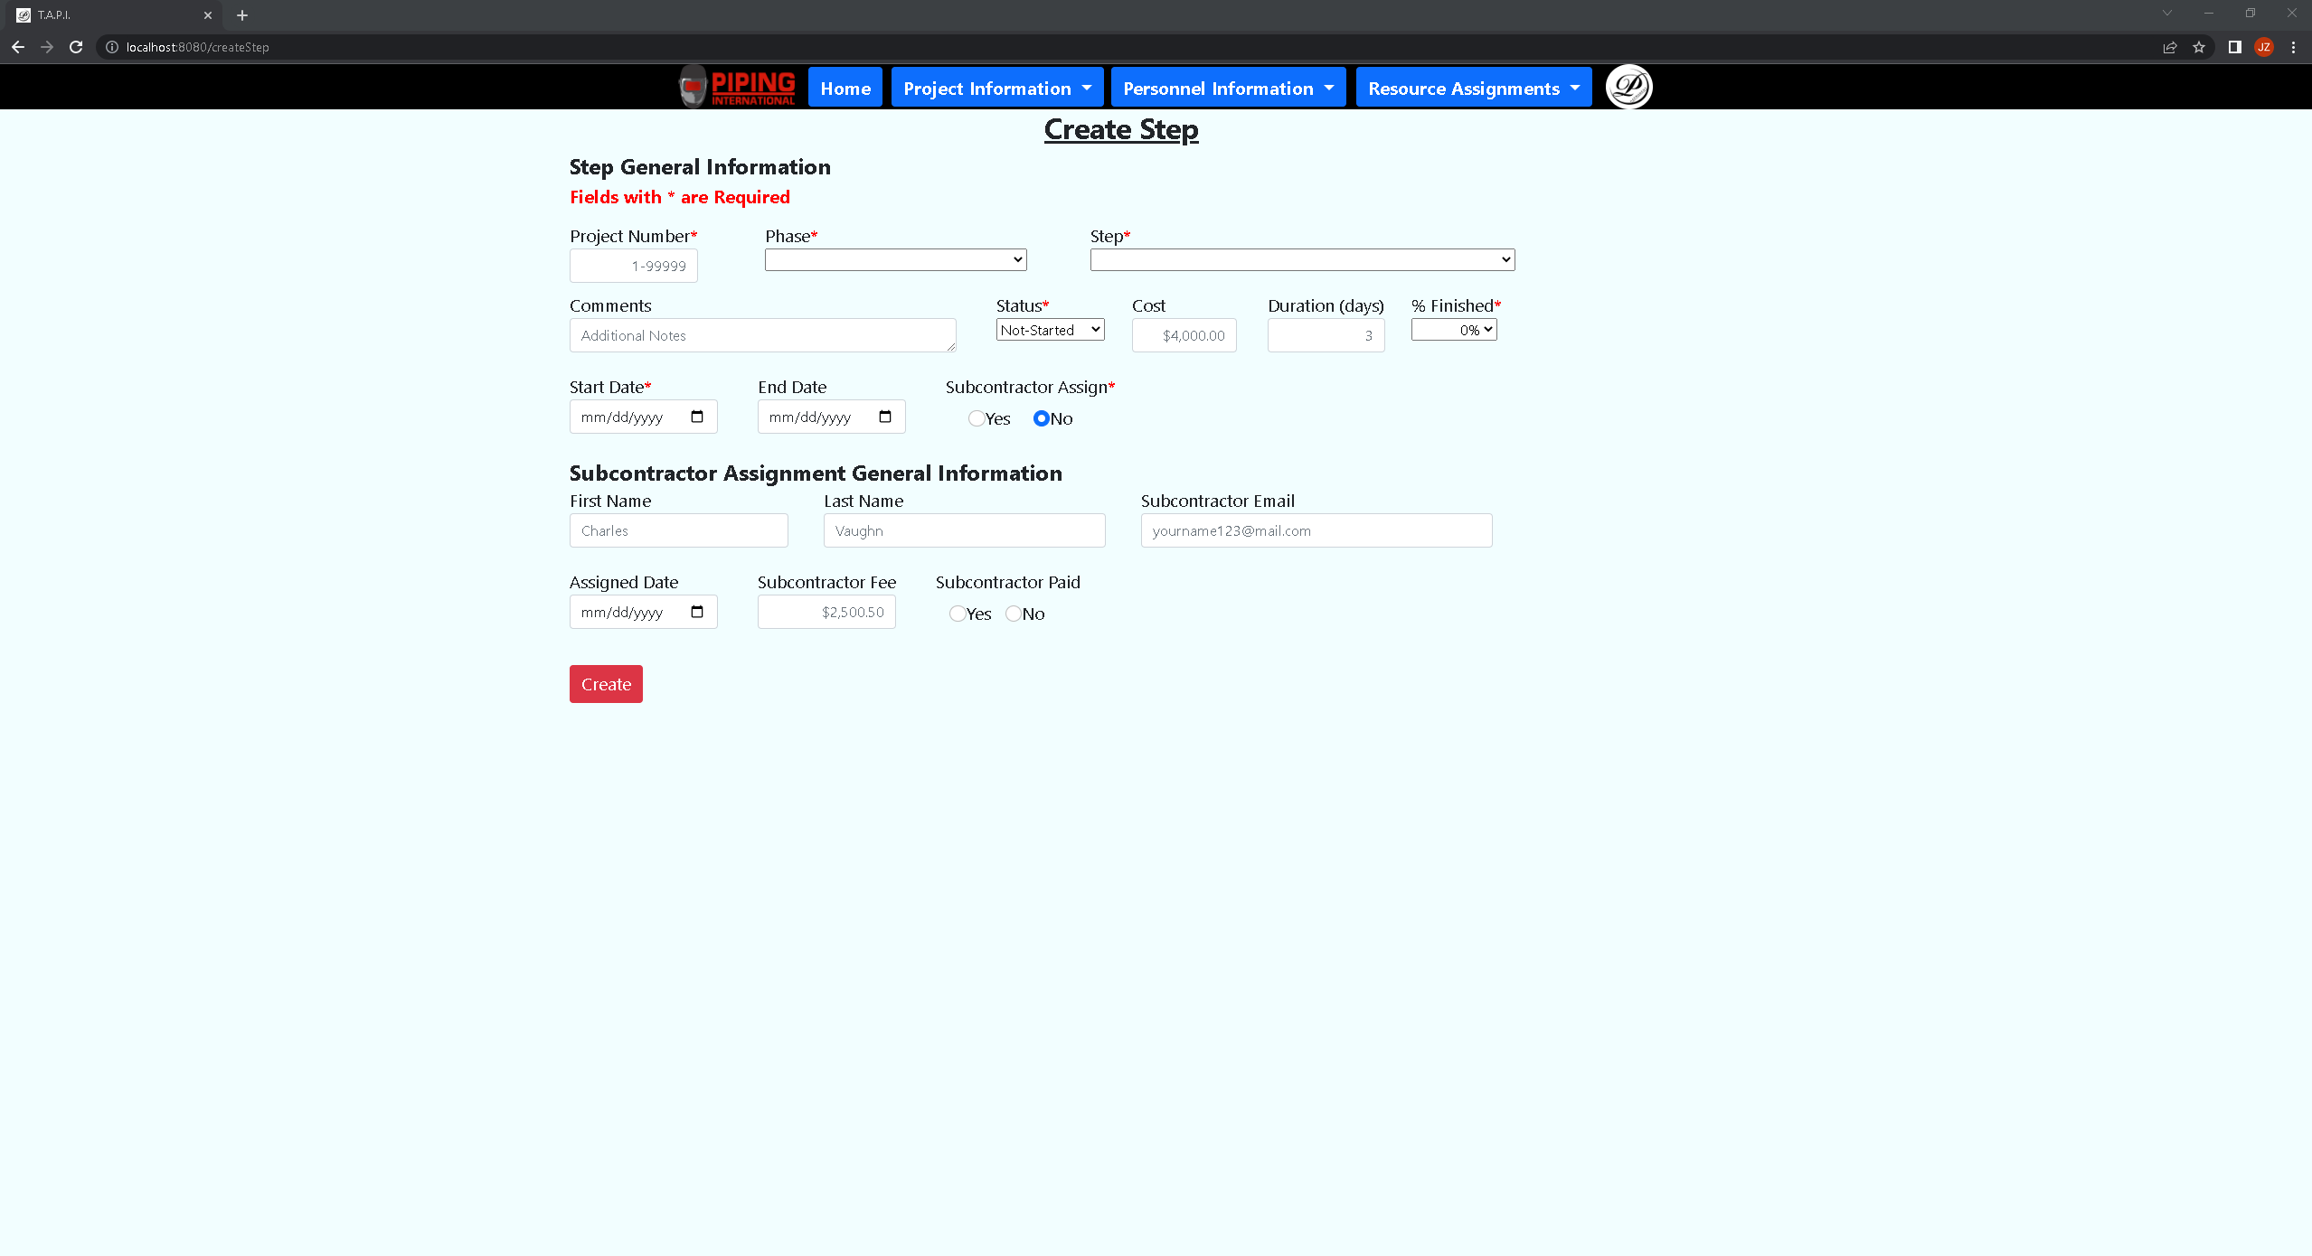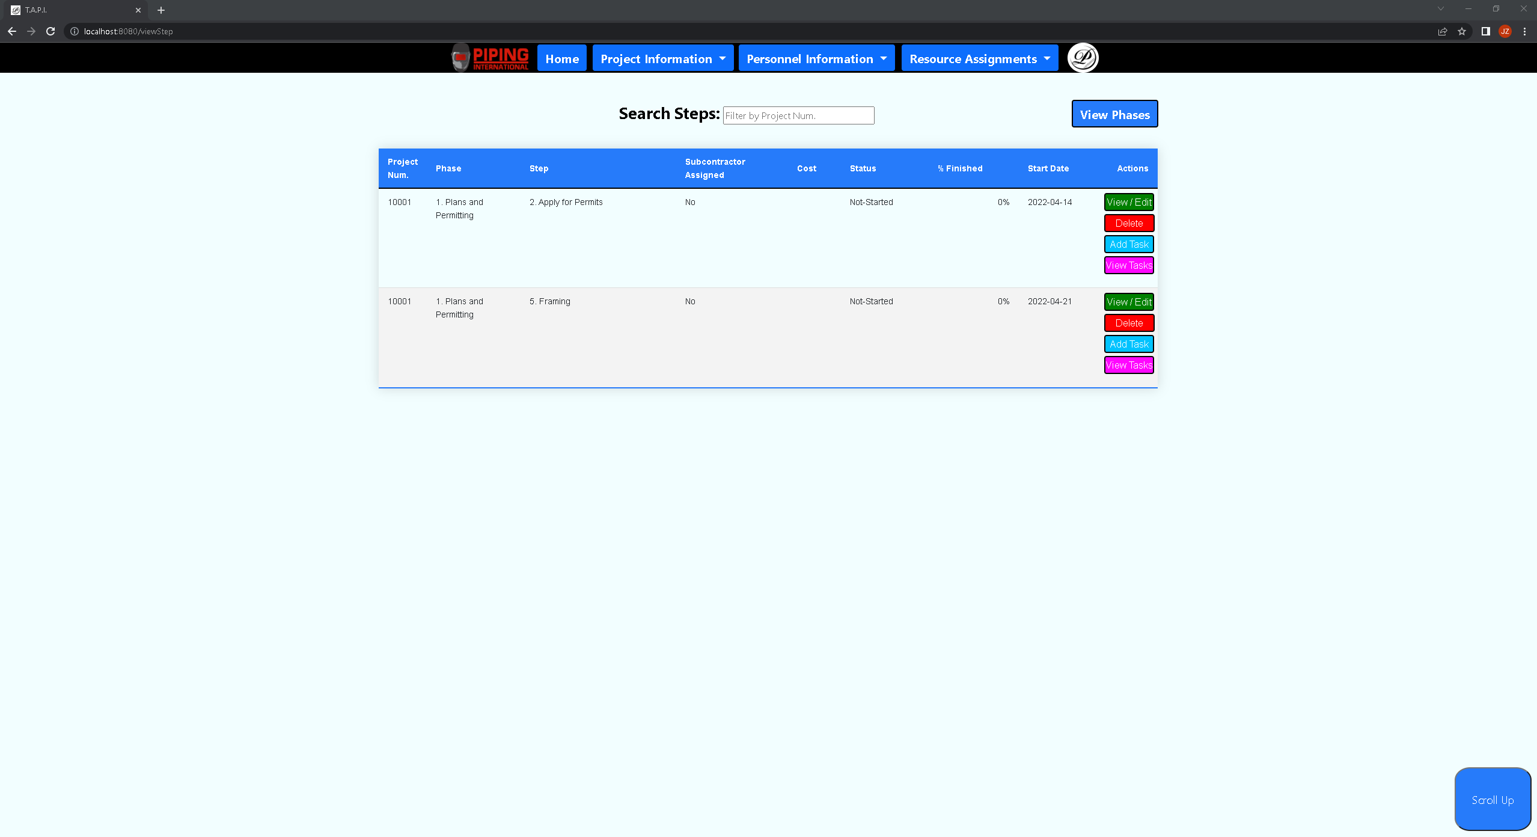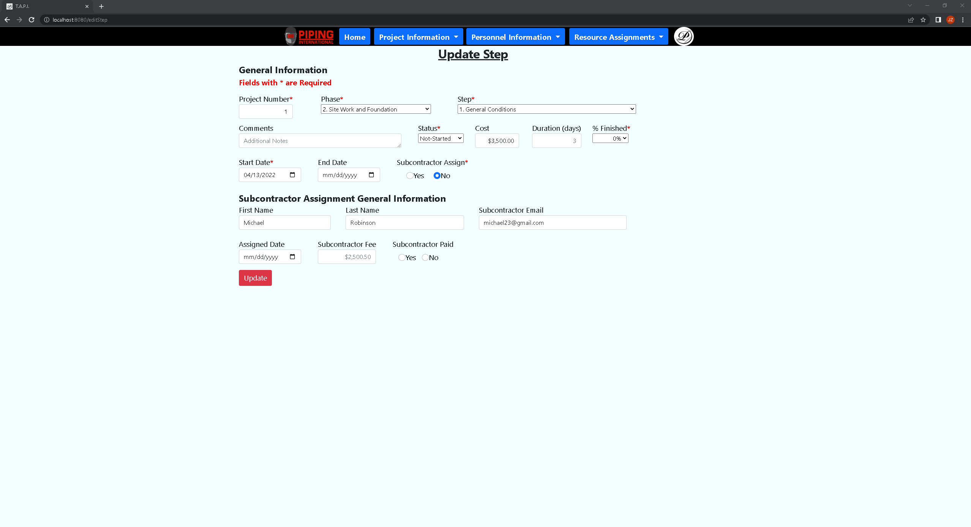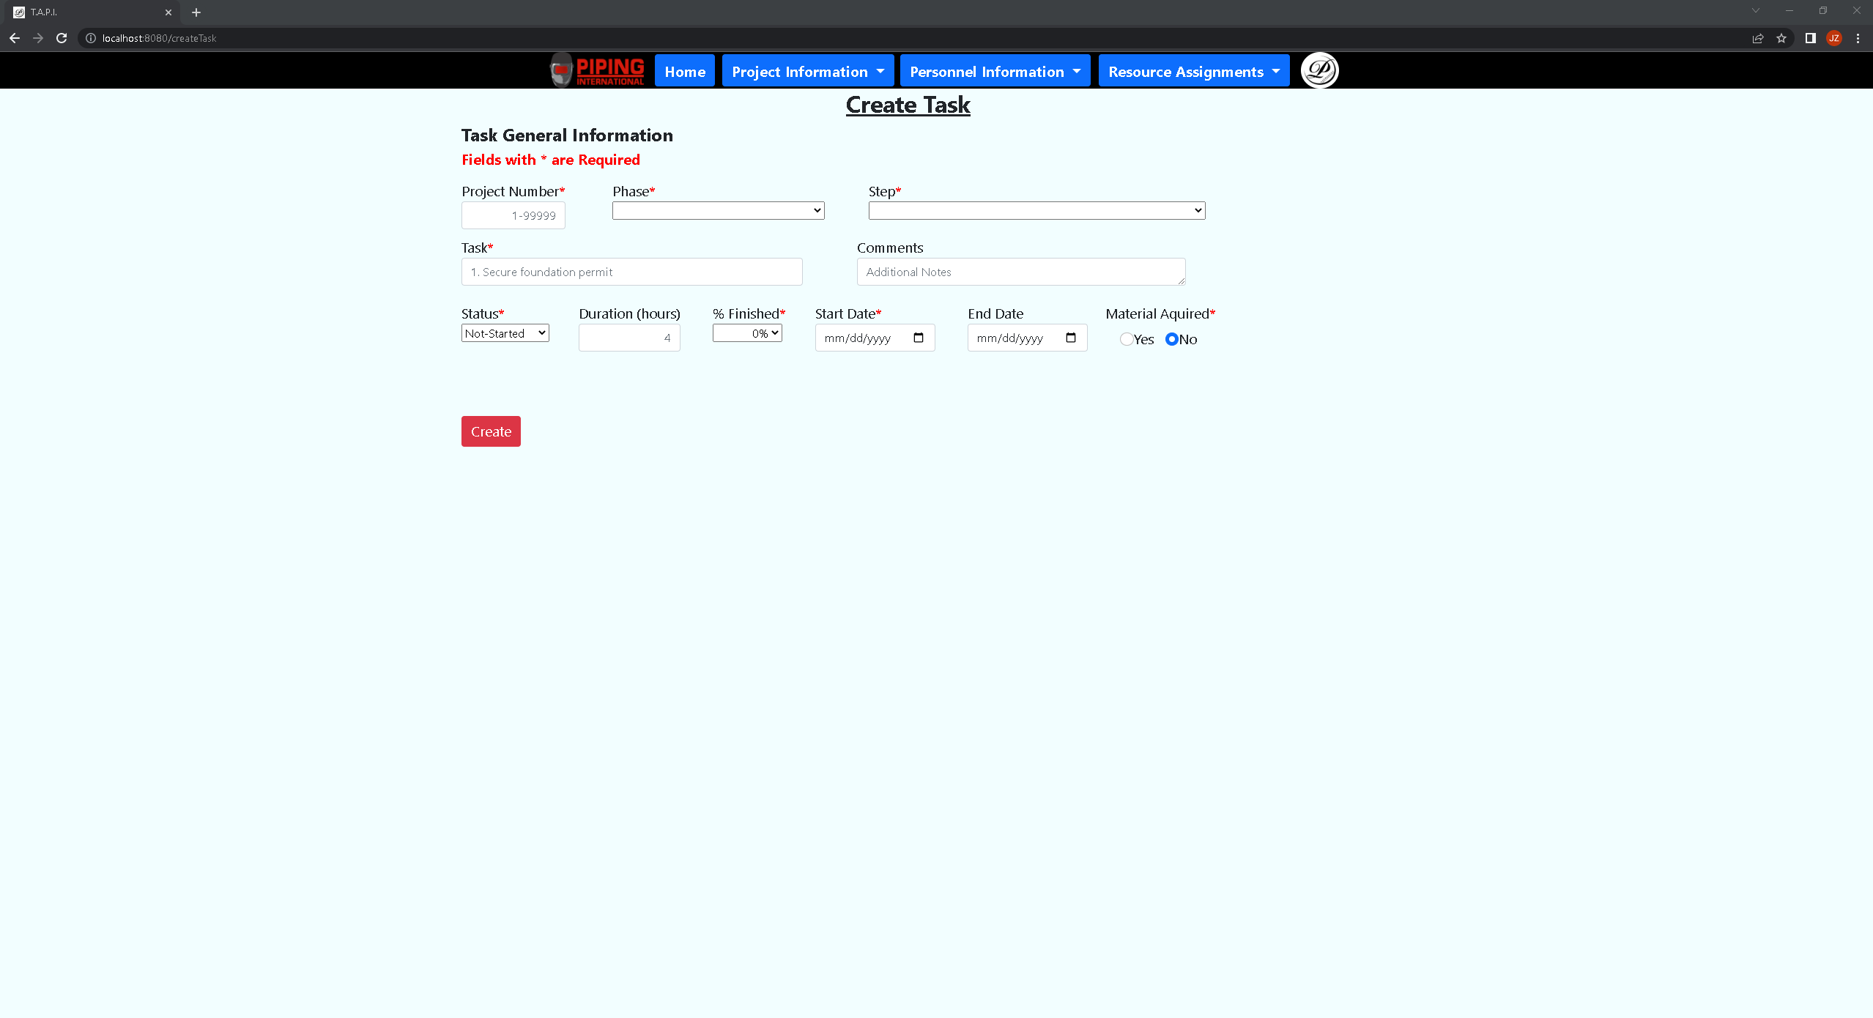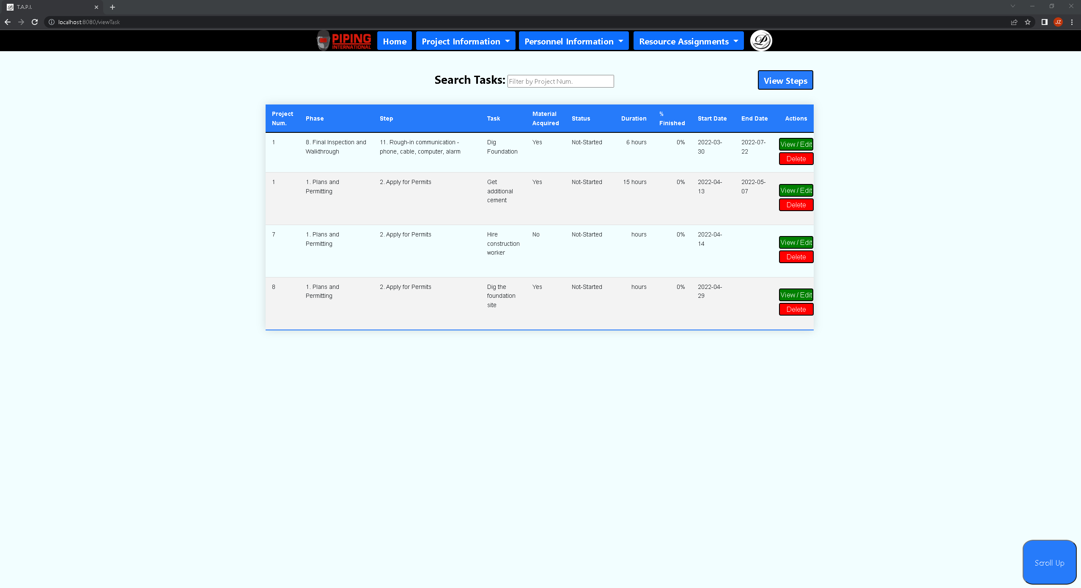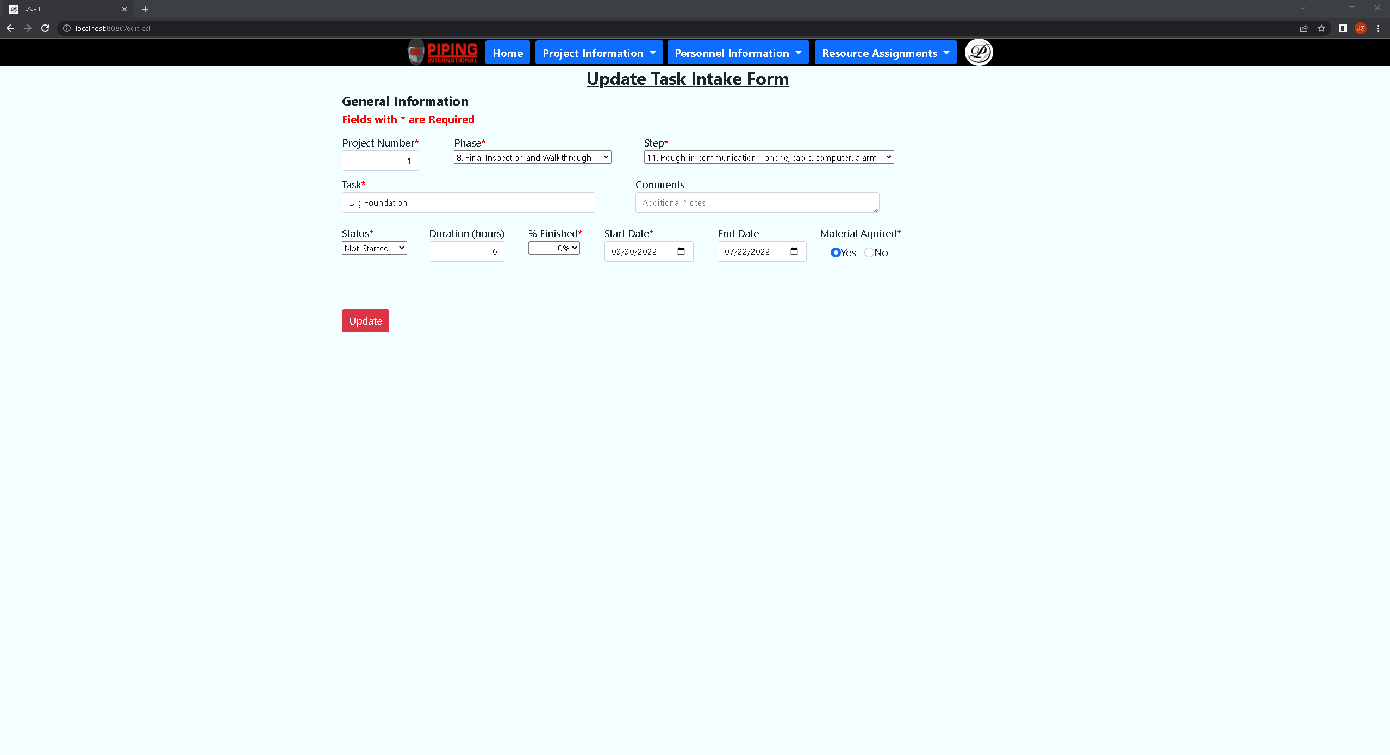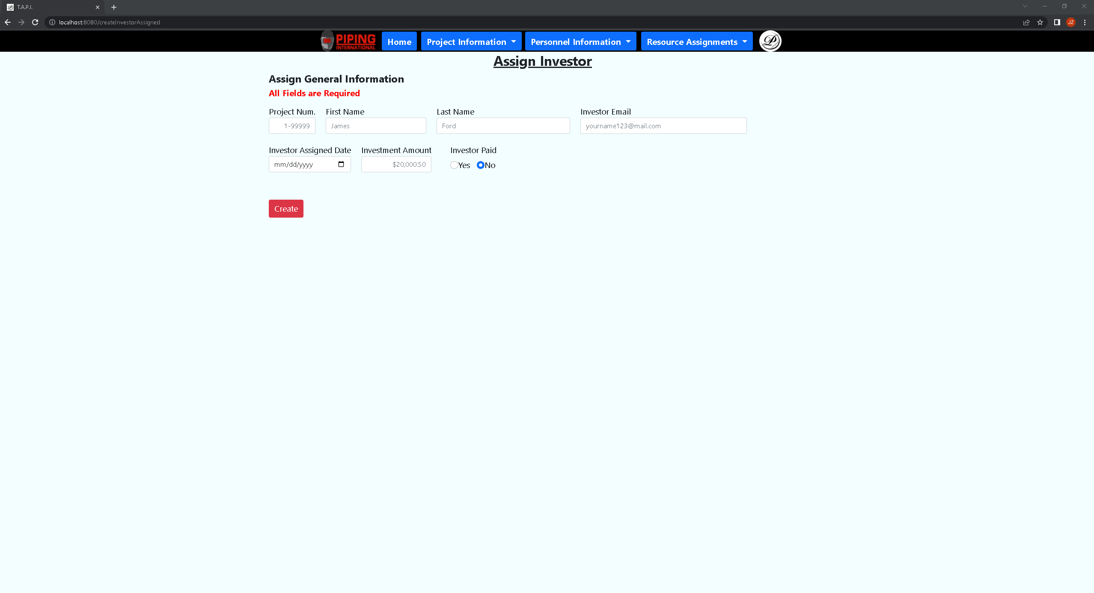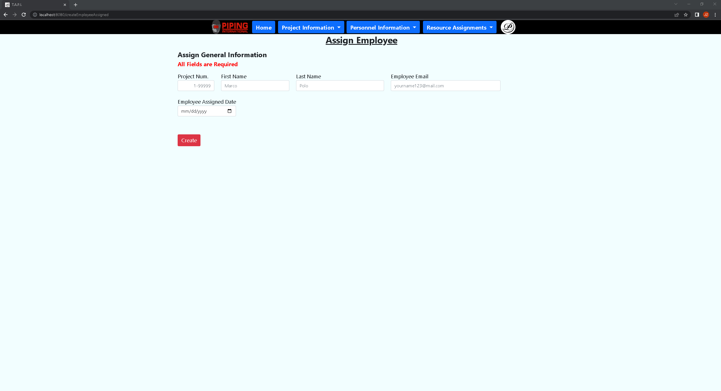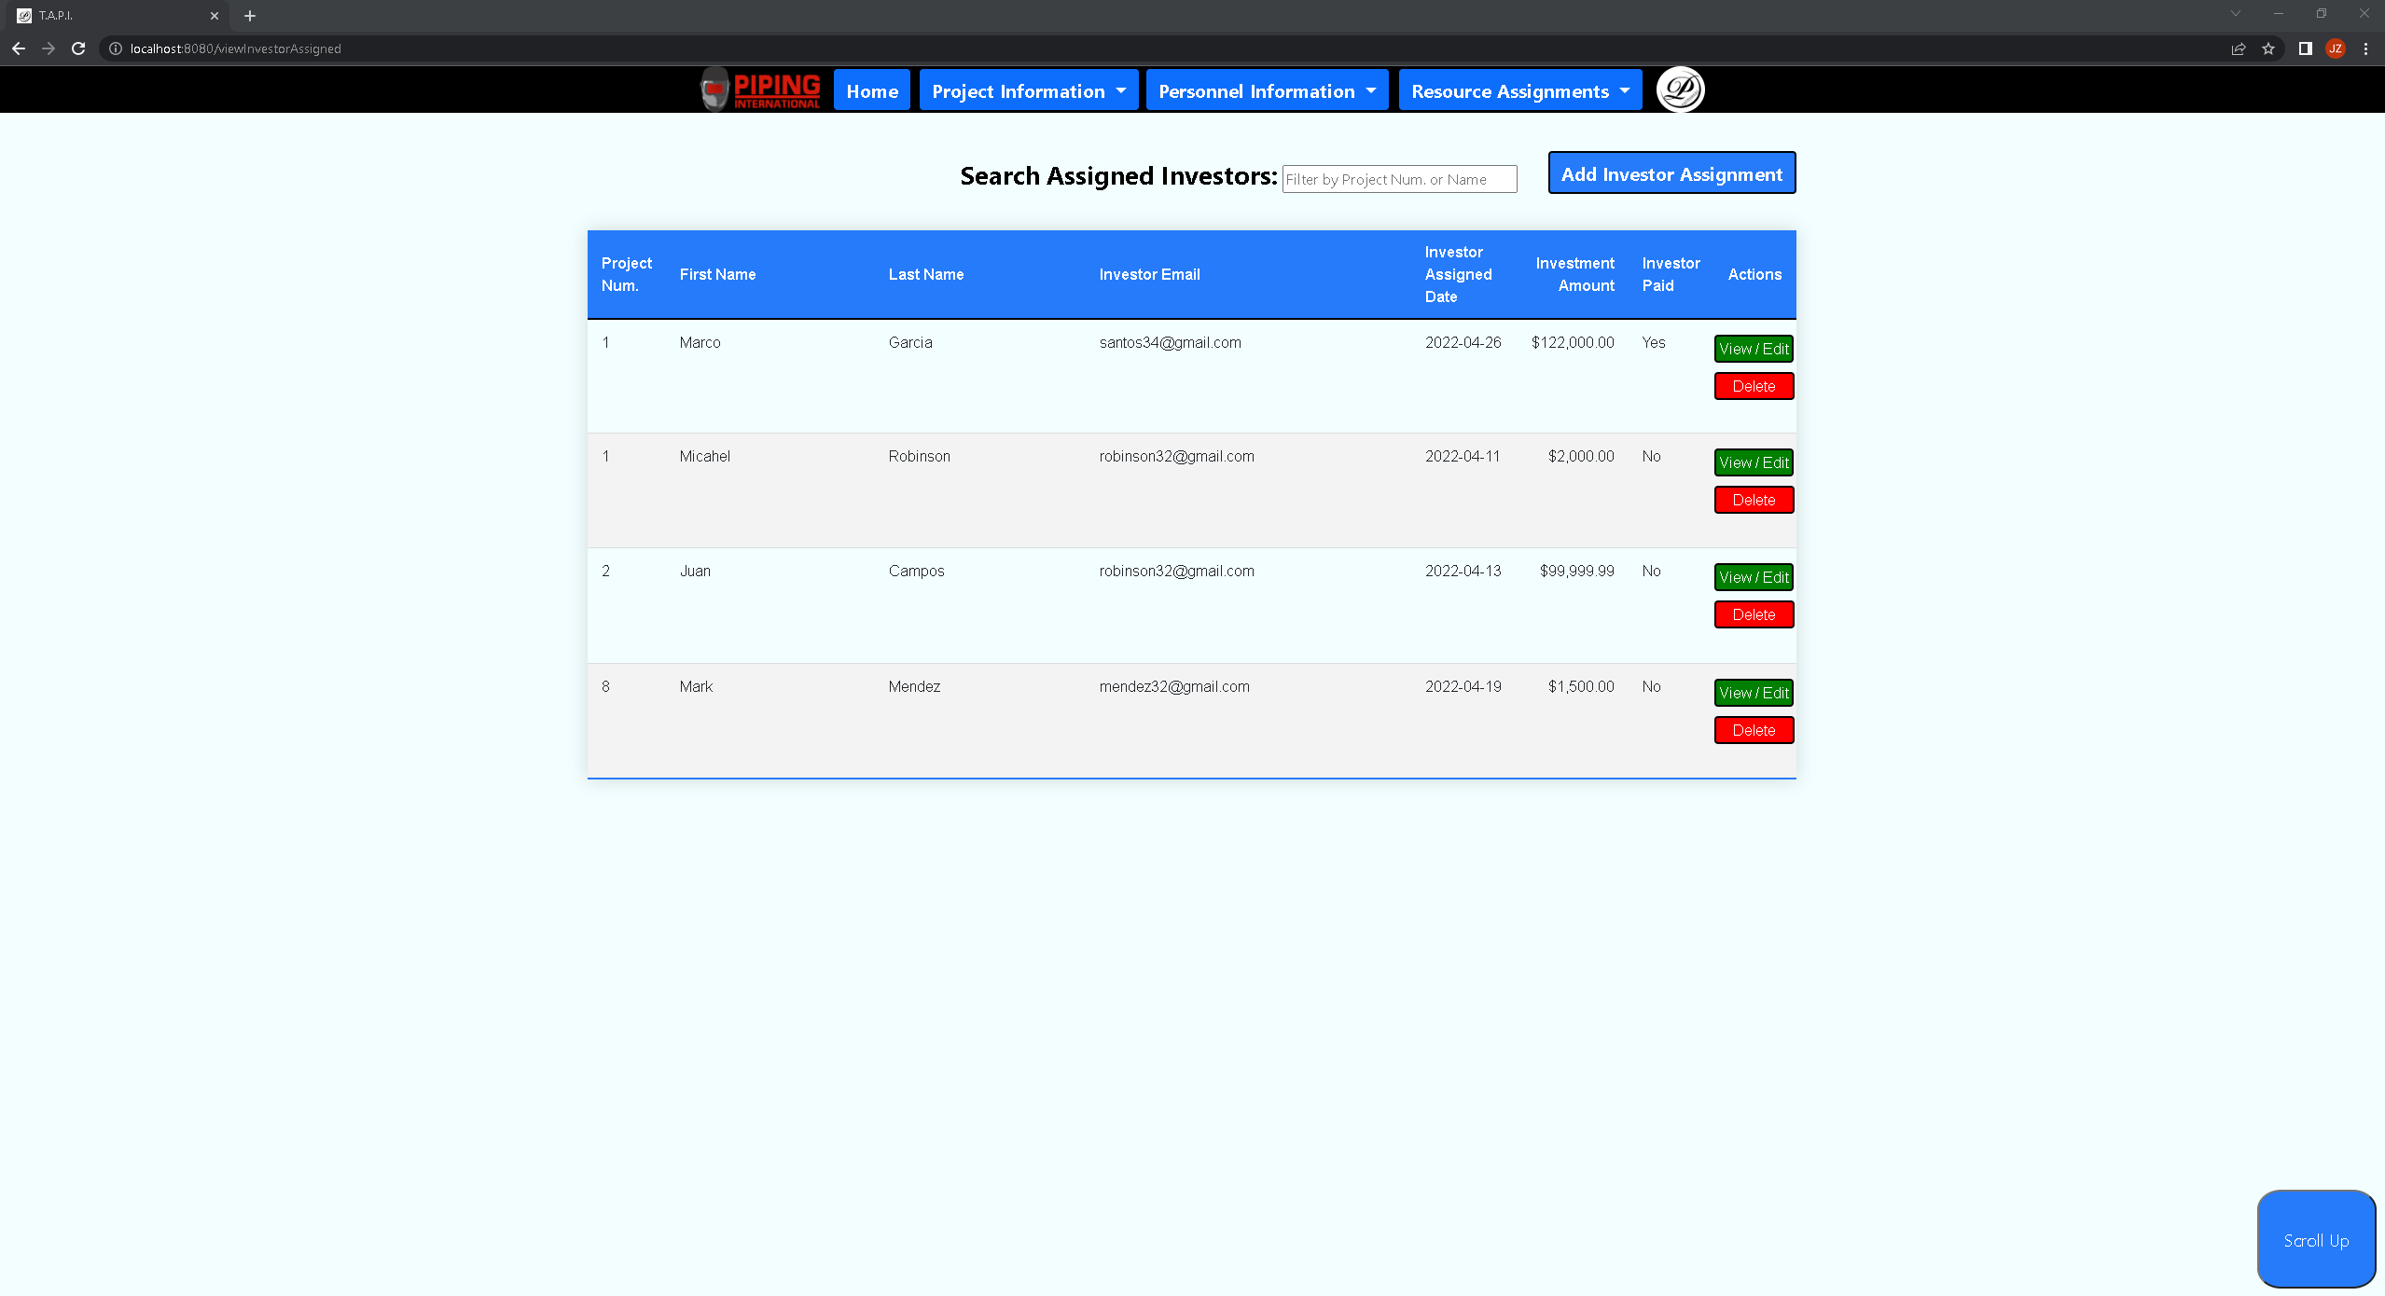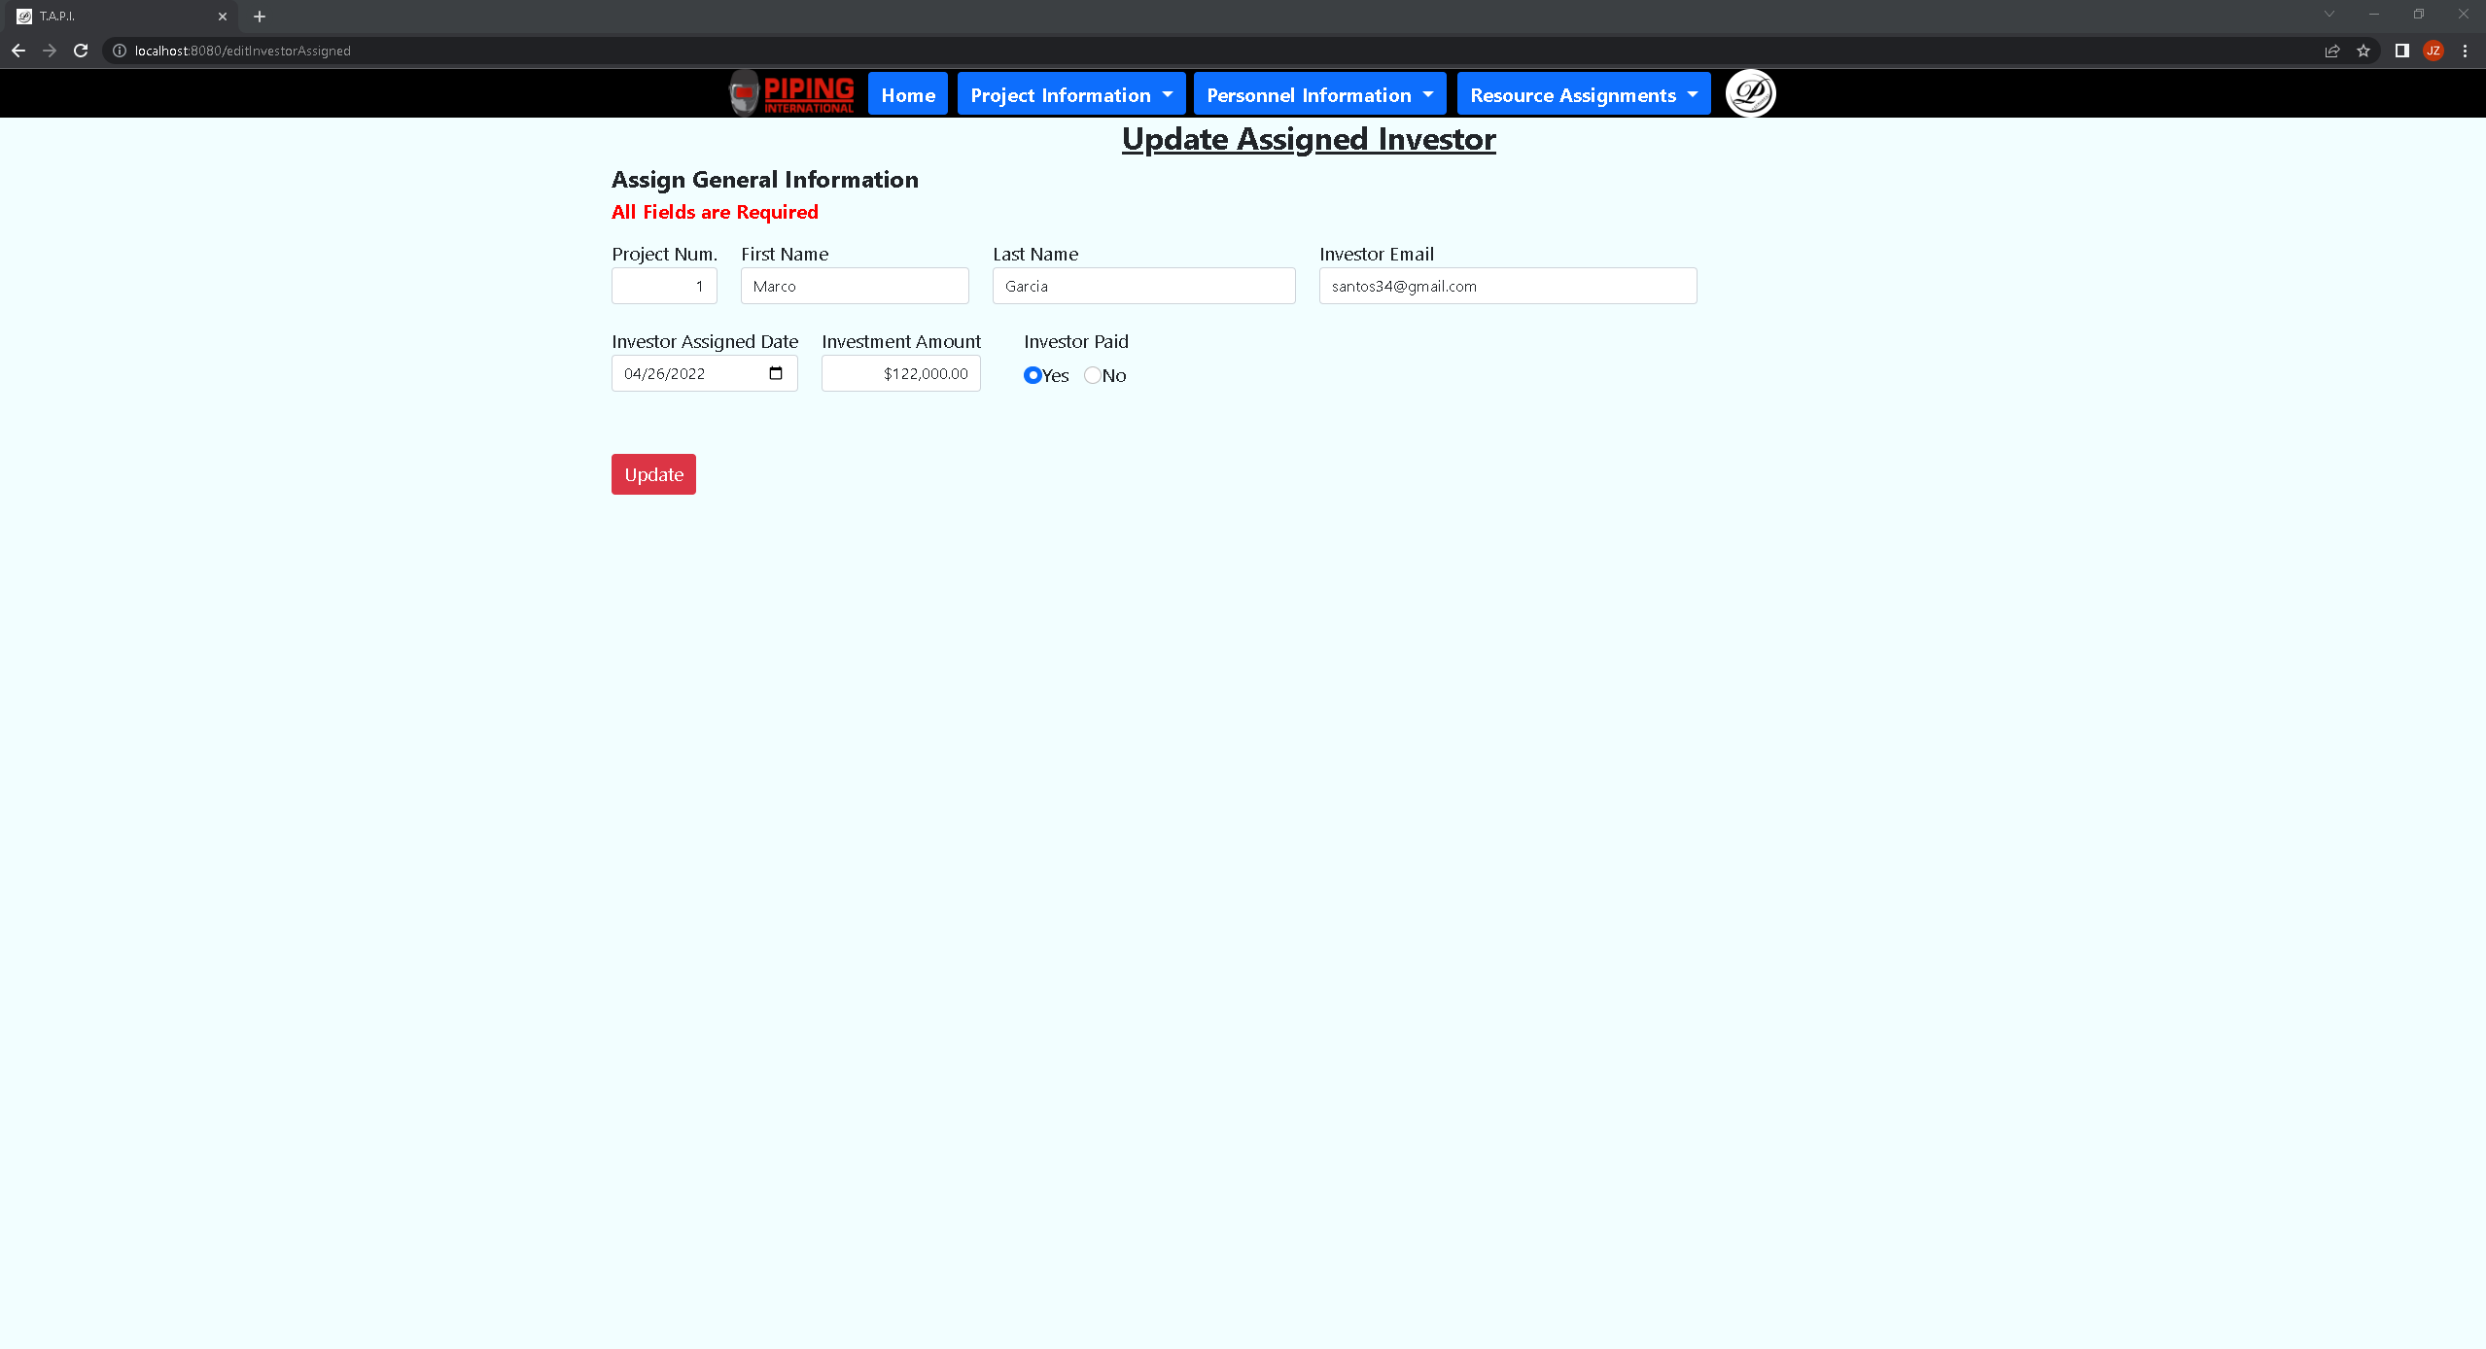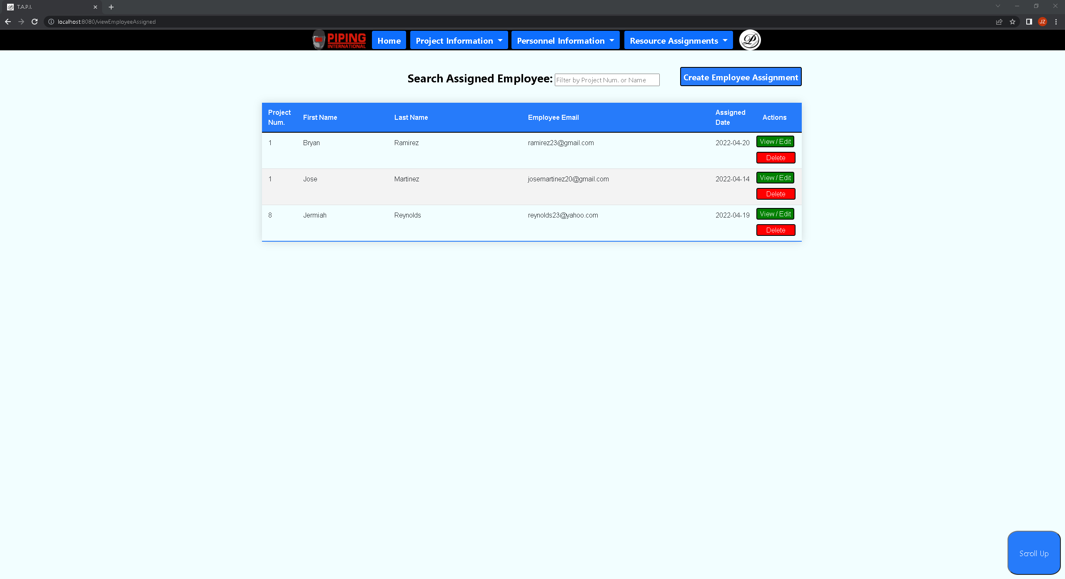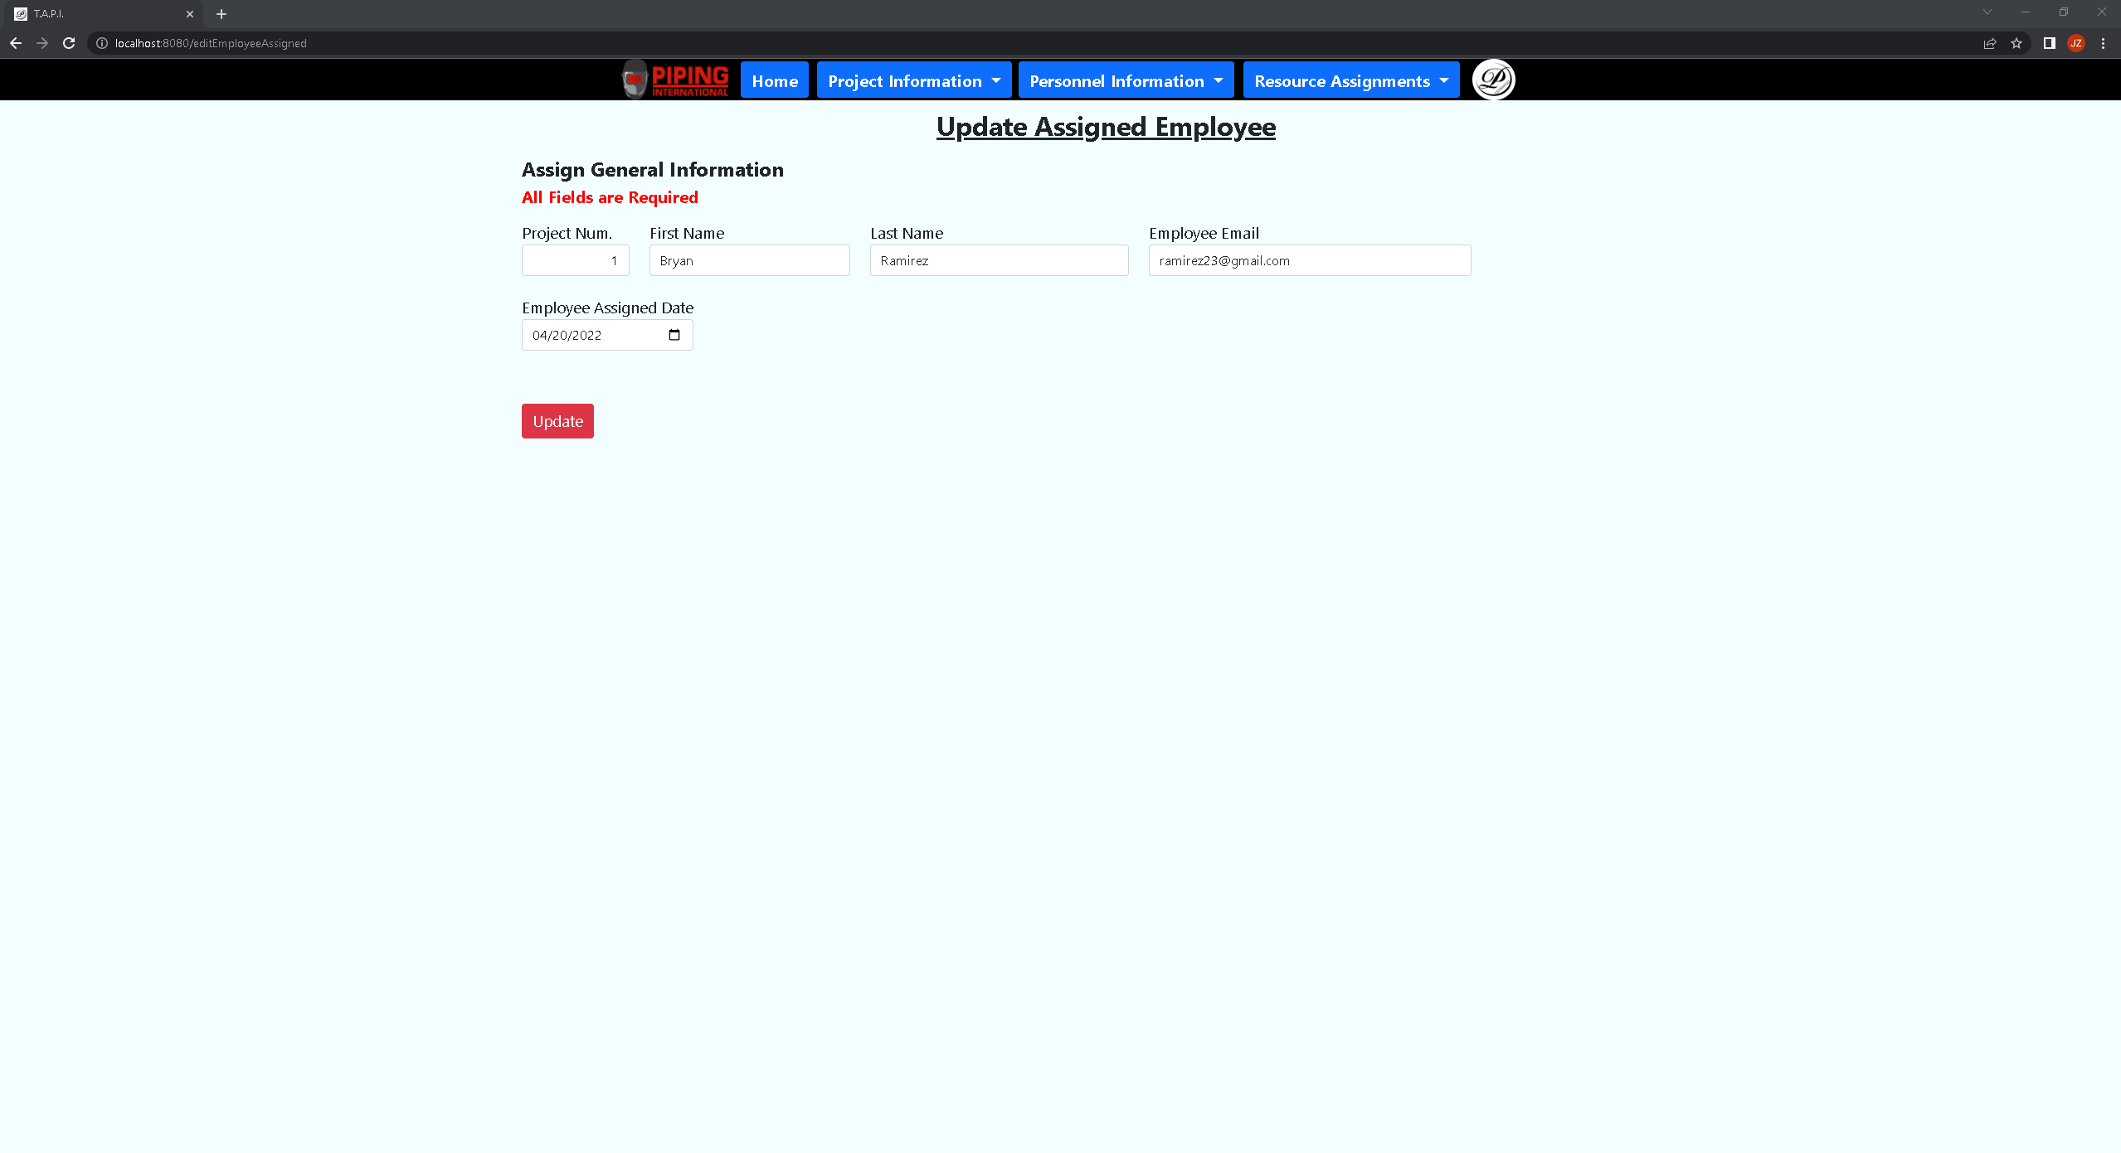

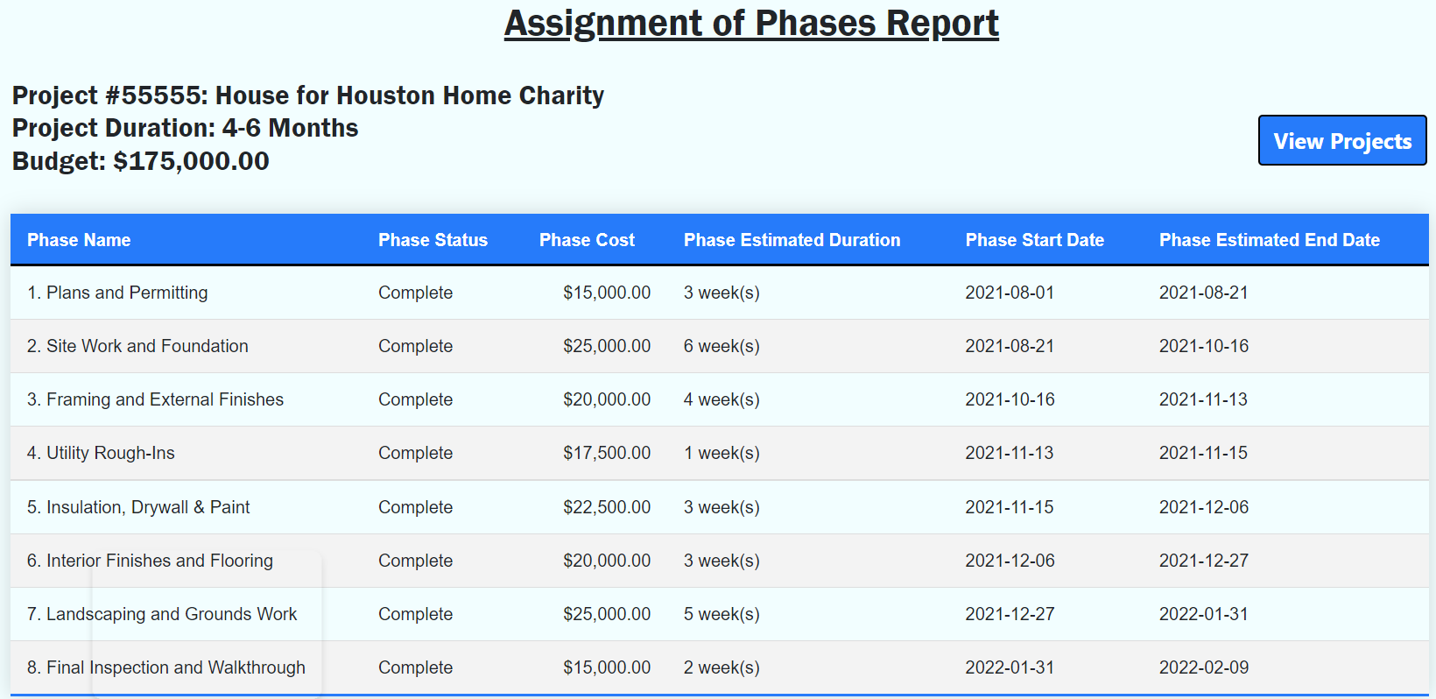

**Tables Involved:** Project, Phase

**Attributes Involved:**

**Project:** Project Number, Project Name, Project Duration, Project Budget

**Phase:** Phase, Phase Status, Phase Cost, Phase Estimated Duration, Phase Start Date, Phase Estimated End Date

**Description:**

This report assembles the phases associated with one project. It displays the project’s correlating phase information, particularly each phase’s status, cost, and duration. This helps the user by giving them an overview of a project’s phases, particularly when trying to understand one project or estimating a future project.

Project Assignment of Investors Report

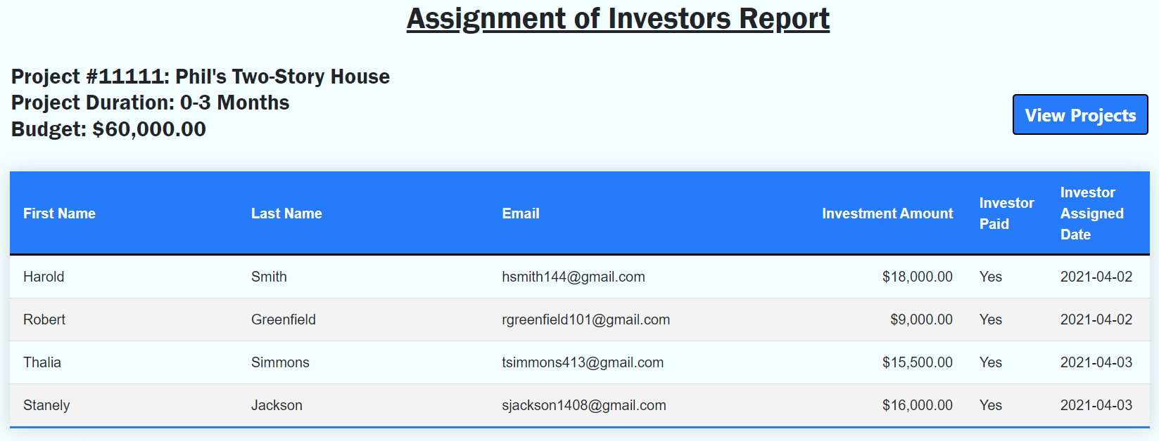

**Tables Involved:** Project, Investor Assigned

**Attributes Involved:**

**Project:** Project Number, Project Name, Project Duration, Project Budget

**Investor Assigned:** Investor Assigned First Name, Investor Assigned Last Name, Investor Email, Investor Assigned Investment Amount, Investor Assigned Paid, Investor Assigned Date

**Description:** This table is designed to display the investors associated with a particular project. This helps the user understand the composition of their budget and the stakeholders involved with that project. This can be useful for identifying who paid how much for a given project and when the transaction occurred.

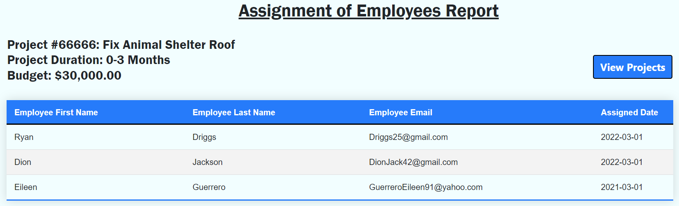

**Tables Involved:** Project, Employee Assigned

**Attributes Involved:**

**Project:** Project Number, Project Name, Project Duration, Project Budget

**Employee:** Employee Assigned First Name, Employee Assigned Last Name, Employee Email, Employee Assigned Date

**Description:**

This report displays the employees assigned to a specific project. This allows the client to keep track of which employees are responsible for handling which projects, as well as keep track of the date they were assigned to that project. By analyzing the Assignment of Employees reports, the user can better understand how to identify and balance their employees’ work distribution.

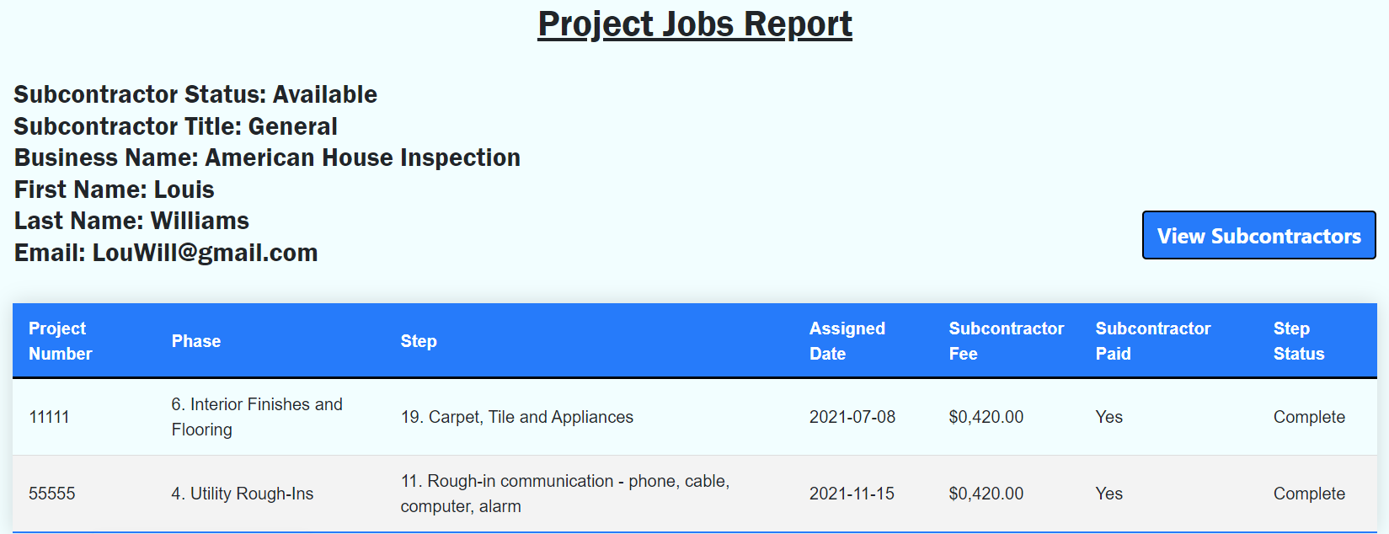

**Tables Involved:** Subcontractor, Step

**Attributes Involved:**

**Subcontractor:** Subcontractor Status, Subcontractor Title, Subcontractor Business Name, Subcontractor First Name, Subcontractor Last Name, Subcontractor Email

**Step:** Project Number, Phase, Step, Step Subcontractor Assigned Date, Step Subcontractor Assigned Fee, Step Subcontractor Assigned Paid, Step Status

**Description:**

The Project Jobs report retrieves information on the steps associated with a specific subcontractor. This gives the user an overview of their history with a given subcontractor by displaying the projects and job steps they worked on as well as how much they were paid for doing so and the date of hire. Also, this information can be used to estimate how much to pay subcontractors for similar contracts in the future.

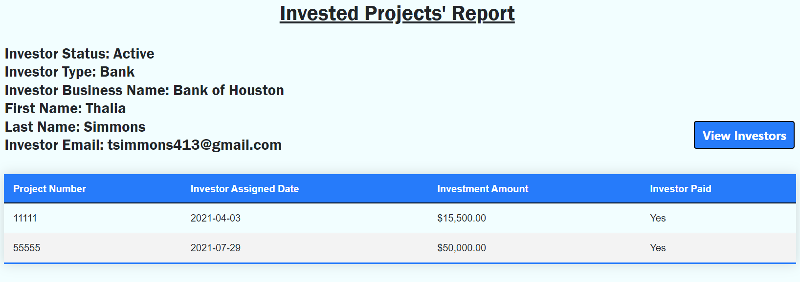

**Tables Involved:** Investor, Investor Assigned

**Attributes Involved:**

**Investor:** Investor Status, Investor Type, Investor Business Name, Investor First Name, Investor Last Name, Investor Email

**Investor Assigned:** Project Number, Investor Assigned Date, Investor Assigned Investment Amount, Investor Assigned Paid

**Description:**

The Invested Projects report displays a given Investor’s past projects with the business. The client will now be able to keep track of Investment amounts on specific projects as well as the date of transaction and if he/she was paid or not. By displaying information on previous projects, the user can analyze an investor’s history, tendencies, and investments, giving them information to make future predictions on.

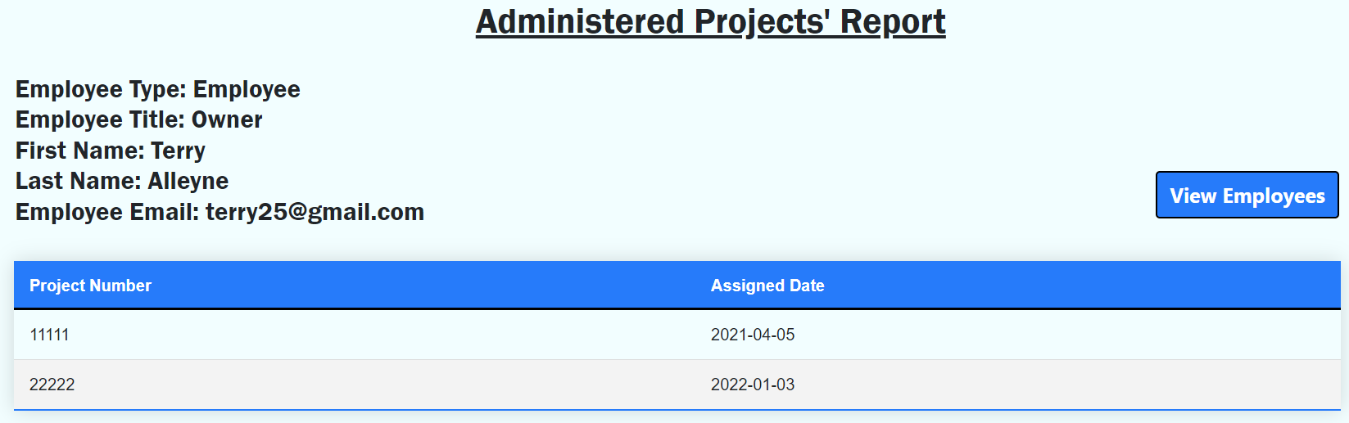

**Tables Involved:** Employee, Employee Assigned

**Attributes Involved:**

**Employee:** Employee Status, Employee Title, Employee First Name, Employee Last Name, Employee Email

**Employee Assigned:** Project Number, Employee Assigned Date

**Description:**

The Administered Projects Report displays the projects administered by a particular employee. This enables the user to analyze their employee’s project history and decide how and who to assign projects to. By knowing an employee’s previous and current work allows for better organization and clarity within the company.

|  |  |  |
| --- | --- | --- |
| **Rank** | **Improvement Name** | **Improvement Description** |
| 1 | Application numeric data validation | Estimating durations based on start and end dates and applying validation for street names and currencies |
| 2 | Adding reports to dashboard | Adding minified reports on the dashboard to display a summary of each table |
| 3 | Integrating application to cloud database | Serve data through MongoDB's cloud database to the frontend. Data will be served through MongoDB’s endpoints instead of Node.js |
| 4 | application security integrations | Improve application security through 2-factor authentication, adding user credentials, and restricting permissions-based user roles |
| 5 | Add more statistical information through charts and graphs in application | Application needs to correlate with each other and make conclusions through charts and graphs such as identifying investors based on type |
| 6 | Style application to be flexible in different screen sizes | Application needs to be styled according to the user’s different screen sizes so that it does not affect the overall appearance of the application |
| 7 | table pagination | Data tables require pagination if the table exceeds at least 10 records. |
| 8 | Navbar does not stick to screen | The navbar does not stick to screen when scrolling down in the application. This reduces functionality by keeping the navbar in reach of the user |
| 9 | Button to turn reports into pdf format for printing | A button should be made for resource assignment tables to convert the report into a printable pdf format for physical record keeping |
| 10 | Additional backup server for data | Application must be able to support an additional server in case of sudden data loss. |
| 11 | Integrate application to Sponsor's company servers | The application should be integrated into the sponsor's servers so that the data can be directly manipulated instead of being on a local database on a single computer |
| 12 | Created dynamic web pages for application | Application must apply transition between different webpages when navigating throughout the website |

What Worked?

Our application functions due to its simple, responsive display of data. When looking at our 7 data tables, our application was able to apply CRUD functionality through data validation and calculation of multiple inputs. Examples such as project tracking through data validation between tables have been implemented by using foreign keys to take data from other tables. We can filter search results to find specific records based on the project number from the projects table or investor email in the investors table. Each record has buttons specifically created to act as CRUD functions and provide functionality to the table. The straightforward design of the application allows us to ensure that we maximize the functionality the user has for each record in the project without reducing the user’s ability to modify any of its data.

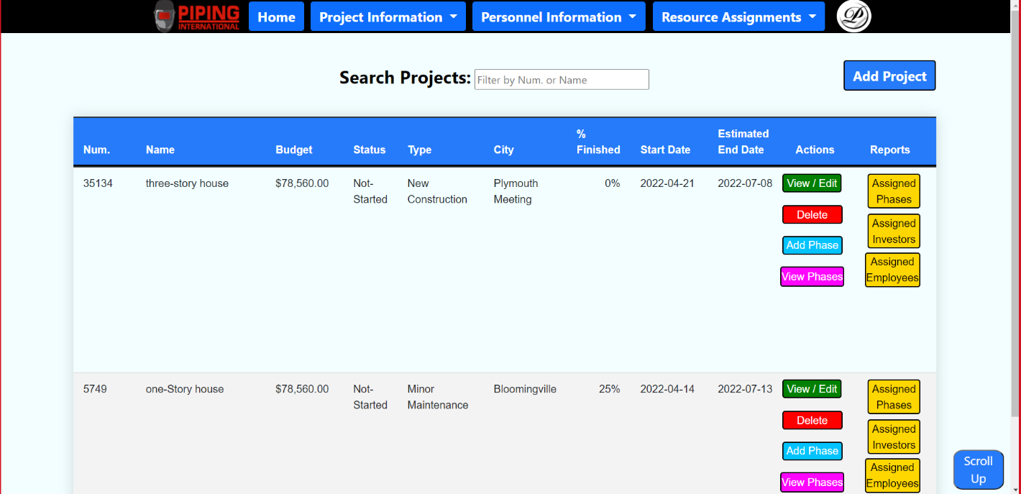

When creating new records in the application, the intake forms can take attributes from existing records in other tables to ensure that the record is connected and retains its data integrity. Data validation ensures that the user does not use data from an incorrect format or range. If the user uses an incorrect format, the intake form will prevent the user from submitting the data until it corrects its errors. Some fields are also required by default to ensure that it can be used as foreign key by other tables.

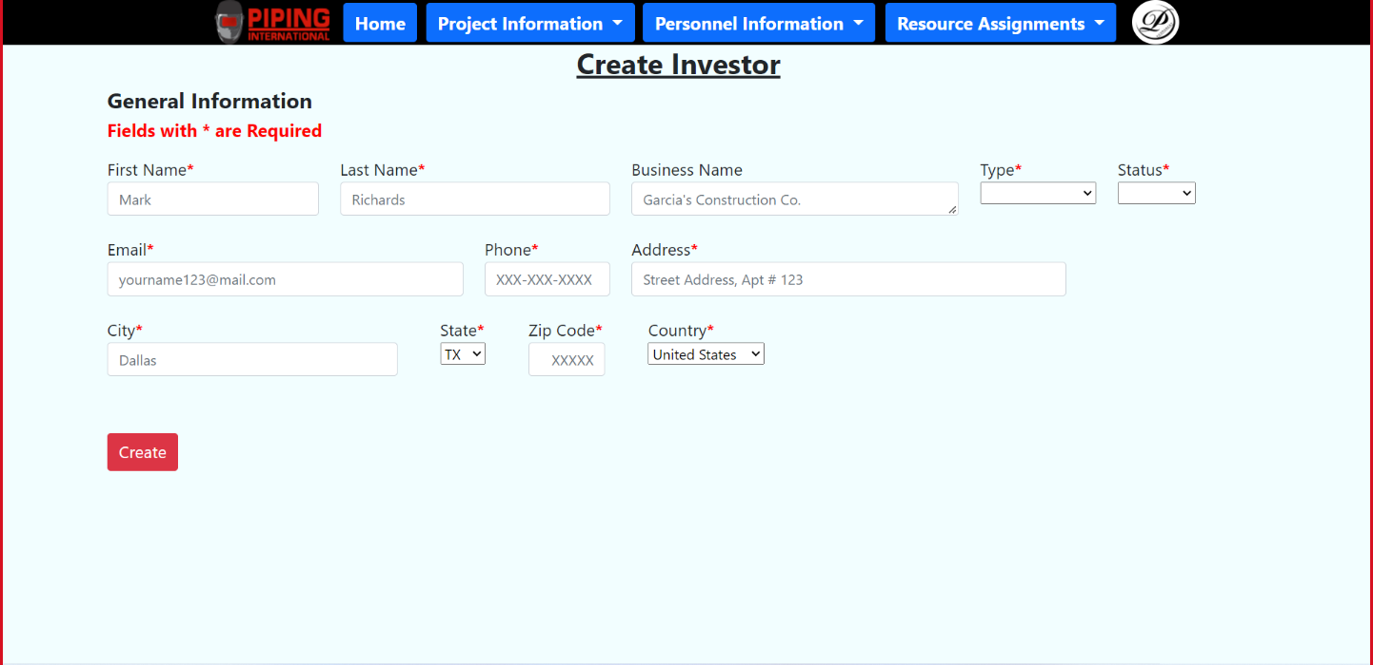

For reports, it takes attributes from existing records in multiple tables to form an aggregate table meant to provide statistical information about the website. The Resource Assignments tab shows the projects assigned to employees, subcontractors, investors through the project number which tracks these reports. Other reports can be created for phases, steps, and tasks but can only be made by navigating to it through the projects tab. This ensures that the report is assigned to a specific project, phase, or step when going through the joined tables. This allows the tables to track each other and sum up multiple fields into a table for making aggregated reports.

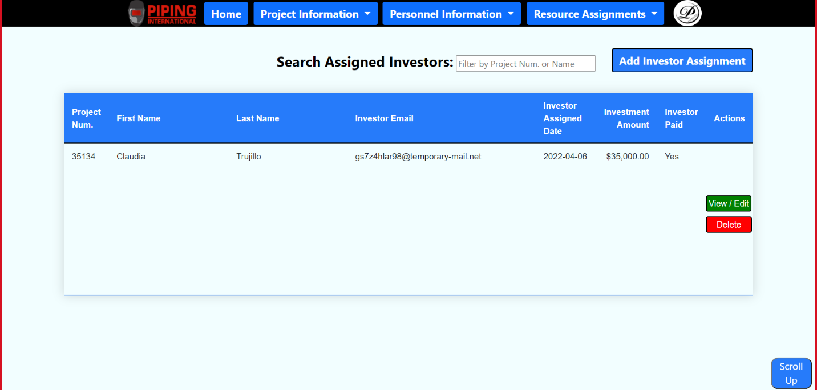

**What did not work?**

While the project was able to ensure that it is displayed correctly and is responsive to each other, there are still a few improvements that should have been made to increase functionality. The application was not designed to be used for smaller screens since it was not styled change dynamically by screen size but by max pixel height and width. The webpages themselves seem less original since they are more similar in functionality and styling. If we had a way to include background images to make it more appealing for the user, it would make the whole application more colorful. The dashboard was supposed to include mini reports to briefly summarize the contents of main tables for the website, but only has a slide gallery, making the dashboard act as more of a home page since it does not have anything to display the website. For the table’s pages, the tables themselves do not have pagination for limiting the amount of scrolling in the webpages. The application could have reduced this effect by making the navbar stick to the screen, thus ensuring that navigation will always be in reach, but it was never truly implemented.

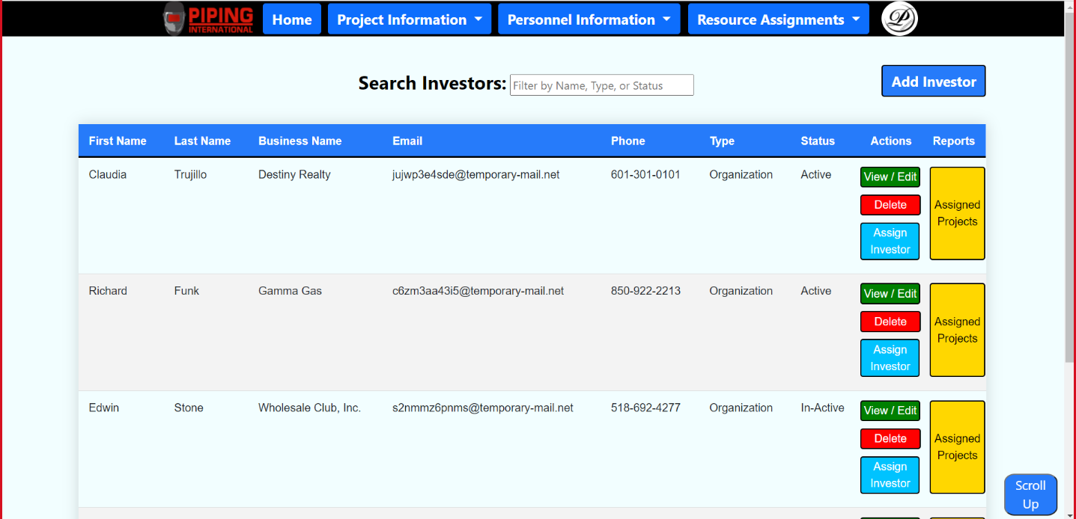

**Future Improvements**

Due to the time constraints of the project, there were many improvements that could have been implemented if there was enough time allotted for the team. Some of those improvements were cloud integration, table pagination, dynamic webpages, and more statistical information through charts and graphs. Cloud integration has been one of the most sought-after implementations that the team has been requesting for. Due to the difficulty of integrating a local database to a cloud database, the application was too far from its creation to fully integrate it without sacrificing too many features in the project. The problem with cloud integration is that the local database is already handling the data itself through joins and aggregations that would then have to be mimicked by the cloud database and validated through the frontend. If it were implemented first instead of a local database, it would have been done a long time ago but there was not enough time to completely integrate it. For table data, pagination could have been implemented, but manipulating the frontend to do such a thing was taking too much time to complete. Another branch was created in GitHub to test these changes before they could be merged to see if it were possible and the code behind making them was taking too long to implement based on the project schedule.

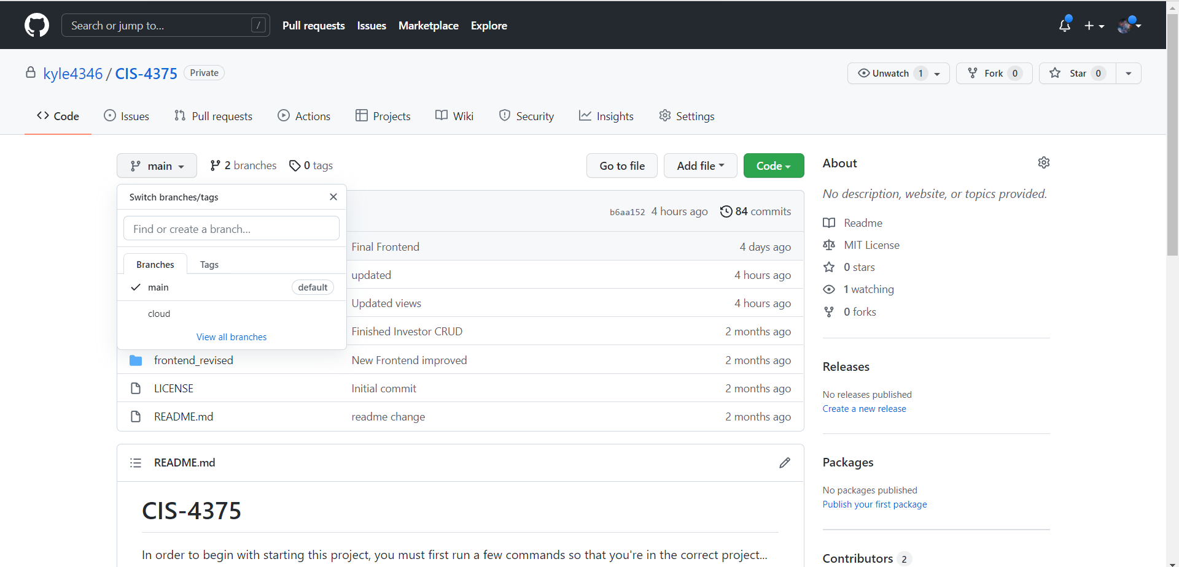

**New Technologies**

In the 4 months we have been developing our application, we have used new technologies that allowed us to complete the deliverables of our project. Some of those applications were discussed in class but were not required since it never specifically utilized them within the scope of the project. Deliverables such as the UML activity diagram, Data flow diagram, and ERDs are examples where our team would use Microsoft Visio to connect entities between each other. In our application, we utilized software such as Visual studio code to create our applications, Node.js to handle the backend, and MongoDB to server as our local database. By utilizing these technologies, our team became more effective by completing our deliverables in a timely manner while expanding our knowledge in the processing data.

**Lessons Utilized**

When our team first started this project, there was already an extensive background knowledge of the application. Our previous class, CIS 4439, prepared us for this project by giving us the tools necessary to build a functioning full-stack application. All our team had to do was simply use the lessons we learned in the past and apply it in this one. The first step of creating the application in the project schedule was to build the backbone of the application through the frontend. In the project schedule this would be called the application design step and it utilized Visual Studio Code’s Vue.js framework to create the frontend of the application. New functions were implemented over time in the GUI design step since it had to navigate from one page to another which is where node.js came in. Node.js made our application act as a client to our MongoDB database by creating its own endpoints to the varied data stores in MongoDB. These helped in creating the intake forms which were served as GET requests and provided the necessary data to the website. Finally, the rest of the application development steps involved MongoDB queries that aggregated data and proved useful in creating the tables you would see from the website. All these technologies working together made the data throughout the different table flexible, allowing room for new technologies to be used in the future as outlined by our future improvement’s deliverable.

# **Database License**

Our sponsor Terry has been advised that in the future he can consider migrating our T.A.P.I. web application to the cloud by Piping International purchasing MongoDB Atlas cloud services and using a dedicated cluster provided by Amazon AWS. We suggested that for his initial implementation of the Amazon AWS services he purchase the entry level service which is the M10 tier that has 10 GB of storage and 2 GB RAM and 2vCPUs. The base price for this is $0.08/hour, which for a month the price is $57.60 and yearly cost is $691.20. This service includes backups which can be configurable snapshots and retention policies as well as on-demand snapshots and point-in-time recovery. Additional, features include online archive which our Sponsor Terry can archive old projects that he works on, which is something that we are not implementing in the T.A.P.I web application as there is a limit on the number of projects that he stores in the MongoDB which is 99,999. Also, MongoDB Atlas has elastic scalability so as the size of storage gets filled it will auto-scale to accommodate additional data even though Piping International typically has one or two project per year, sometimes more if they receive small projects like maintenance or remodeling projects. Furthermore, cloud services provide security measures such as always- authenticated connections as well as private-networking and end-to-end encryption. Also, client-side field-level encryption to ensure that data that is being accessed by our sponsor cannot be infiltrated or accessed by suspicious users on the internet also their granular database auditing. Now the granular database auditing is a tracking system of deployments with multiple users if Terry ever needs to have the T.A.P.I. web app deployed across multiple users.

# **Backups/Recovery Plan**

As we suggested that Piping International should consider I the future purchasing the MongoDB Atlas cloud services and have a M10 tier dedicated cluster with Amazon AWS. The backups will be configurable snapshots which are scheduled to be made every two weeks of the month. More specifically, they are to occur on the weekend of every 2nd week, meaning that there will be two back up periods every 14 days. These backups will be partial, so the first 14 days backup on a given day that falls on will be a 50 percent snapshot of the current data while in the last week of the month the remaining data that makes up the other 50 percent will have a snapshot taken. So, by next month there will have been a full backup completed this same process will repeat for the following month and so forth.

When it comes to recovery Piping International has the option of conducting a point-in-time recovery which allows him to go back in time and recover a snapshot of data which he can obtain and reintegrate that lost data in the current database. Now this point-in-time recovery can be conducted at any point in time in which Terry desires to conduct a recovery as this is part of the service of purchasing MongoDB Atlas cloud service.

# **Data Archival**

Data will be archived every business quarter through the online archival feature on the MongoDB Atlas cloud service. Permanent Communications will not be responsible for that as that is outside our service level agreement as we are only responsible for installing the T.A.P.I. web app locally on Terry’s laptop. Now the responsible party for doing these data archiving will refer to the support services that MongoDB offers which help assist small business with managing their cloud service. Now that online archival mechanism is an auto-archive data which is default to occur on a quarterly basis. Therefore, our sponsor Terry will not have to manage that aspect of the MongoDB Atlas cloud service. If he needs to make changes then he will need to contact MongoDB Atlas’s support.

# **Data Indexes and Rebuilding**

When it comes to data indexes and rebuilding this feature is available through MongoDB Atlas cloud services which Piping International can get the support team from MongoDB Atlas to conduct the data indexing and rebuilding. As that service is not under Permanent Communications service level agreement therefore, we suggested to our sponsor Terry if down the road he need to conduct data indexing and rebuilding Terry would have to seek MongoDB support which is free of charge with the cloud service. And the rebuilding process can be done but if the sponsor does not need to do it then he can just conduct a data indexing on the current data as he starts using the MongoDB Atlas cloud service.

# **How to deal with “Bad Data” – Data Cleanup**

When it comes to bad data, there has been intensive implementation of data validation in the backend and frontend. In the backend for example, for each schema that was created like the employee table each field has some form of validation, for example the type whether it is string or number. Additionally, there is also some size limit in the number of values that can be inputted in a field name like max length for first name, which can be twenty-five characters and be required and not allow null values. In the frontend there is further validation in which you must pass the type which for string is text, then you can pass a pattern. A pattern is regex validation which allows the developer to impose a rule when a user is filling out an input field. For example, for first name a pattern can be only allow capital and lowercase letters as well as space and have a min length of two characters and max of twenty-five characters. This same example was applied to all fields that were present in the intake forms to ensure that there was some validation in the intake forms. There are some fields in which validation was partially implemented and that was the case with the street address and currency values. But even if the sponsor inputs the wrong field for an address special character, he still has the option to update that field until it is right. Therefore, the CRUD operations are fully functional across all the intake forms that are part of the T.A.P.I. web application. When it comes to data cleanup that is the equivalent of updating intake forms or simply deleting data individually as doing bulk deletes is risky but in our T.A.P.I. web application the ability to delete one line item at a time. For bulk deletions, Terry would have to ask for MongoDB Atlas cloud support to conduct bulk deletions.

# **Security Patches**

As for the security patch, Piping International will not need to worry about the database’s requirement to be manually updated as the MongoDB Atlas cloud service ensures that weekly updates are made to ensure that all services are fully functional. Now something that our sponsor Terry will have to make sure that he does on his computer is conduct updates on his laptop check for Windows updates on a weekly basis. This is to ensure that his operating system, hardware, and components are up to date so that there are minimal technical problems. The security patches are part of the updates that MongoDB Atlas cloud service provides so when it comes to those patches Terry will not need to manually update the cloud server. The team will be providing a technical manual that goes over how Terry can maintain his Windows 11 and optimize on his laptop so that he can minimize technical problems on his laptop that will ensure that he can maximize his experience on using the MongoDB cloud services.

**Service Level Agreement**

BETWEEN

Permanent Communications

AND

Piping International

**Parties**

This SERVICE LEVEL AGREEMENT ("Agreement"), dated April 10, 2022, is made by and between **Chad Johnson** of **Permanent Communications** ("Service Provider") and **Terry Alleyne** of **Piping International** ("Client"), collectively referred to as "Parties".

**Services and Support Covered**

Whereas the Client depends on IT equipment, software, and services ("IT Systems") that are provided, updated, and maintained by the Service Provider. Some of these items are required to ensure the success of various business transactions and operations.

Whereas the Service Provider and the Client agree to enter into this Agreement with the understanding that each party has obligations and roles. Henceforth, the Parties, with confidence and consideration, accept the terms and conditions stipulated in this Agreement.

The Service Provider agrees to perform and complete the following services ("Services") for the IT Systems in a timely, efficient, and professional manner:

* Install TAPI in a computer at Piping International on May 13th, 2022
* Record and closely monitor the problems, queries, and concerns of the TAPI Application
* Provide or discuss the resolution and answers to the issues mentioned by the Client in less than 2 hours
* Application support for **30 days** after installation

**TERMS AND CONDITIONS**

**Term and Termination**

This Agreement shall be effective for five (2), months, starting on May 13, 2022, and terminating on July 12, 2022 ("Term"). The Client may renew this Agreement for another Term.

Services and Support Covered

**Performance Monitoring**

The Service Provider shall utilize all monitoring procedures to measure, supervise, and observe whether the performance reaches the expectations of the Client. If the Service Provider fails to meet the obligations, a written report shall be given to the client.

**Client Signature**



**Permanent Communications**

**T.A.P.I. 1.0 - Technical Manual**

# Technical Manual

Windows 11 Optimization to maximize MongoDB Atlas Cloud Services

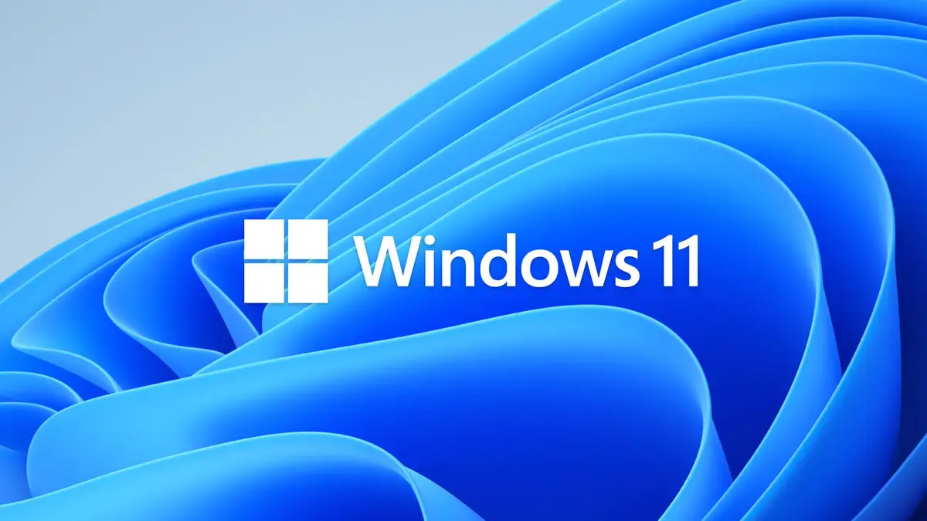

First task that we recommend Piping International is to remove any Windows 11 Bloatware on his laptop this will ensure that there is enough storage on his SSD or hard drive. Having extra space will be a plus when it comes to running T.A.P.I. web app on his PC locally. Additionally, learning these methods of optimizing Windows 11 will allow him to be better prepared when it comes to migrating his locally run database to MongoDB Atlas cloud services. As he will be informed in maintaining an optimized Windows 11 operating system. The following images and text will guide our sponsor on how to conduct that optimization on his Windows 11 laptop. The following images and texts that will be presented will help guide Terry in making the needed updates to his Windows 11 laptop to make sure that his local experience of running the T.A.P.I. web application is excellent.

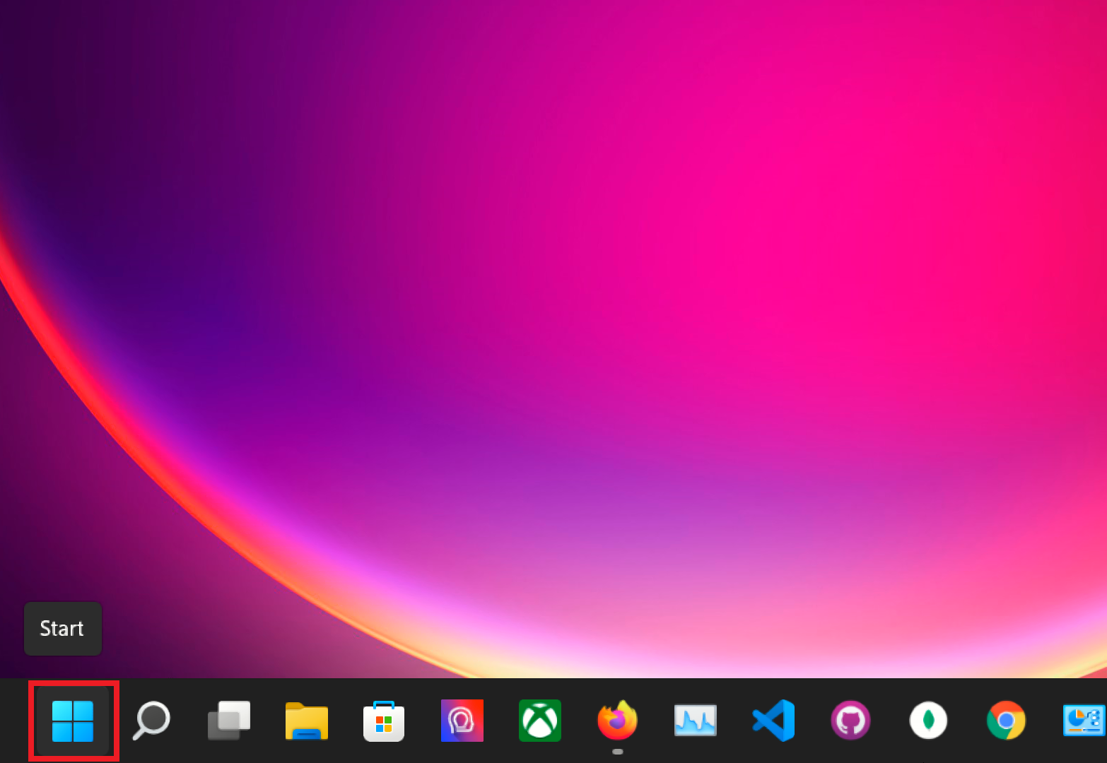

**On** the **bottom taskbar** **click** on the **blue** Windows **Start** **button**.

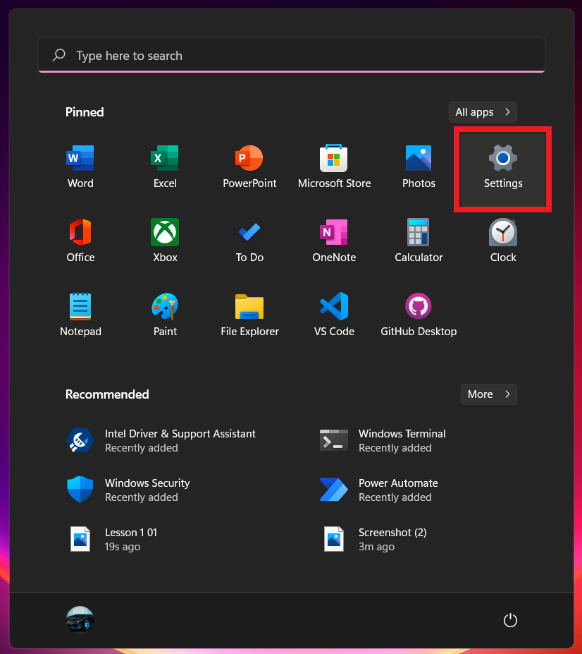

**Text: Once** on the **Start window** **click** on the **Settings button**.

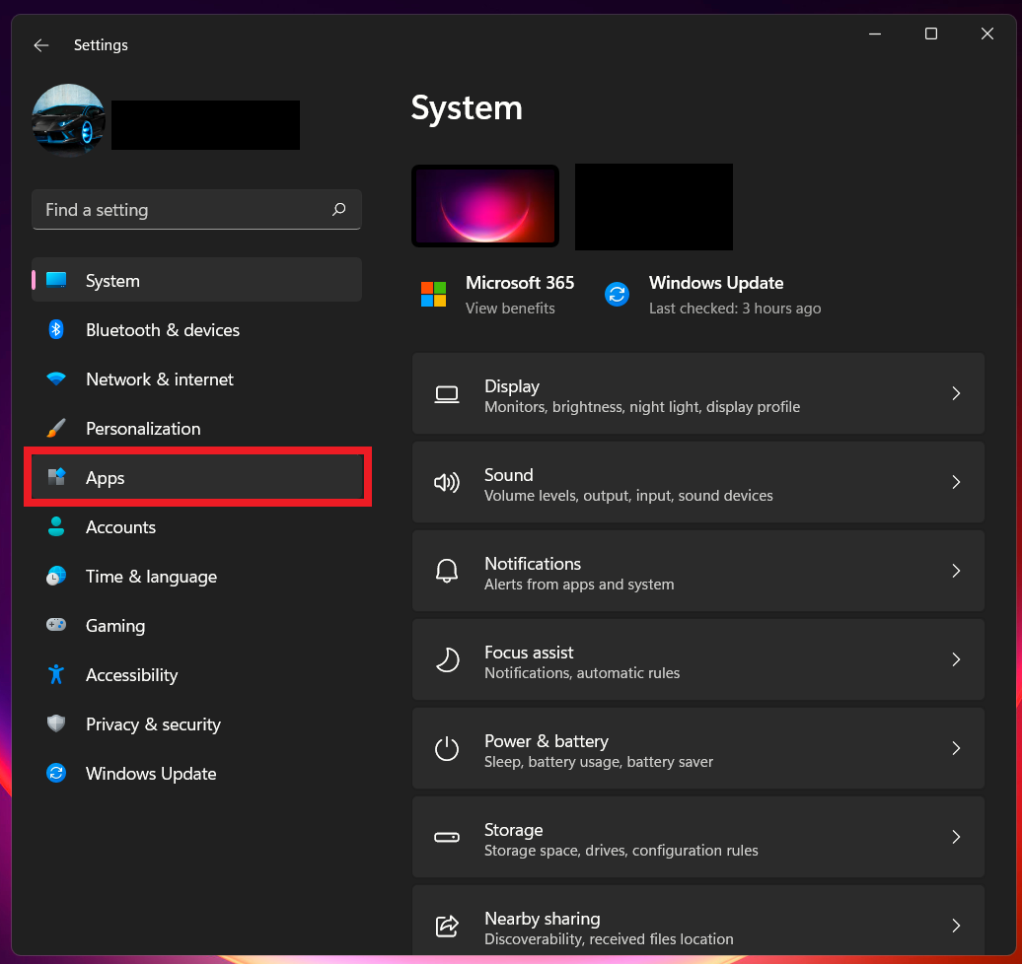

**Text: On** the **left** navigation **pane** **click** on the **Apps button**.

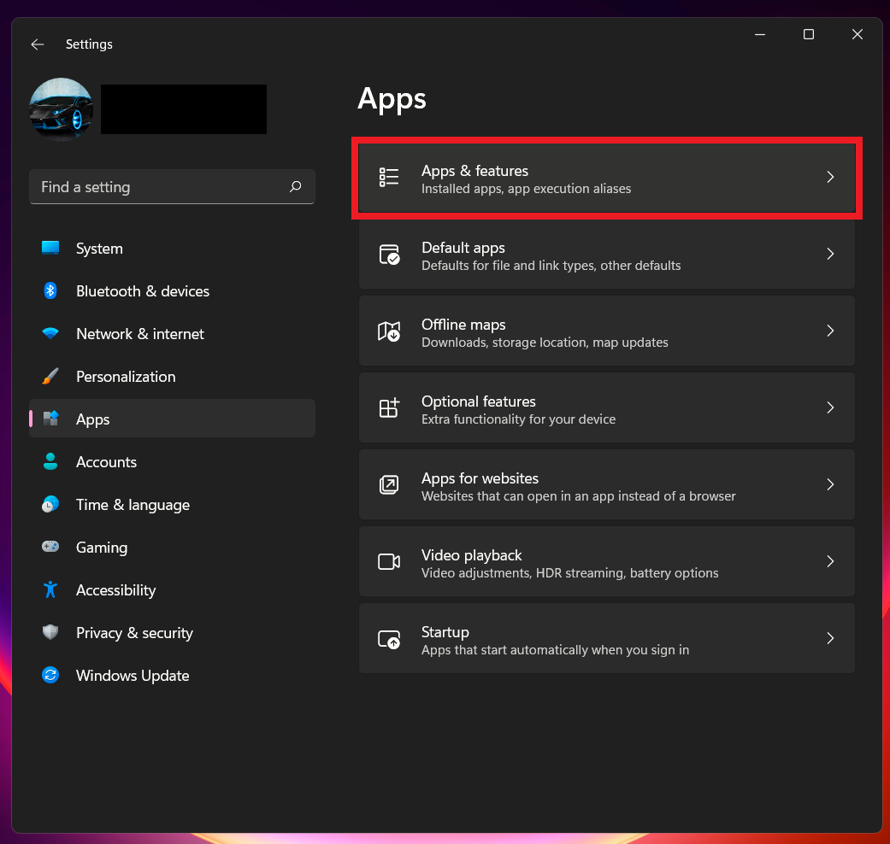

Once on the **Apps window** click on the **Apps & features tab**.

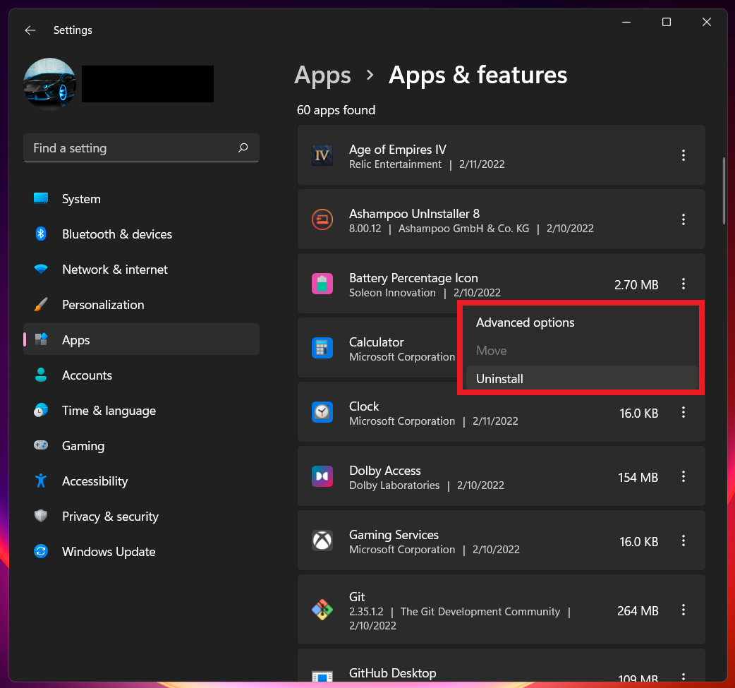

On the **Apps & features** window **scroll down** and you will see all the **programs** currently **installed** on your **hard drive**. To **uninstal**l a **program**, **click** on the vertical **three dots** next to the **program name** and **click** on **Uninstall** to **remove** the **program**.

The second suggestion that we have for our sponsor is that he must weekly check for Windows 11 updates to ensure that both software and hardware is up to date on his laptop. Having an updated operating system ensure that his laptop is not running into hardware or software related errors. The following images and text will guide our sponsor how to perform those actions.

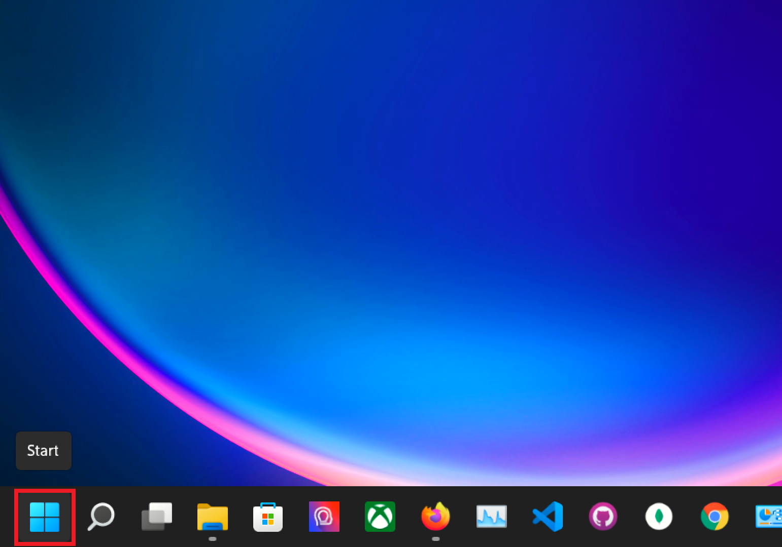

**First**, on the **bottom taskbar** **click** on the blue **Windows Start button**.

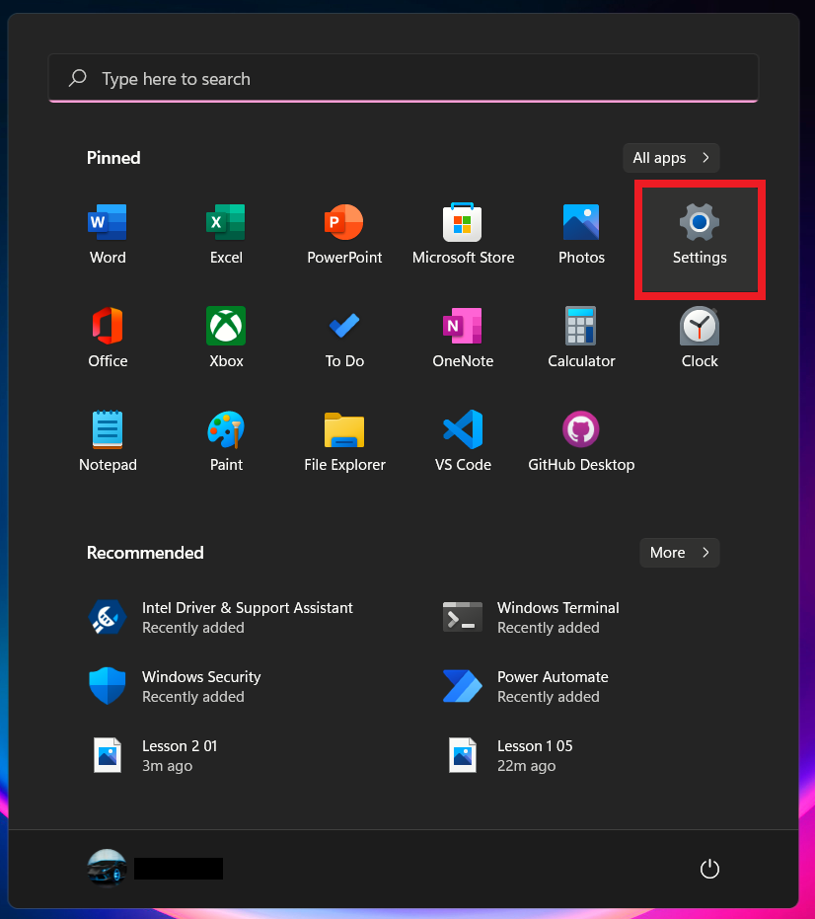

**Second**, once on the **Start Window** **click** on the **Settings button**.

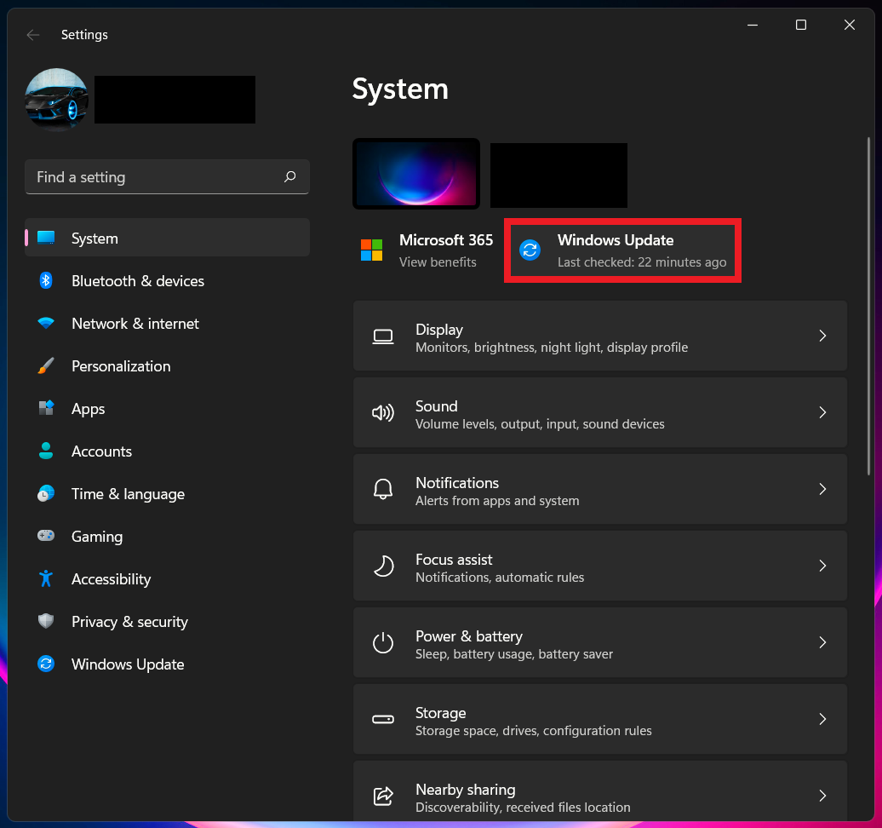

Third, on the **System window** **click** on the **Windows Update button**.

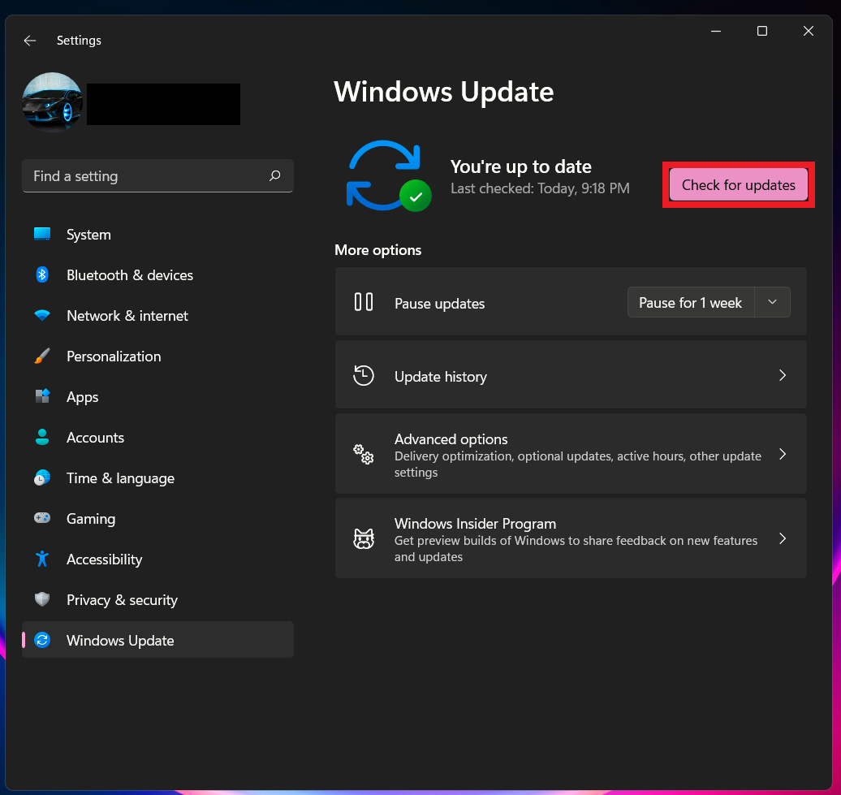

Lastly, on the **Windows Update window** **click** on the **Check for updates button**.

The third suggestion that we have for our sponsor Terry is that he should optimize system storage that is conduct defragmentation on his hard drives or trimming on his SSDs. This will ensure that files are organized on his hard drives or SSDs. By conducting this type of optimization, the time to access files will decrease and the operating system will feel smoother more responsive and not run sluggish or have freezing of screen.

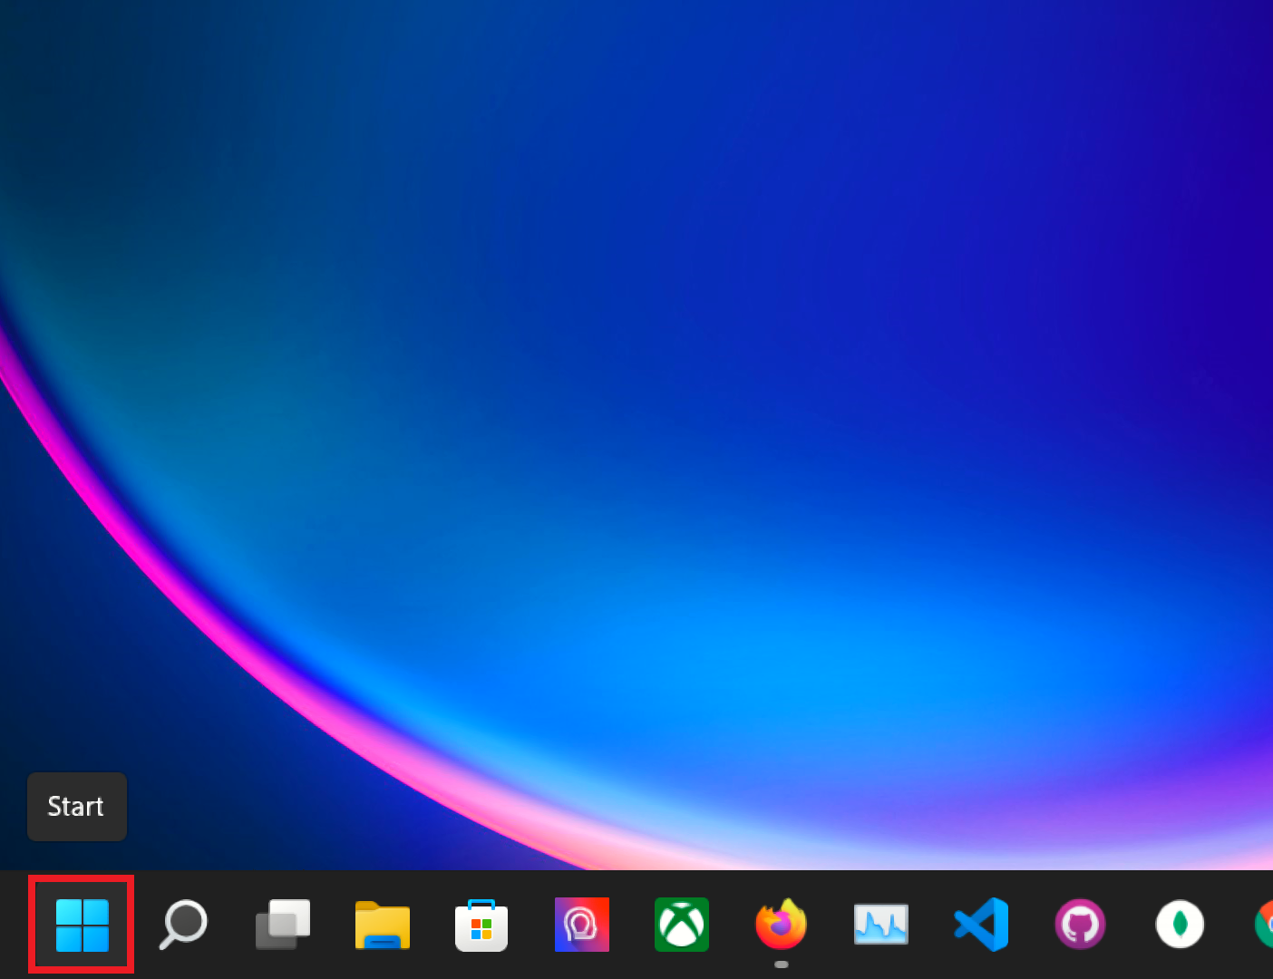

Step 1, on the **bottom taskbar click** on the blue **Windows Start button**.

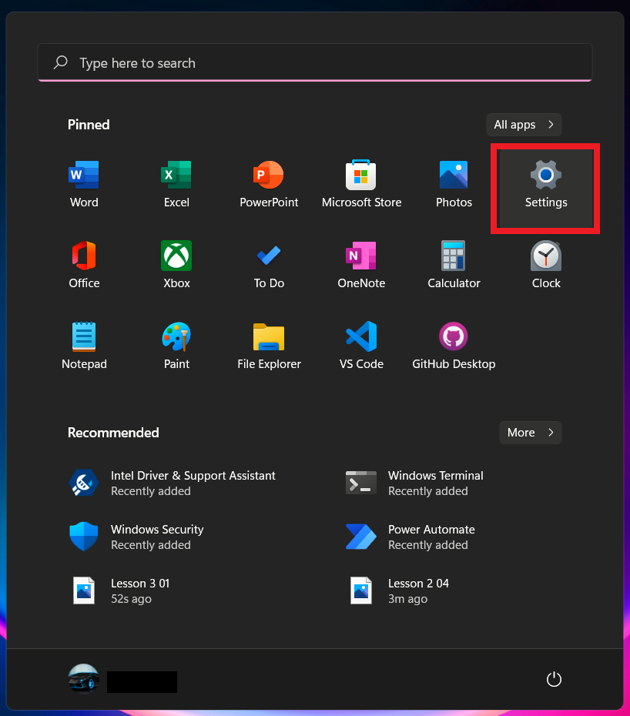

Step 2, on the **Start Window click** on the **Settings button**.

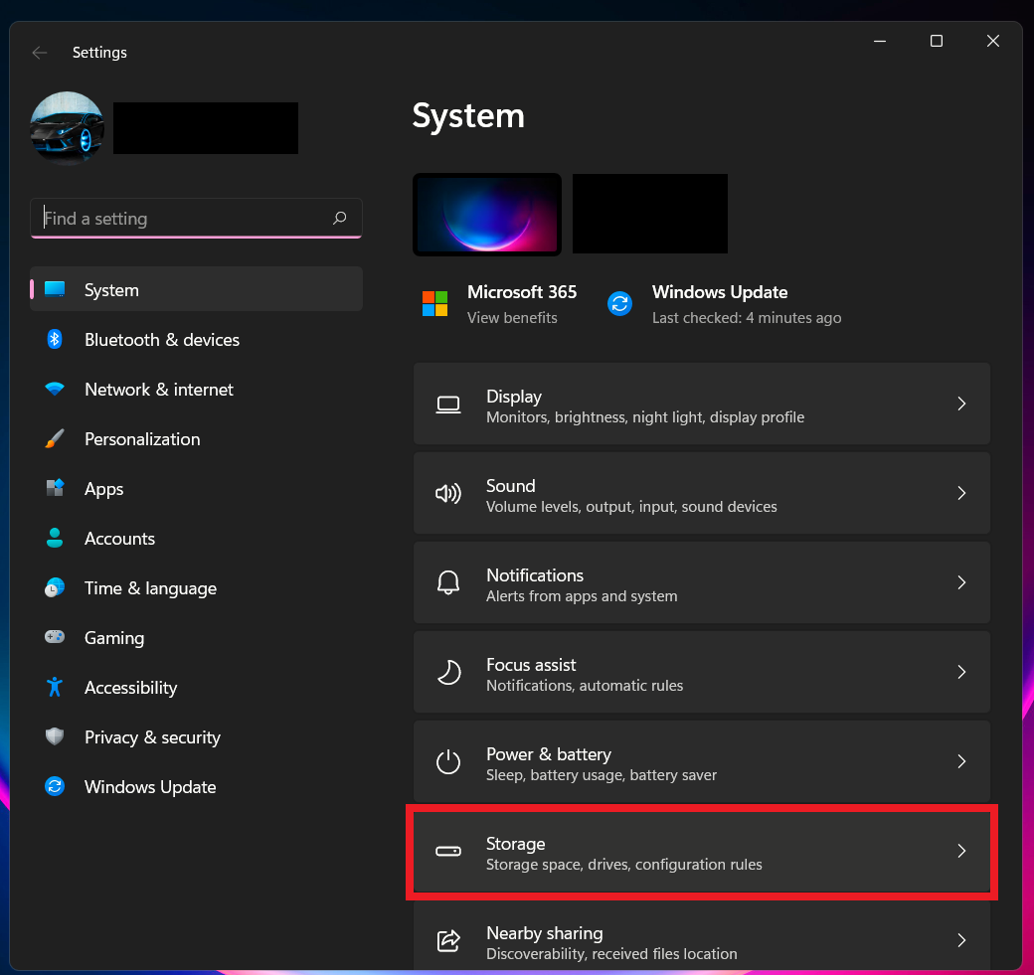

Step 3, on the **left Windows Pane click** on **System** then **click** on **Storage** tab.

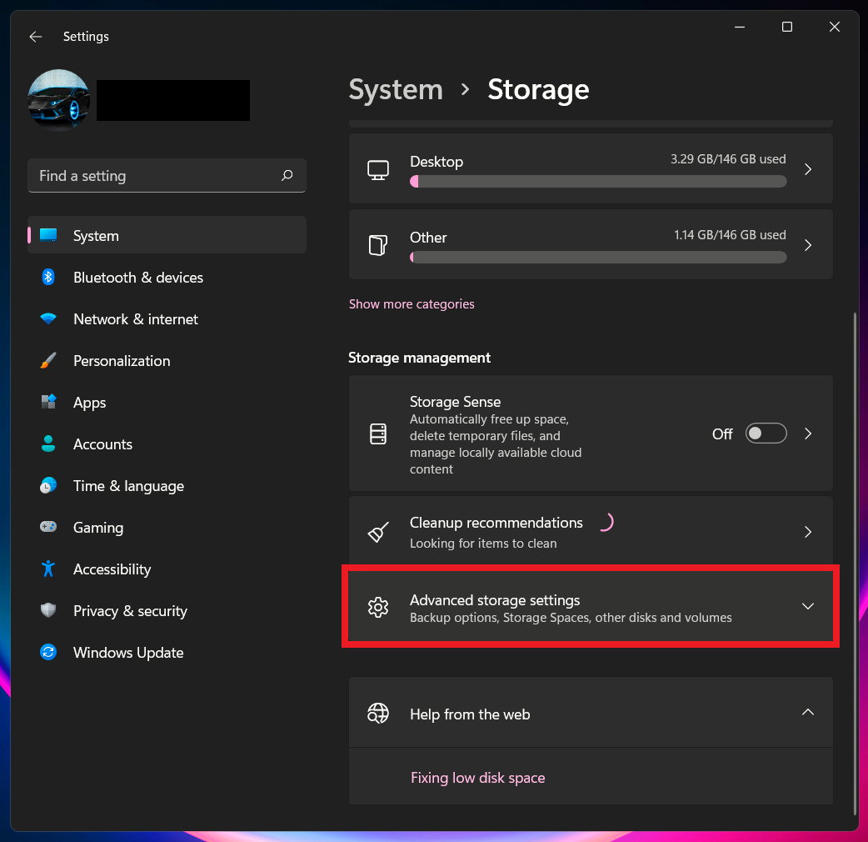

Step 4, on the **Storage window** scroll down and **click** on the **Advance storage** settings tab.

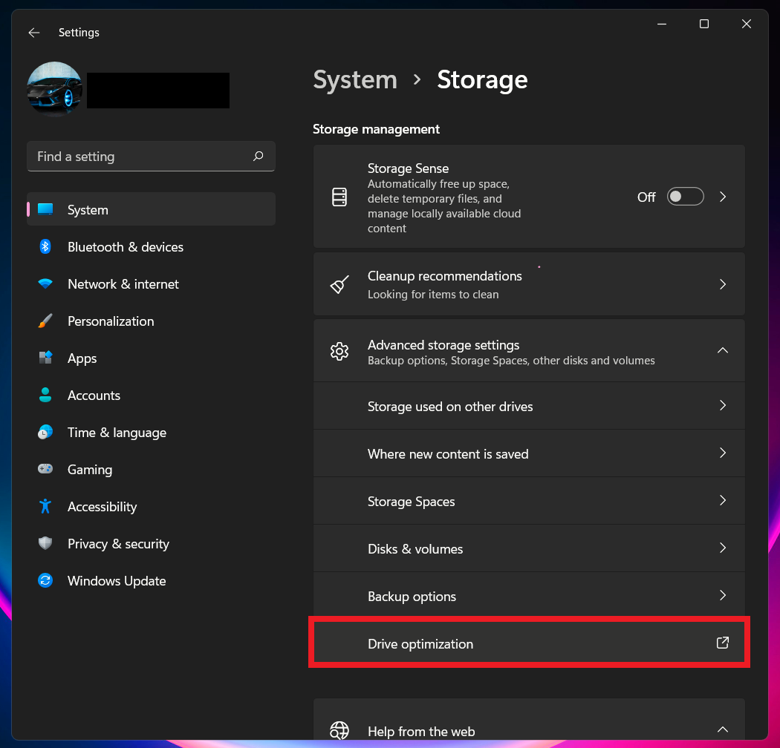

Step 5, on the **Advance Storage** settings scroll down and **click** on **Drive optimization**. This will open an external Window titled Optimize Drives.

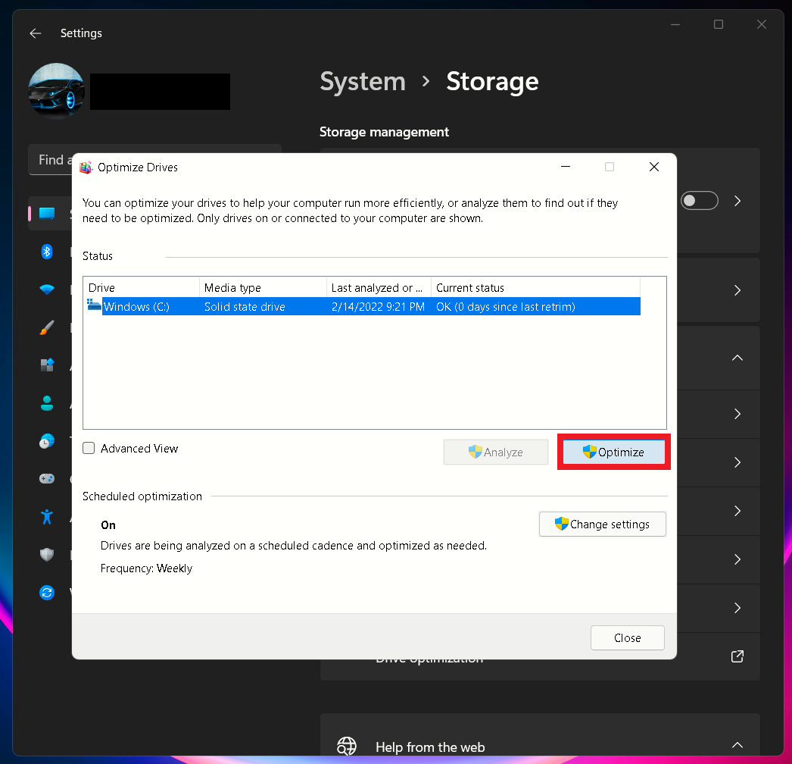

Step 6, on the **Optimizes Drives** **window** on the **Drive tab** select a **drive** then **click** on **Optimize** button to optimize the drive of your choice.

The fourth suggestion that we have for our sponsor Terry is that when working with demanding programs or if he wants his laptop to run at high performance. Then Terry within Windows 11 will need to set laptop computer system to performance. This will help speed up Windows 11 for the end-user providing a better Windows 11 experience.

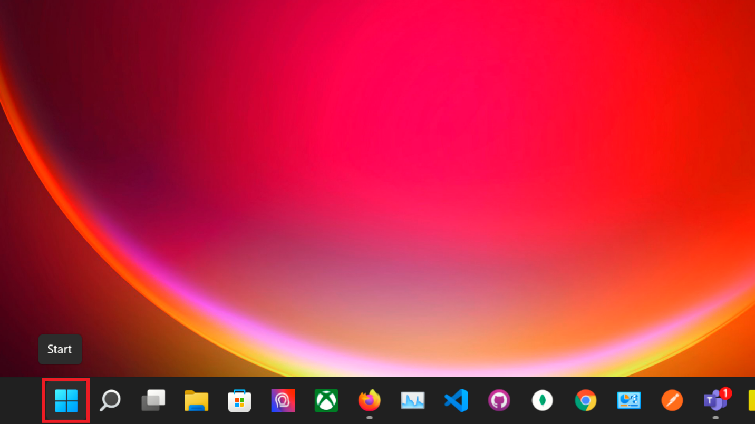

Step 1, on the **bottom taskbar click** on the red **Windows Start button**.

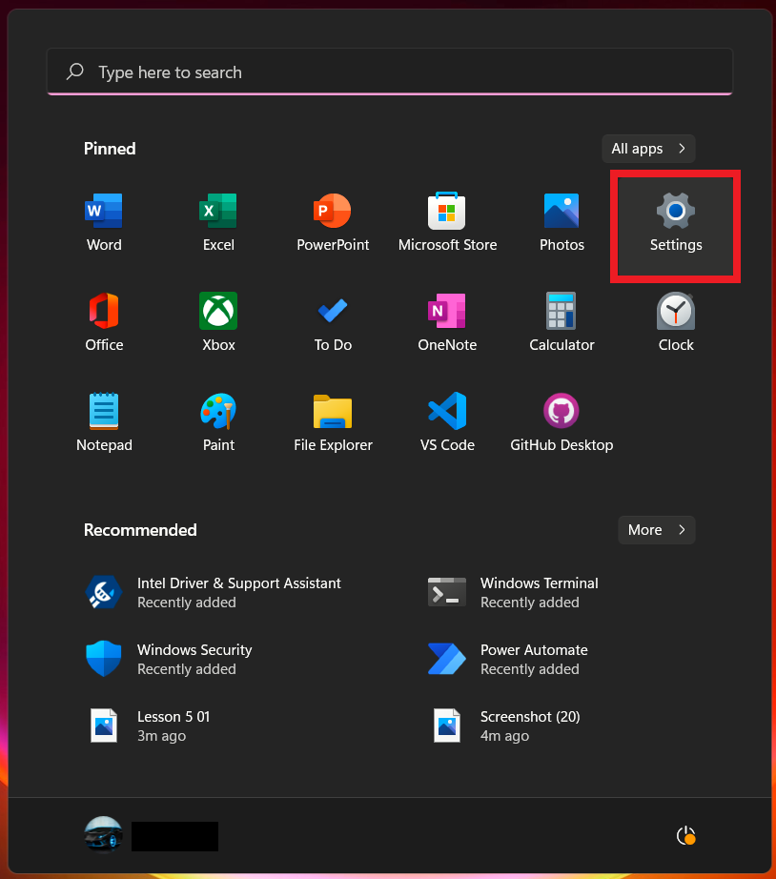

Step 2, on the **Start Window click** on the **Settings button**.

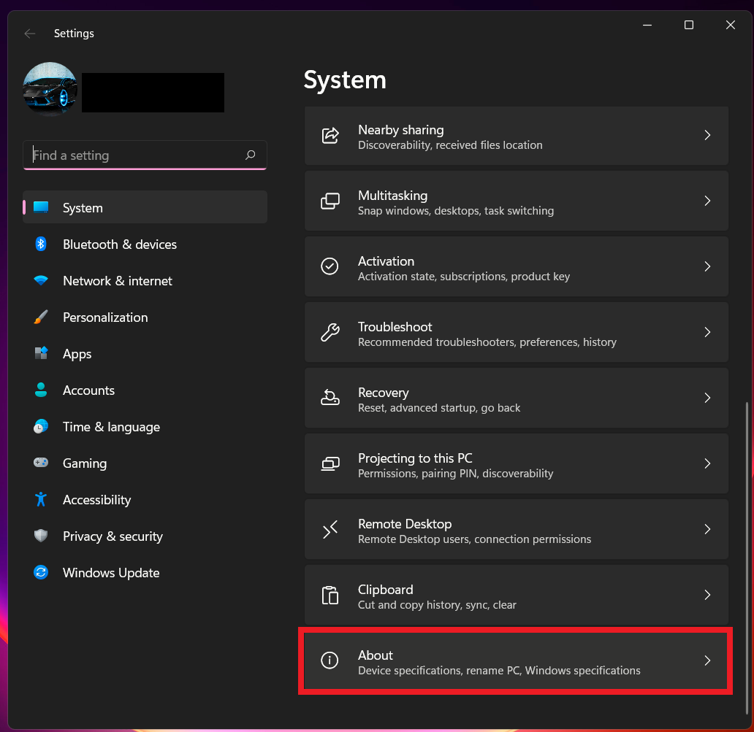

Step 3, on the **right Windows Pane click** on **System** then **click** on **about** tab.

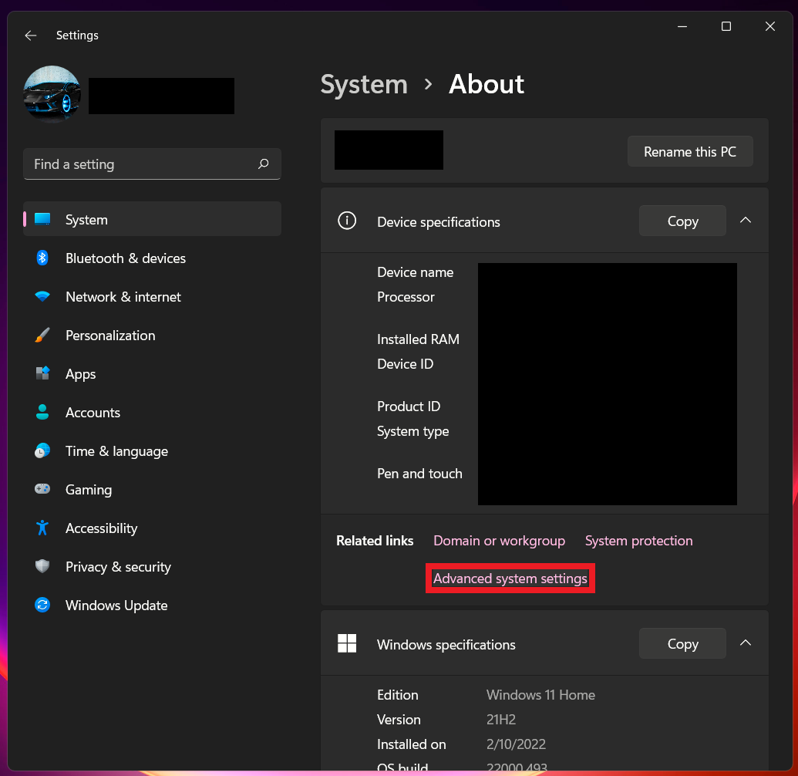

Step 4, under **Related links** tab **click** on **advanced system settings.**

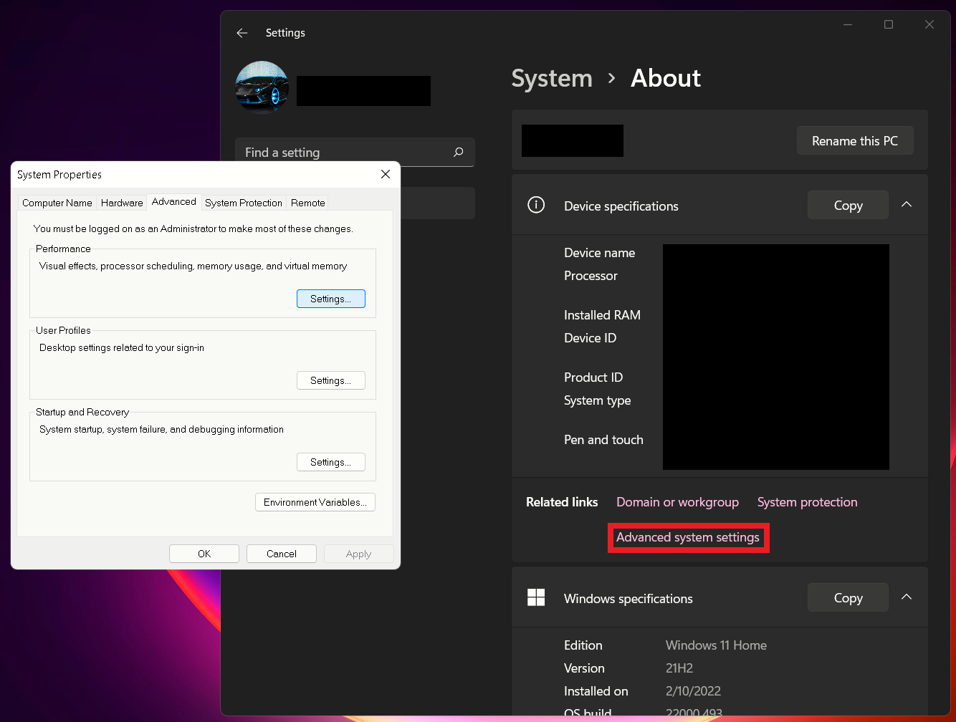

Step 5, on **System Properties** popup, **click** on **Settings.**

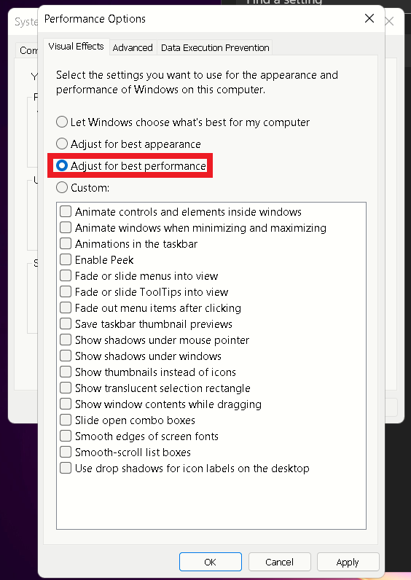

Step 6, on **Performance Options** popup, put **check** on **Adjust for best performance.**

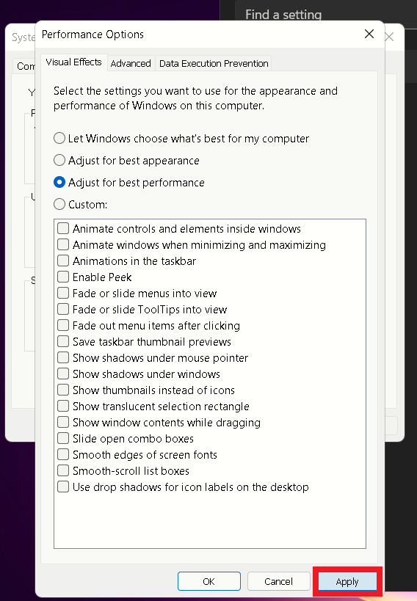

Step 7, on **Performance Options** popup, then **click** on **Apply.**

Suggestion five to optimize Windows 11 is that our sponsor should check that his dedicated graphics card on his laptop is updated. As not having an updated dedicated graphics card can cause stability problems when running programs that rely on graphics card like simple task as using chrome browser. That is why it is important that the graphics card is always updated to not run into problems running programs on the laptop.

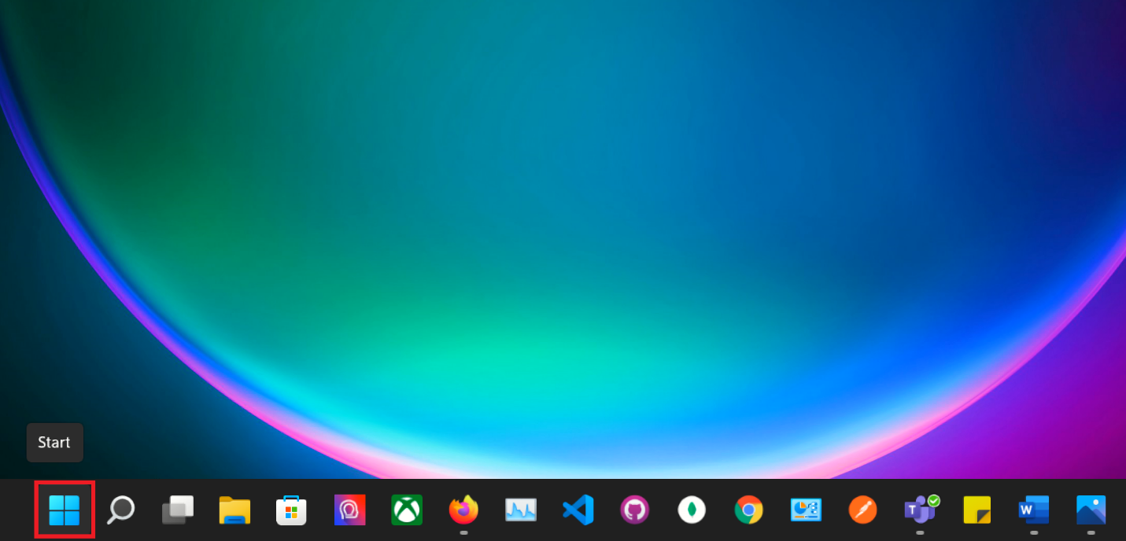

Step 1, on the **bottom taskbar click** on the red **Windows Start button.**

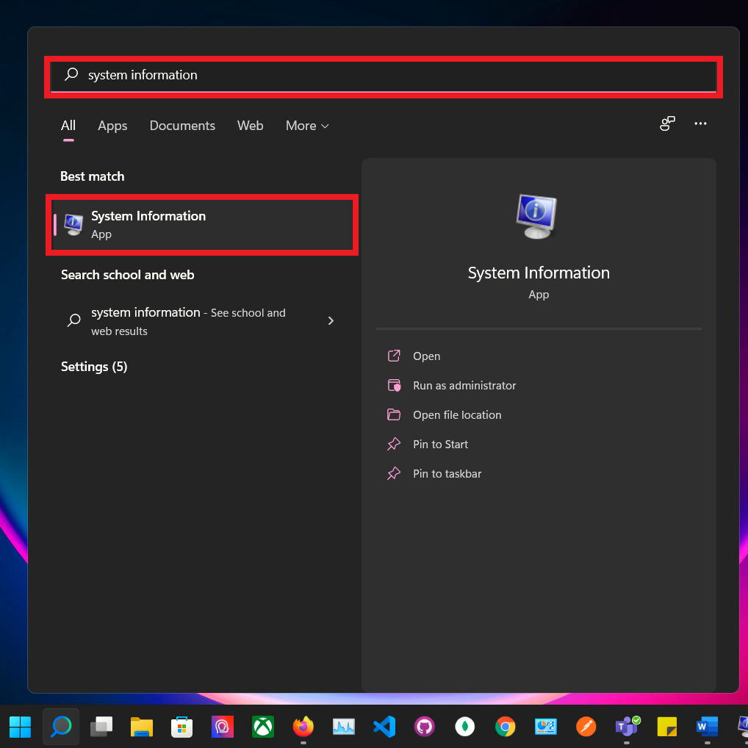

Step 2, on the **Start Window search bar** type System Information and click on it.

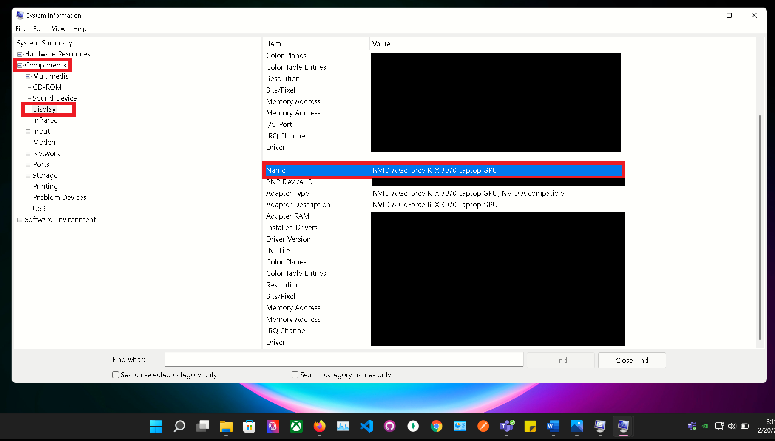

Step 3, on **Systems Information** pop up, **expand** the **Components,** and **click** on **Display** to know which graphic card you have on your computer.

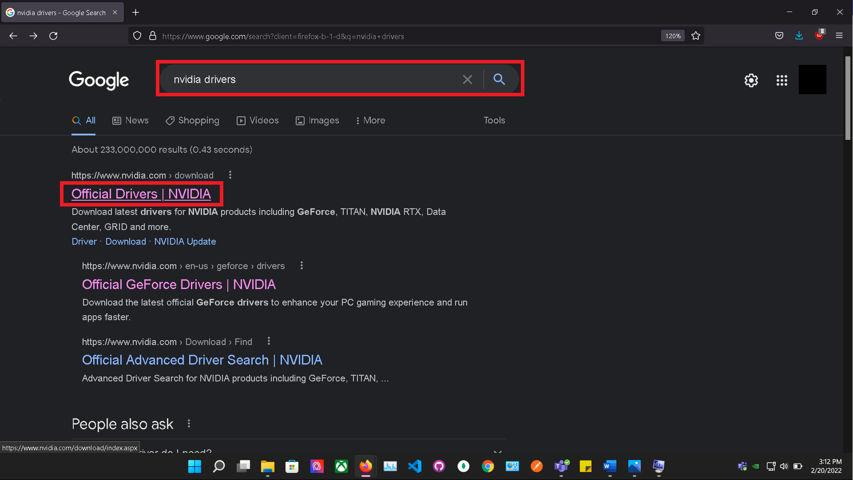

Step 4, (For NVIDIA driver user) **open your browser** and search for **NVIDIA Drivers.**

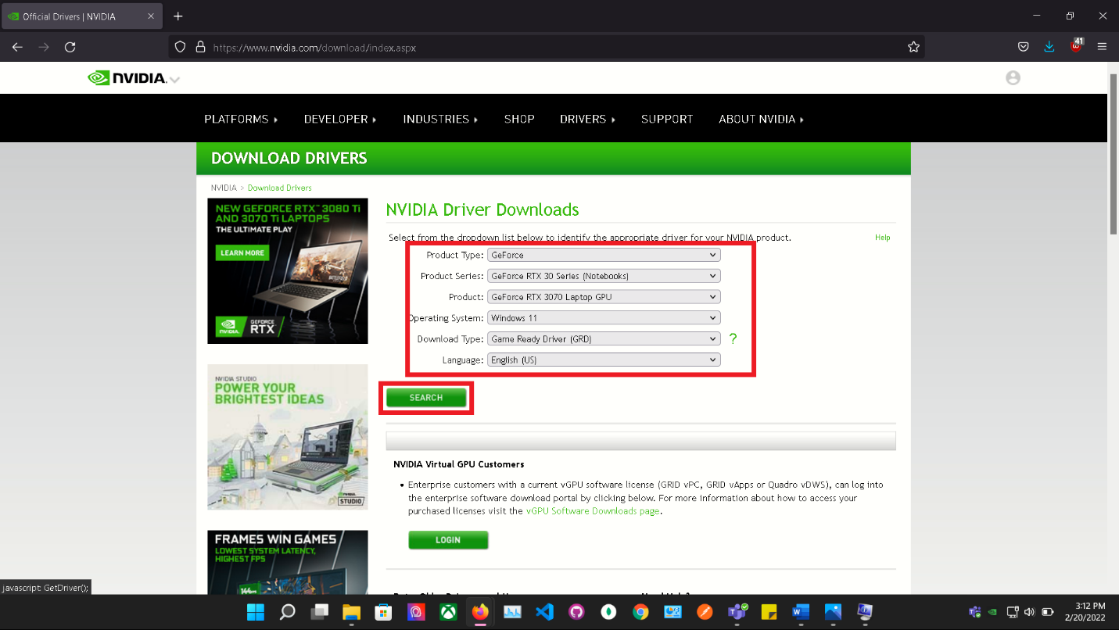

Step 5, on NVIDIA website select your current graphic card and **click Search.**

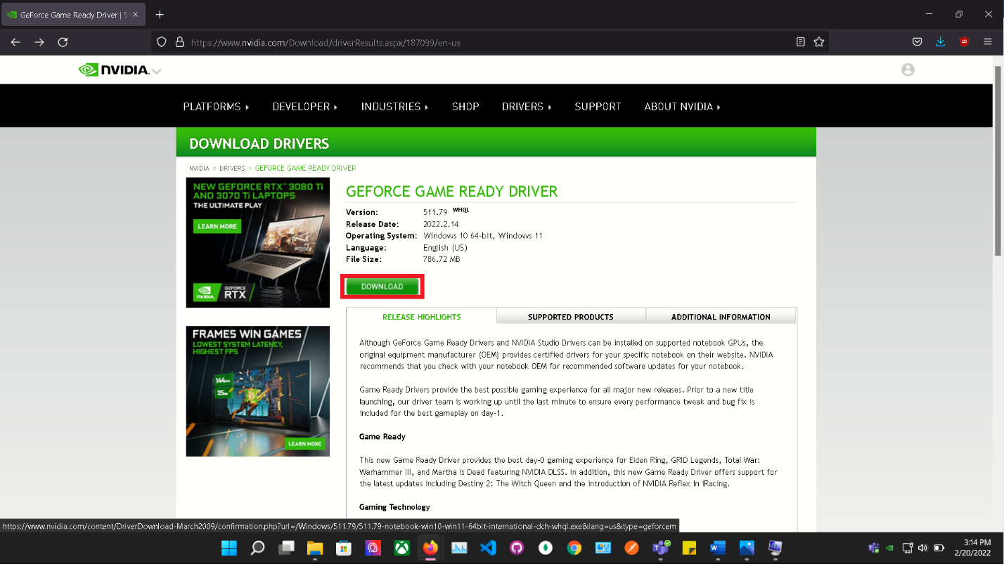

Step 6, **click** on **Download.**

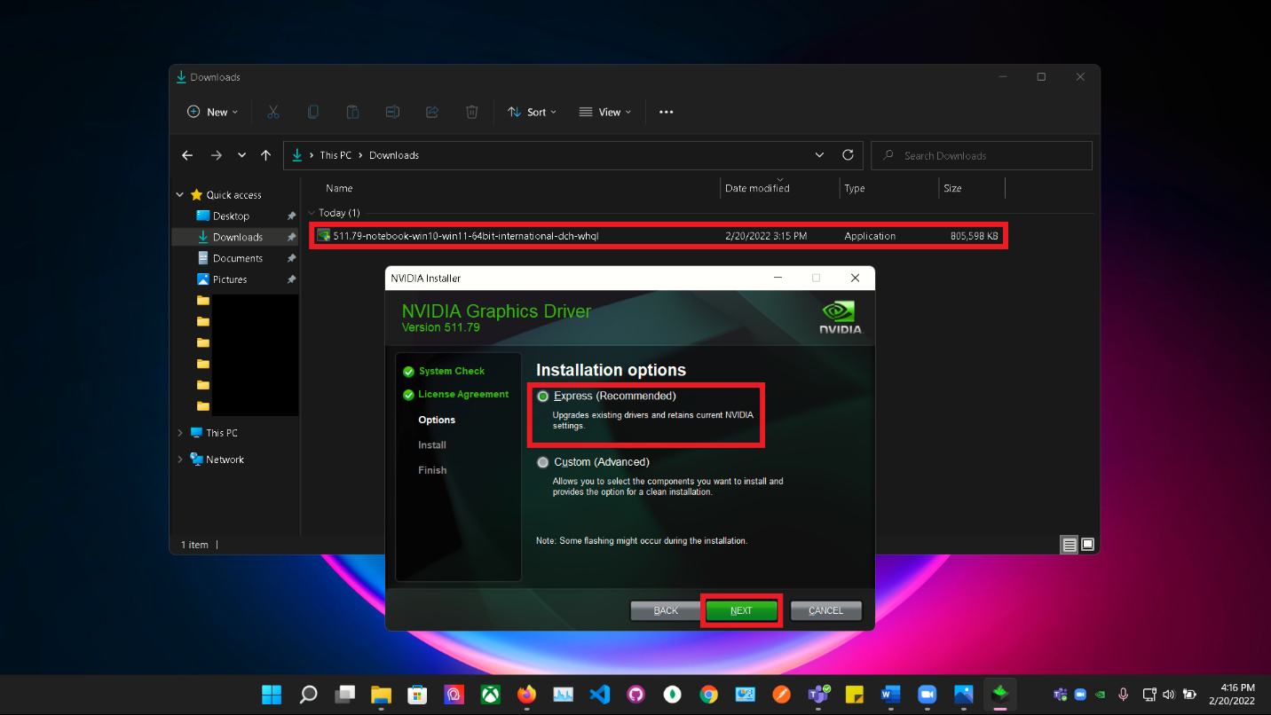

Step 7, on NVIDIA Installer, **select Express (recommended)** option and **click next.**

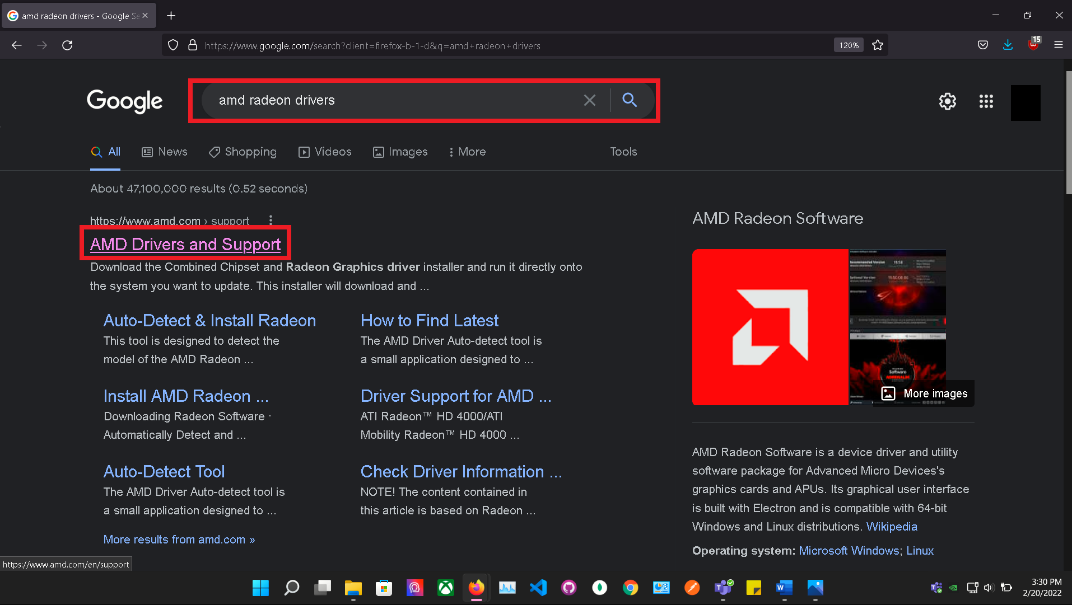

Step 8, (For AMD driver user), **open your browser** and search for **AMD Drivers.**

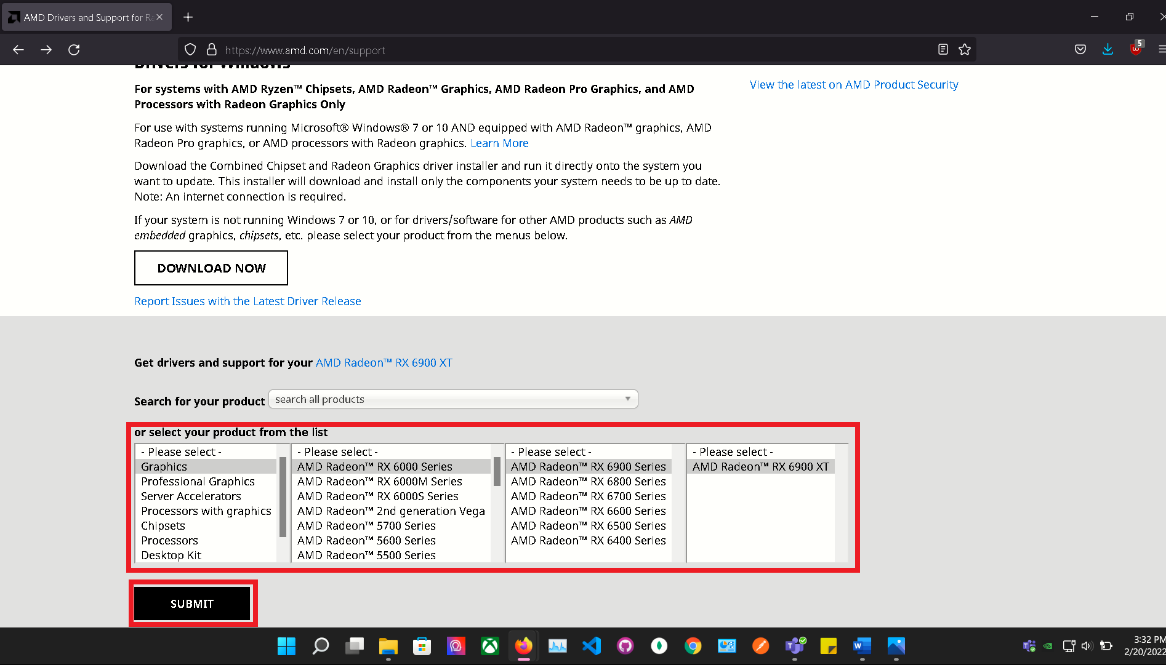

Step 9, on AMD website select your current graphic card and **click Search.**

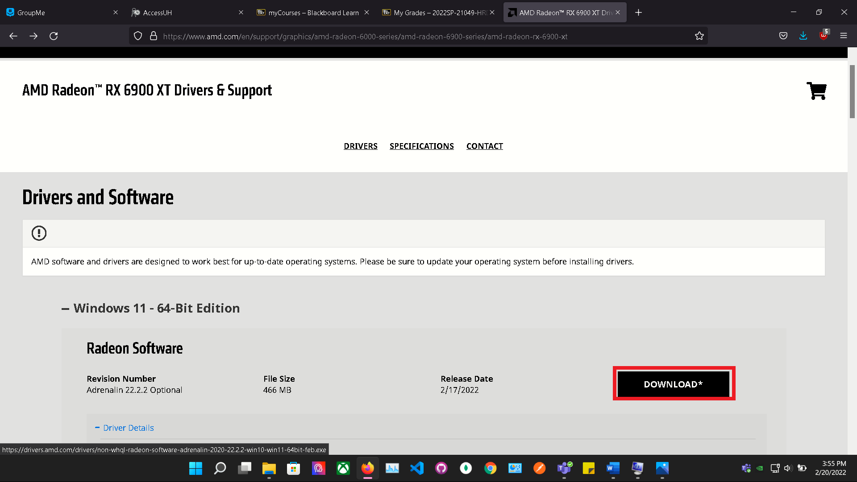

Step 10, **click** on **Download.**

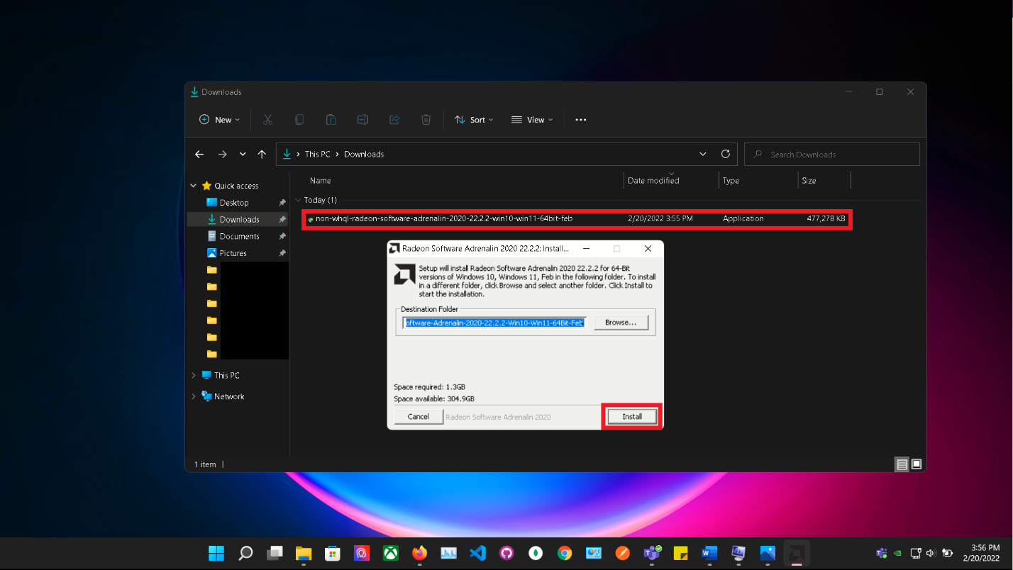

Step 11, on AMD Installer, **click Install.**

Suggestion six is only applicable if Terry laptop has Nvidia graphics card. Which if Terry does than he needs to optimize the Nvidia control panel to ensure that his graphics card is operating optimally. Also, sometimes the default Nvidia control panel settings because slowdowns in running programs as the default graphics processor I s the integrated graphics which gives the user a slow Windows 11 experience.

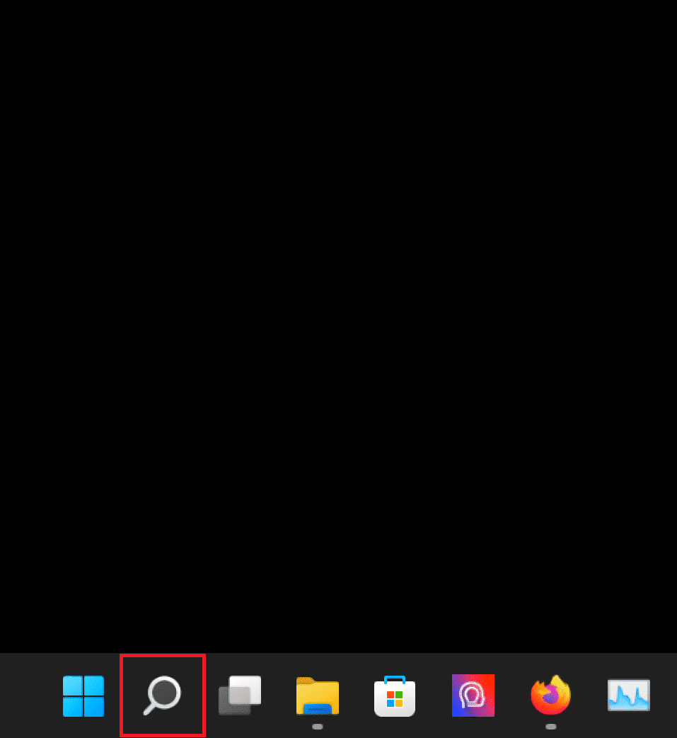

Step 1: **Click** on the **magnifying glass** on the **task bar** located at the **bottom** of the **screen**.

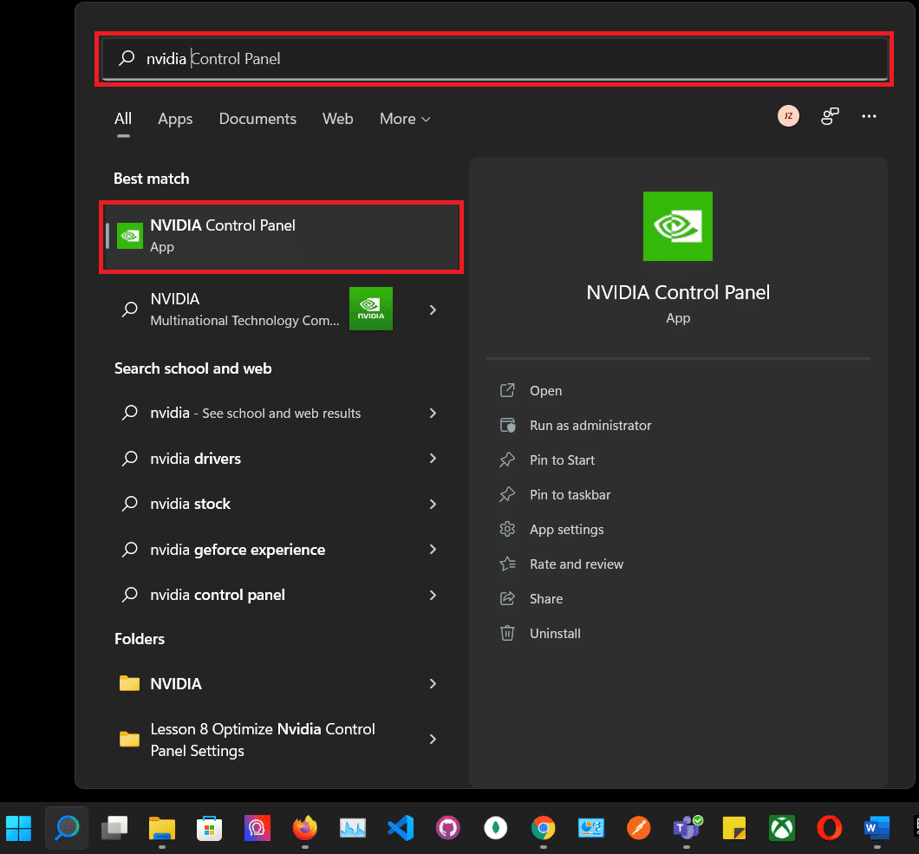

Step 2: Type “**nvidia**” in the **search bar**, and then **click** “**NVIDIA Control Panel**”.

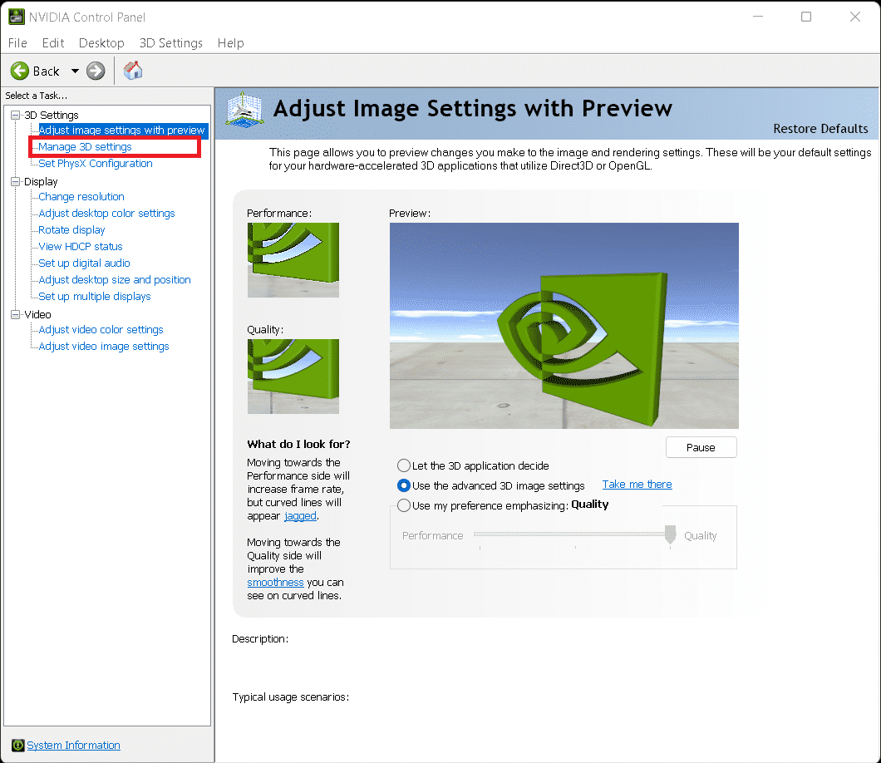

Step 3: **Click** on “**Manage 3D settings**” in the **top left corner** of the **NVIDIA Control Panel**.

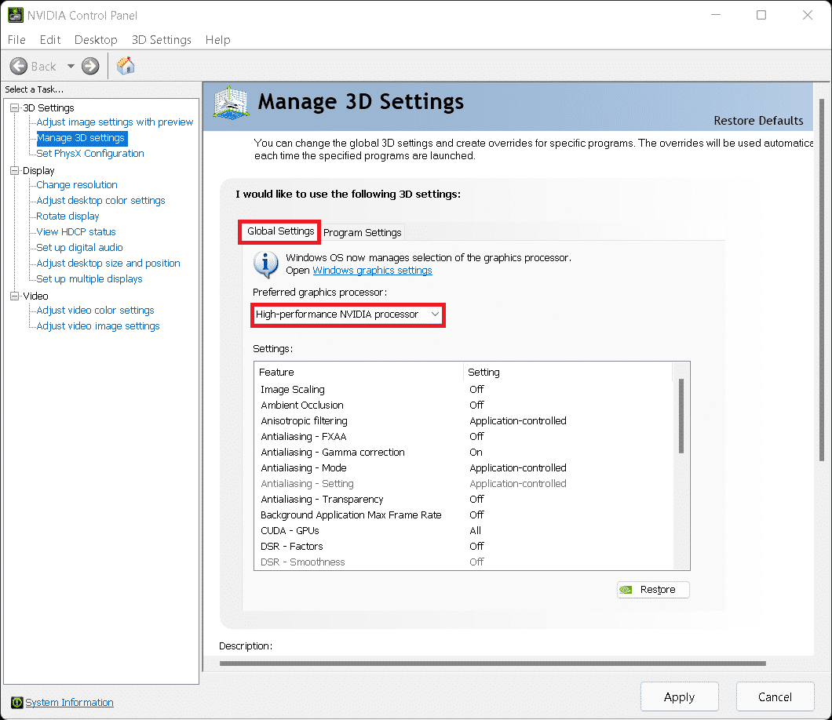

Step 4: Make sure the “**Global Settings**” tab is **selected**, then **click** the drop-down menu under “**Preferred graphics processor**:” Select “**High-performance NVIDIA processor**.”

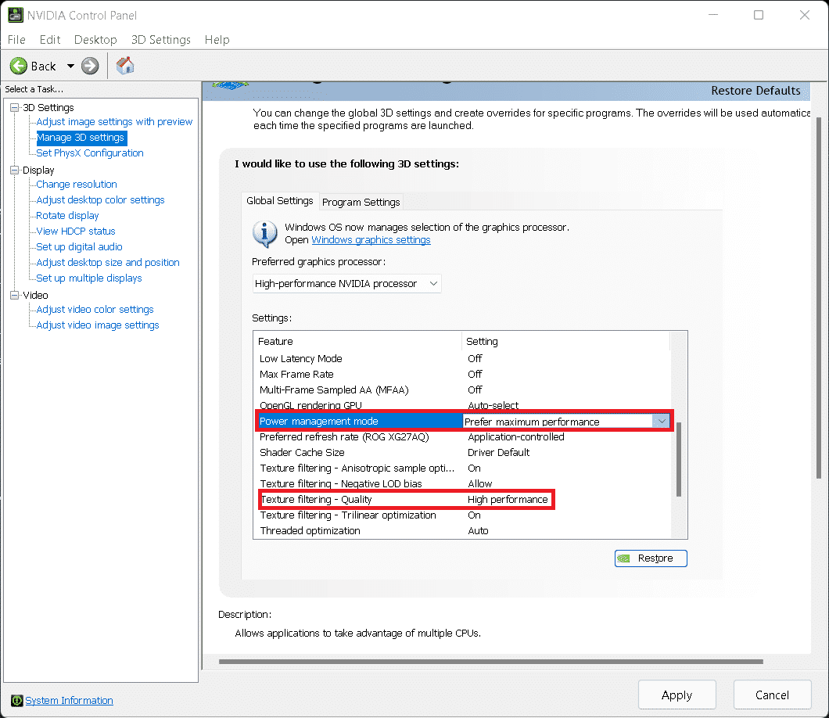

Step 5: Under the “**Settings**:” box, scroll down to “**Power management mode**”. **Click**on “**Normal**,” then select the “**Prefer maximum performance**” option. Lastly, under the “**Texture filtering – Quality**” setting select the “**High Performance**” option.

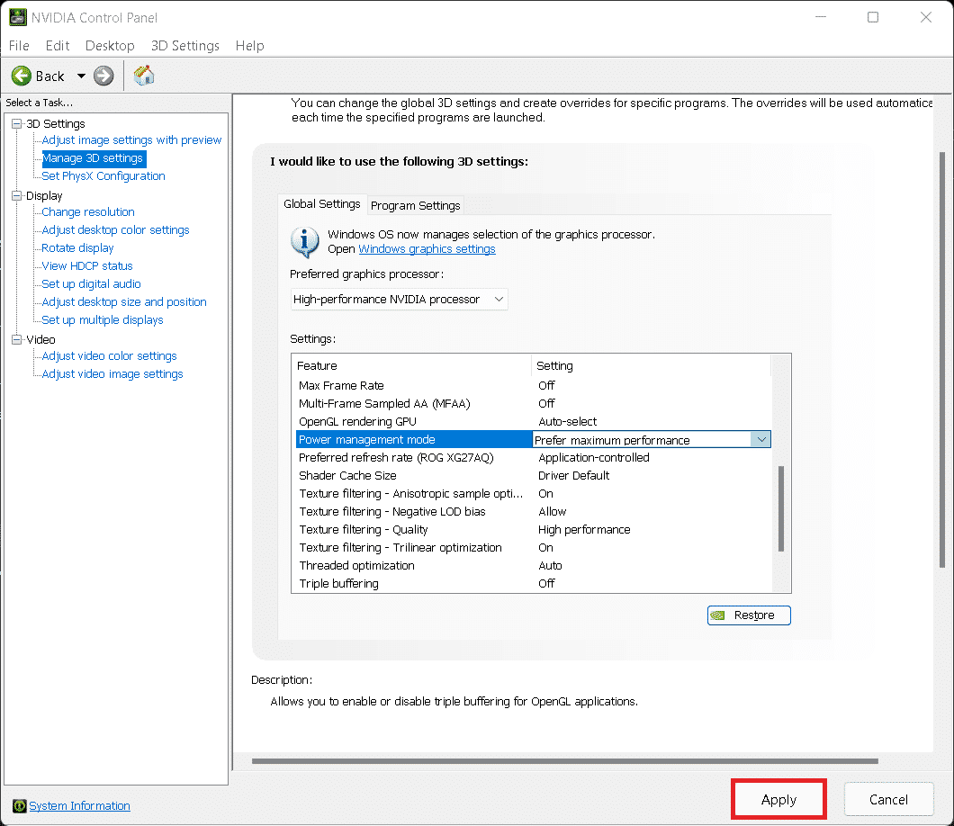

Step 6: Once **finished**, **click** on “**Apply**” in the bottom **right corner** of the **NVIDIA Control Panel.**

Suggestion seven for our sponsor Terry is to enable or disable the default enabled game mode options in Windows 11 as this option creates more stability problems on Windows 11. Also, since Terry will not be using his laptop to play games but instead conduct business operations, we suggest that he disables the gaming mode as his laptop will not see any tangible benefits from having it enabled.

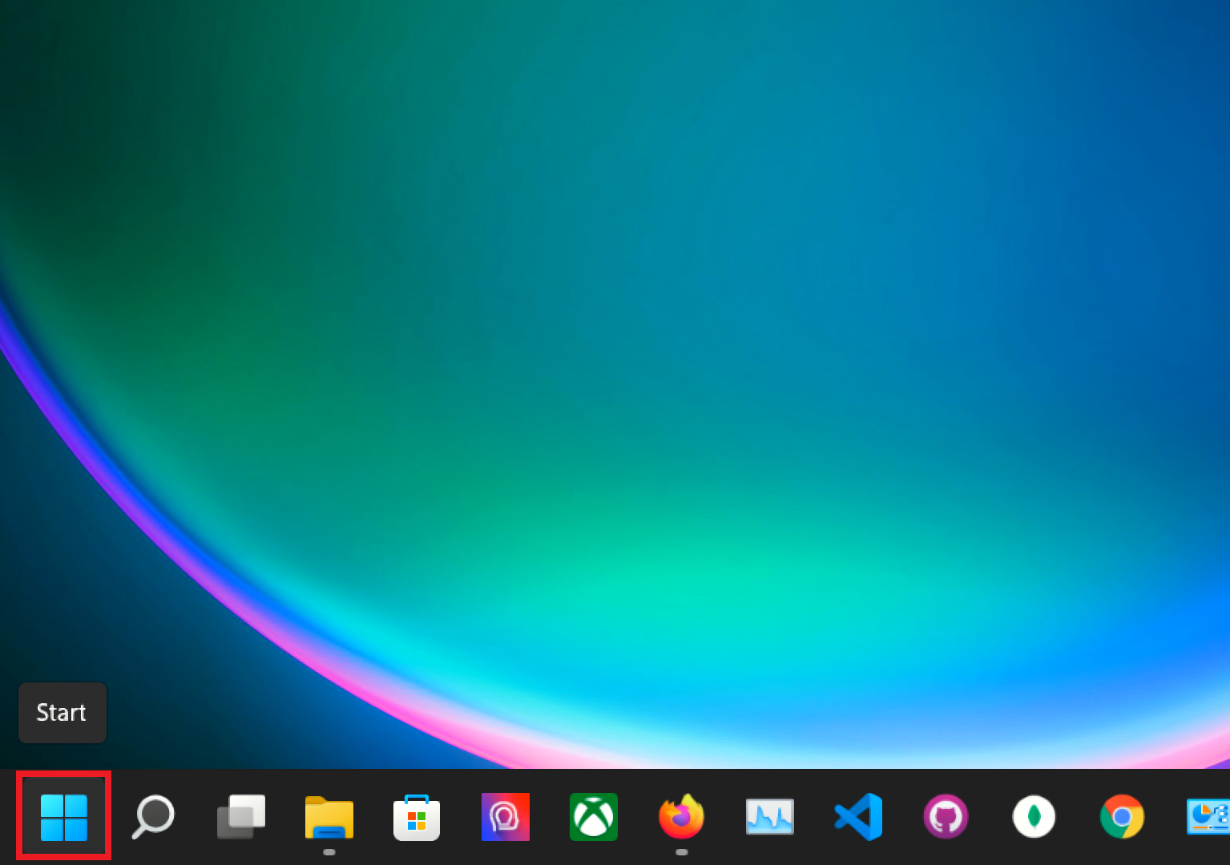

Step 1: At the bottom taskbar click on the **Windows Start Button**.

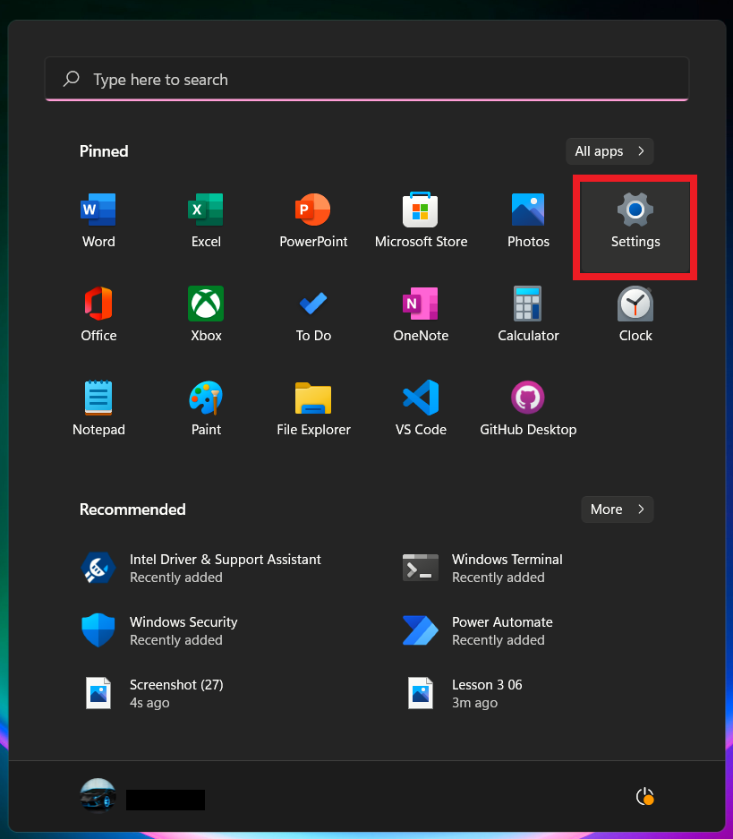

Step 2: Locate and click on **Settings** in the top right.

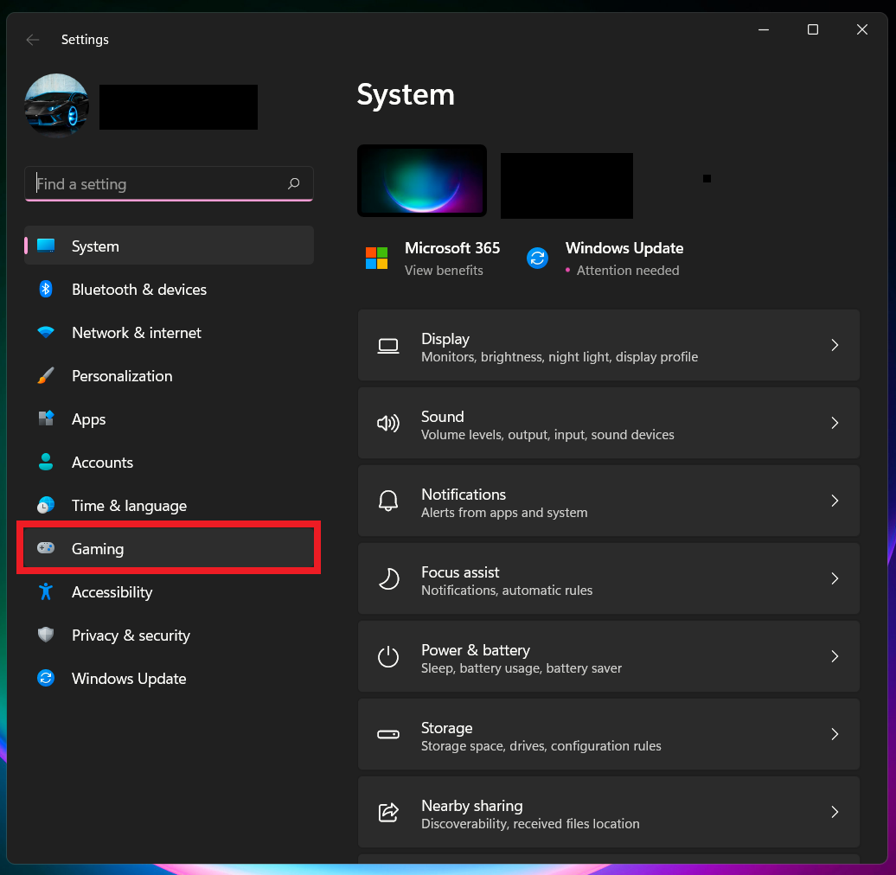

Step 3: Select **Gaming** in the settings menu.

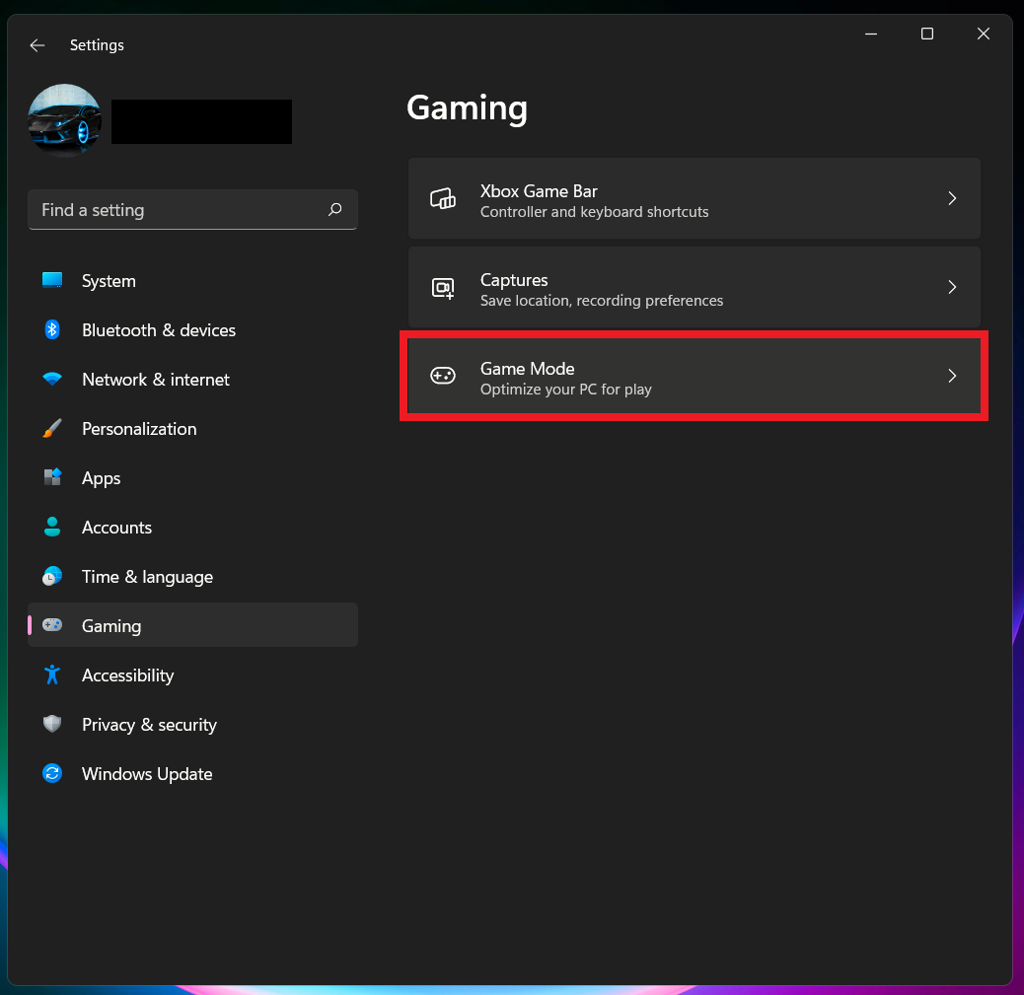

Step 4: Navigate to **Game Mode** in the gaming sidebar.

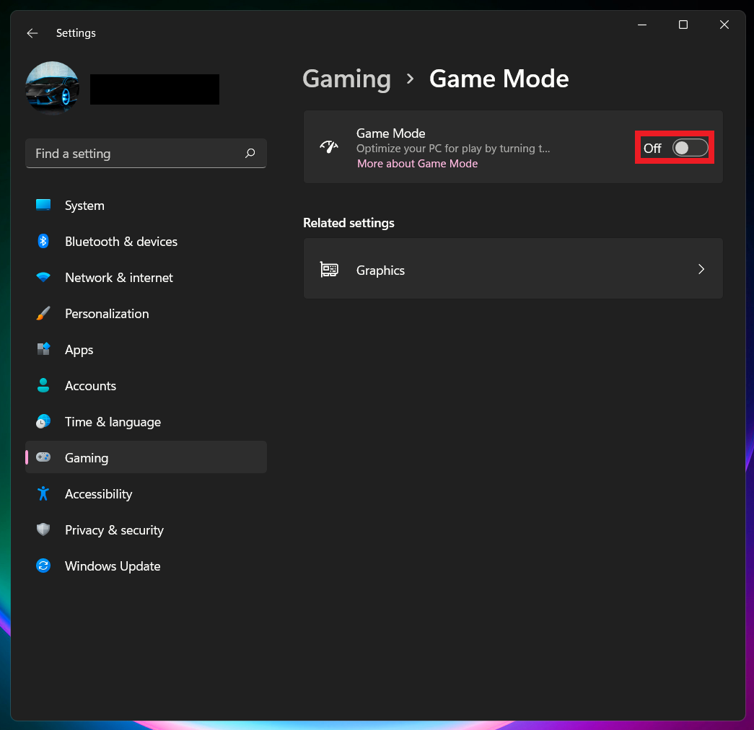

Step 5: Locate and **click** on the **toggle** for **game mode** and click on/off make sure it is on off.

Lastly, the eighth suggestion that we have for our sponsor Terry is that if he wants his laptop to run at high performance then he will need to make some changes in the Windows 11 setting options. Which he will be able to set his computer power options to high performance. The following images and text will guide Terry in achieving those changes on his laptop.

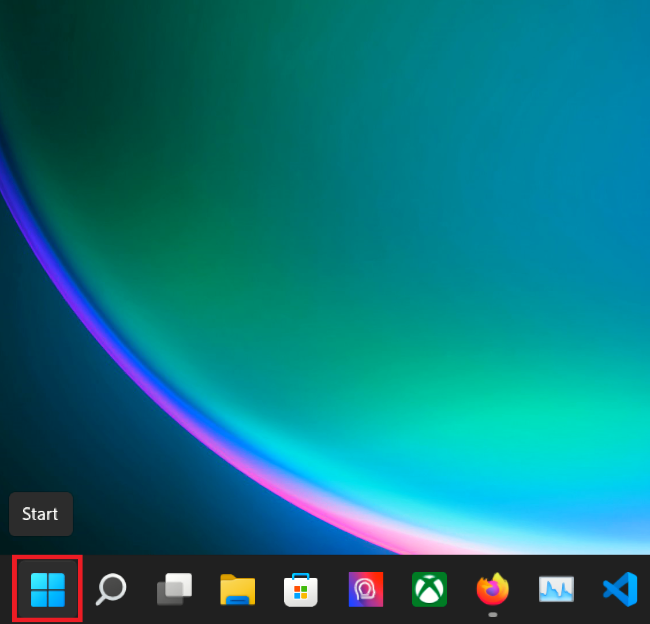

Step 1: Locate and click on the **Windows Start Button** at the bottom of the taskbar.

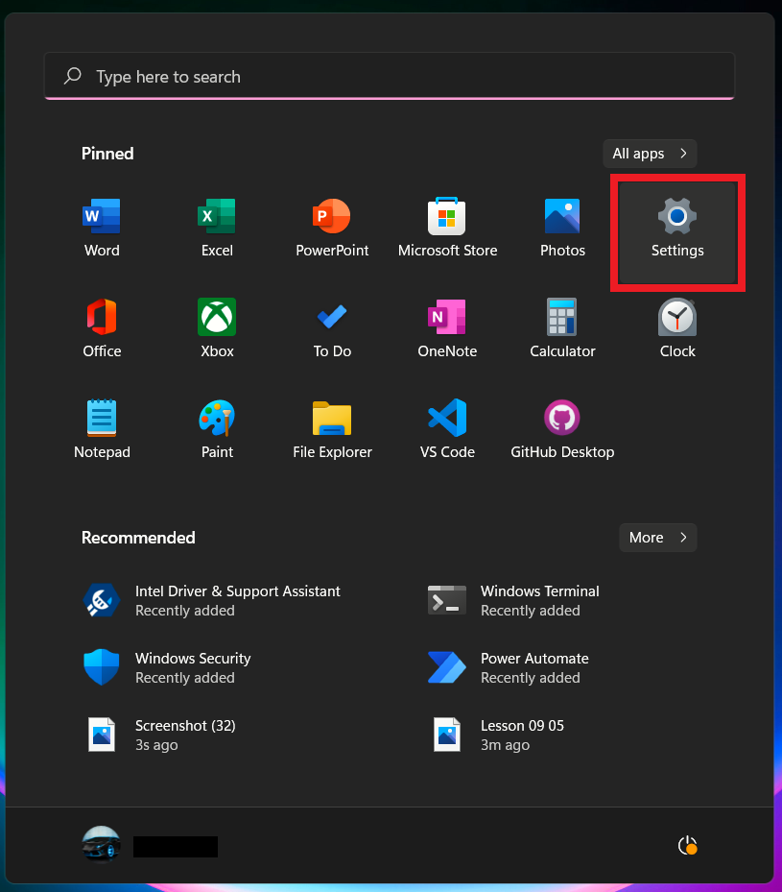

Step 2: Click on **Settings** located towards the top right.

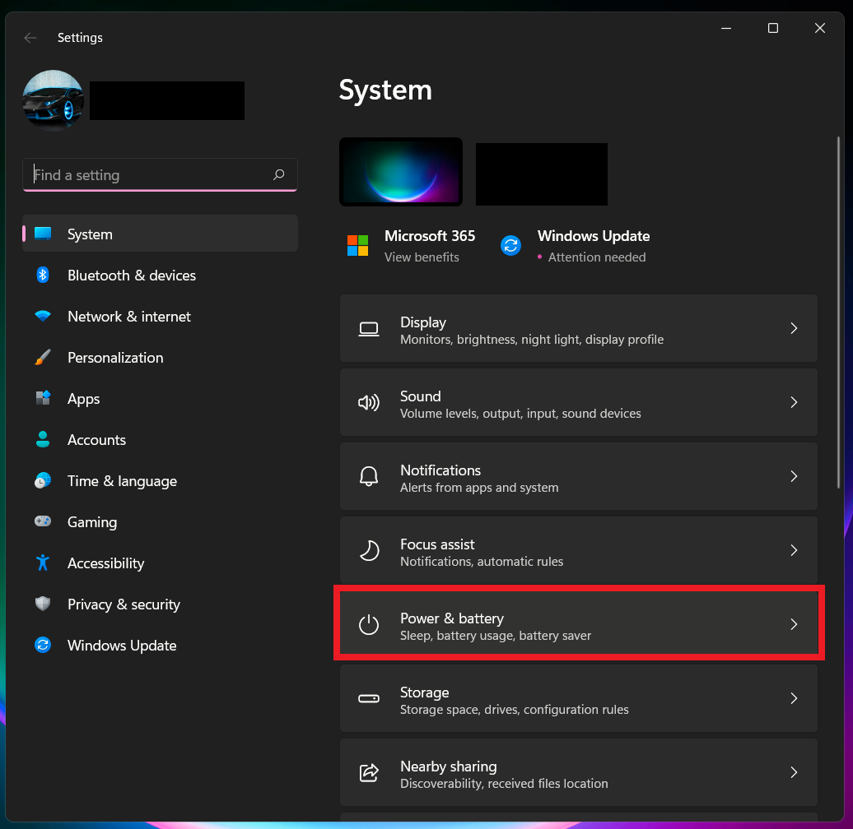

Step 3: Locate and select **System** at the top of the left panel. Once you have selected “System” locate and click on **Power & Battery** on the right panel.

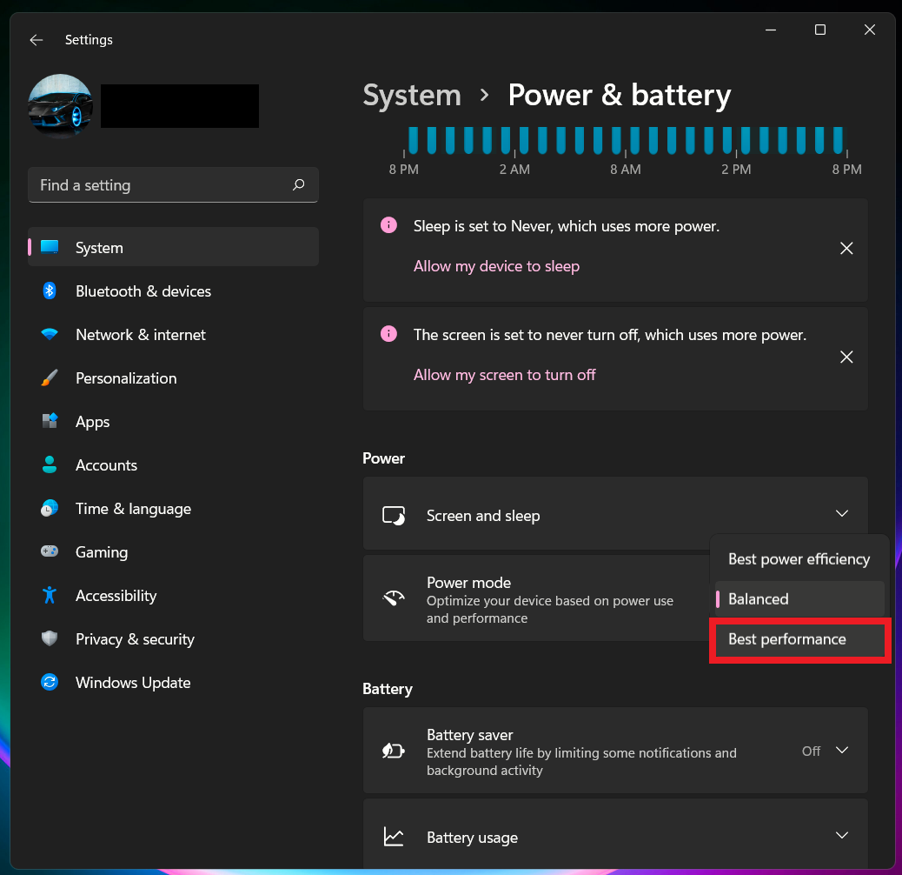

Step 4: Once “Power & Battery” have been selected, click on **High Performance** from the three options.